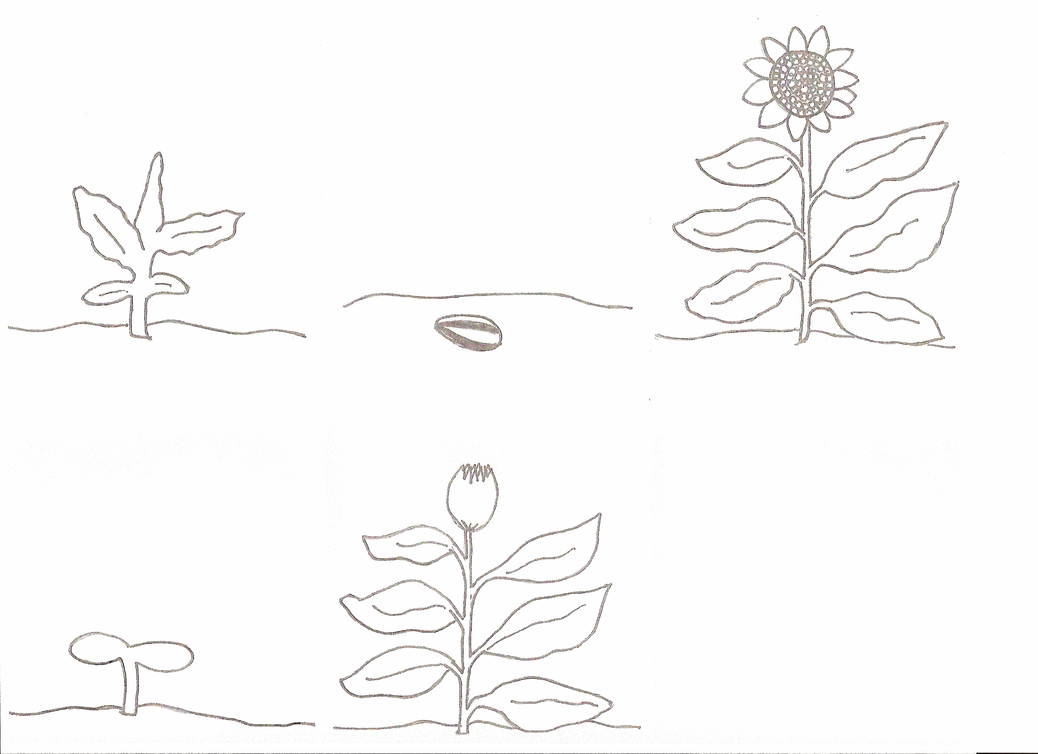
leaves
flower
bud
sprout
seed

