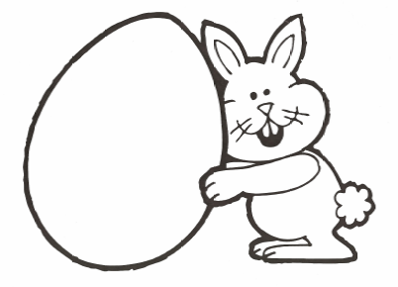
orange
purple
yellow
blue
orange
purple
yellow
blue

orange
purple
yellow
blue
pink
green
orange
blue

pink
green
orange
blue
green
pink
purple
yellow

pink
green
orange
blue
green
pink
purple
yellow

green
pink
purple
yellow
pink
yellow
purple
blue

pink
yellow
purple
blue
pink
yellow
purple
blue

green
orange
purple
blue
green
orange
purple
blue

green
orange
purple
blue
pink
orange
green
yellow

pink
orange
green
yellow
pink
orange
purple
blue

pink
orange
green
yellow
pink
orange
purple
blue

pink
green
orange
blue

pink
orange
purple
blue

green
orange
yellow
purple
yellow
yellow
green
pink

