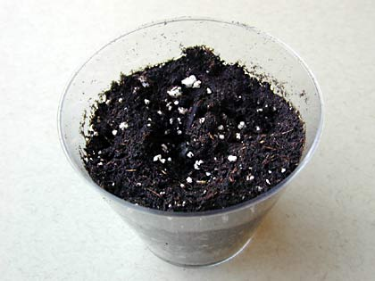
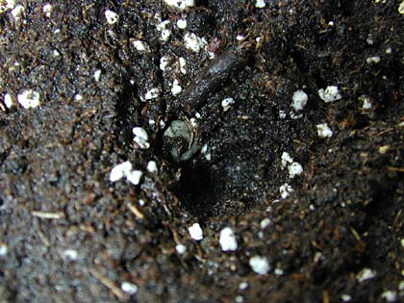
This is the Way We Plant Our Seeds

This is the way we plant our seeds, plant our seeds, plant our seeds.
This it the way we plant our seeds. We hope that they will grow!

This the way we poke a hole, poke a hole, poke a hole.
This is the way we poke a hole to put the tiny seed in.

This is the way we cover the seed, cover the seed, cover the seed.
This is the way we cover the seed and pat the dirt down.

This the way we water our seeds, water our seeds, water our seeds.
This is the way we water our seeds. Psst Psst Psst (make spraying sound).

