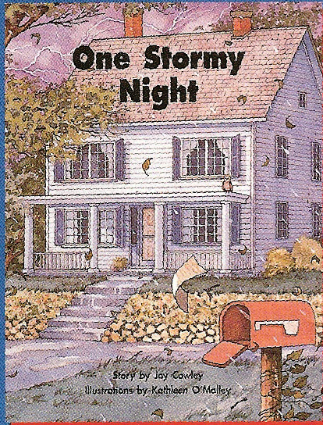
Name:

Glue

Write a sentence telling what happened in each part of the story.

