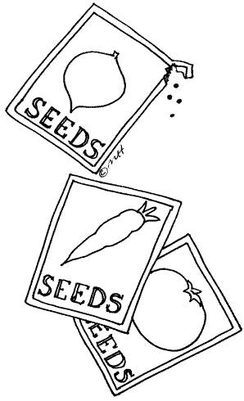
My Seed
By:

My Seed
By:

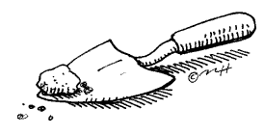
I
a seed.

I
a seed.
Nerds, Nerds what do you see?

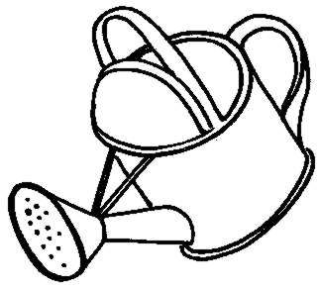
I
butdidn’t grow.

I
butdidn’t grow.

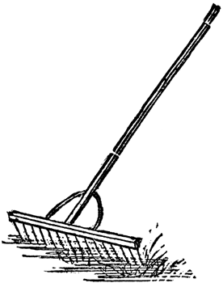
I
butdidn’t grow.

I
butdidn’t grow.

.’s not going to grow,
I said.

.’s not going to grow,
I said.


.
I
and.


Smarties, Smarties what do you ?
.
I
and.

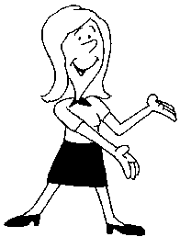
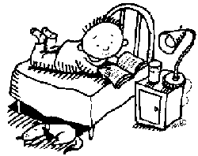
One day, Mom said
Come and look at this!


Laffy Taffy, Laffy Taffy what do you

?
One day, Mom said
Come and look at this!

A!
A!

