How to Dye Easter Eggs

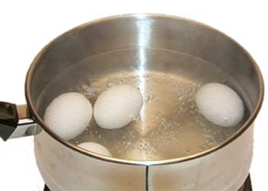
- Cook the eggs.

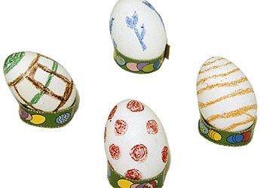
- Draw on the eggs with crayons or put stickers on the eggs.

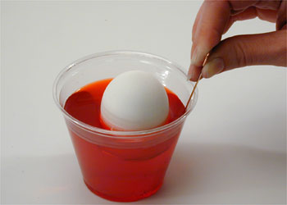
- Dip the eggs in the dye.

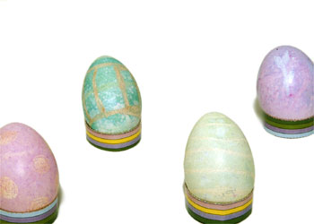
- Let the eggs dry.

