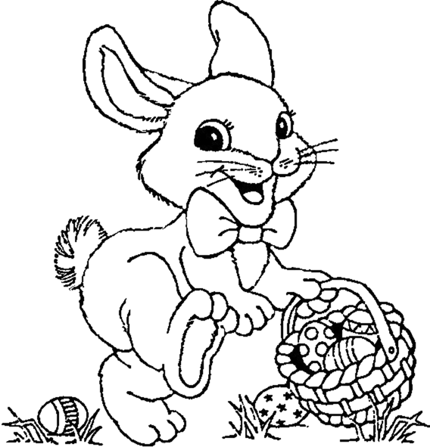
Easter Bunny, Easter Bunny what do you see?
By:

Easter Bunny, Easter Bunny what do you see?
By:

I Nerds looking at me.

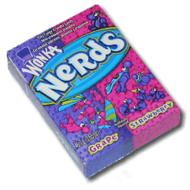

Nerds, Nerds what do you ?

I Nerds looking at me.

Nerds, Nerds what do you see?

Nerds, Nerds what do you ?

I M&Ms looking at me.

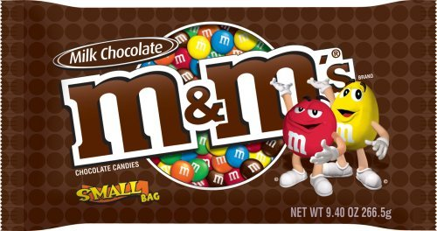

M&Ms, M&Ms what do you ?

I M&Ms looking at me.
M&Ms, M&Ms what do you ?



I Snickers looking at me.
Snickers, Snickers what do you ?

I Snickers looking at me.

Snickers, Snickers what do you ?

I Gummy Bears looking at me.

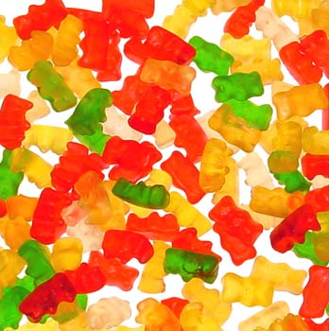

Gummy Bears, Gummy Bears what do

you ?

I Gummy Bears looking at me.

Gummy Bears, Gummy Bears what do

you ?

I Smarties looking at me.

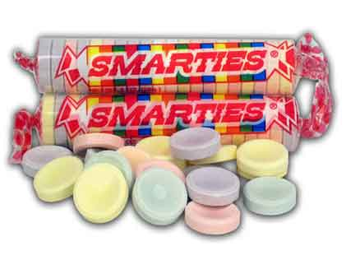

Smarties, Smarties what do you ?

I Smarties looking at me.
Smarties, Smarties what do you ?

I Laffy Taffy looking at me.

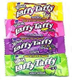

Laffy Taffy, Laffy Taffy what do you

?

I Laffy Taffy looking at me.
Laffy Taffy, Laffy Taffy what do you

?

I an Easter basket looking at me!

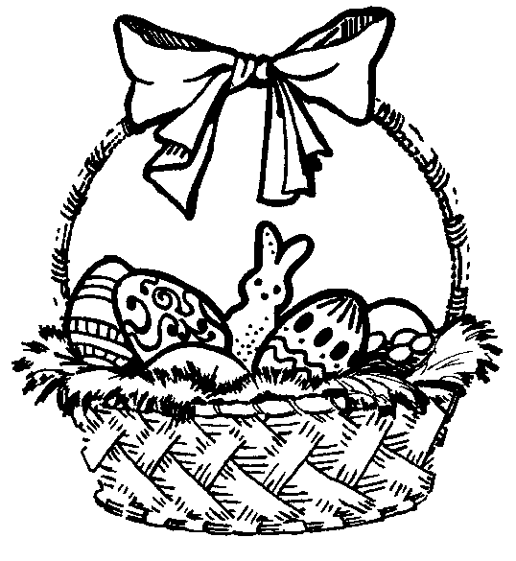

I an Easter basket looking at me!

