Easter Bunny, Easter Bunny what do you see?
I see Nerds looking at me.

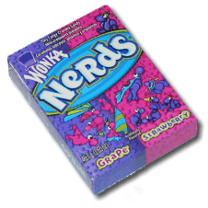

Nerds, Nerds what do you see?

I see M&Ms looking at me.

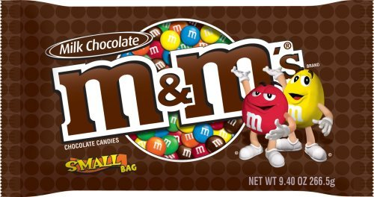

M&Ms, M&Ms what do you see?

I see Snickers looking at me.



Snickers, Snickers what do you see?

I see Gummy Bears looking at me.

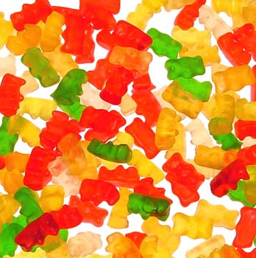

Gummy Bears, Gummy Bears what do you see?

I see Smarties looking at me.

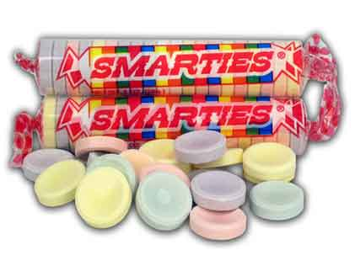

Smarties, Smarties what do you see?

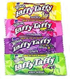
I see Laffy Taffy looking at me.
Laffy Taffy, Laffy Taffy what do you see?

I see an Easter basket looking at me.

Happy Easter!

