Kindergarten Homework

Kindergarten students will receive monthly homework calendars. These calendars (along with the corresponding work packet) are secured in the middle of their homework folders. Each day (Monday-Thursday) will have one or two assignments for the students to complete. Some assignments are written while others are activities for your child to do orally or with materials at home. All written assignments have a page in the packet for your child to complete the work. Please help your child complete the work each night and return the folder every Friday so that I can check the week’s work. I will send the folders home again the following Monday.

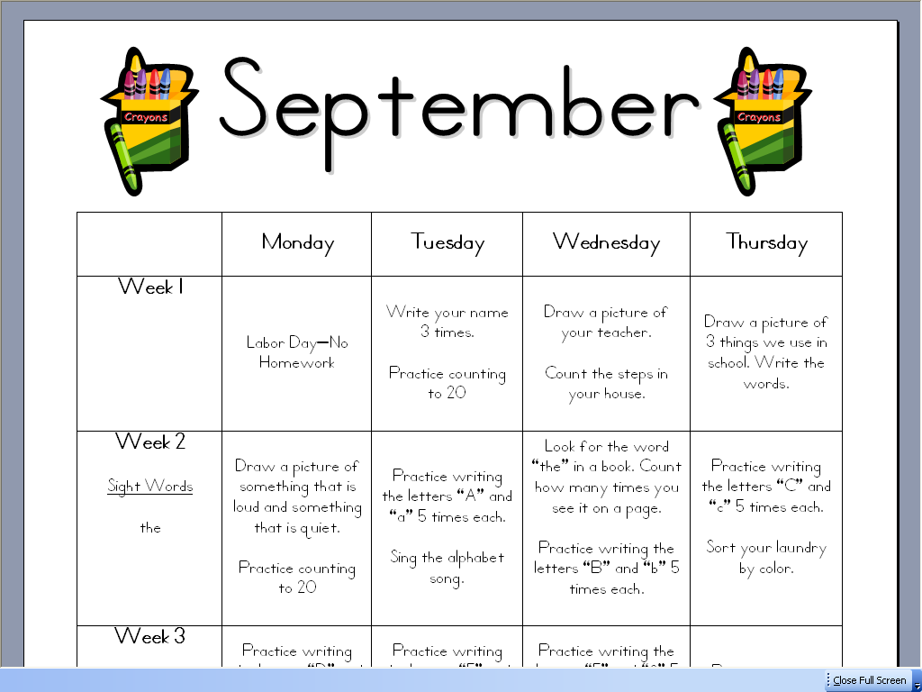
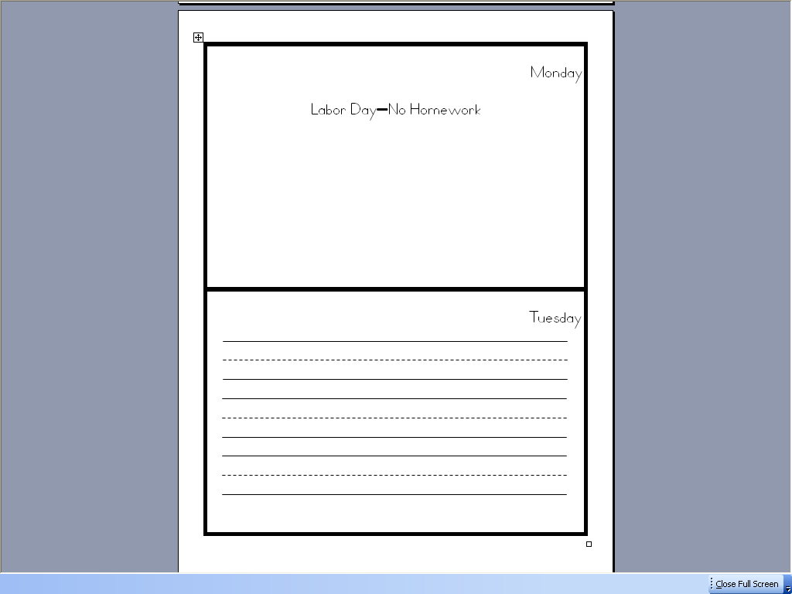

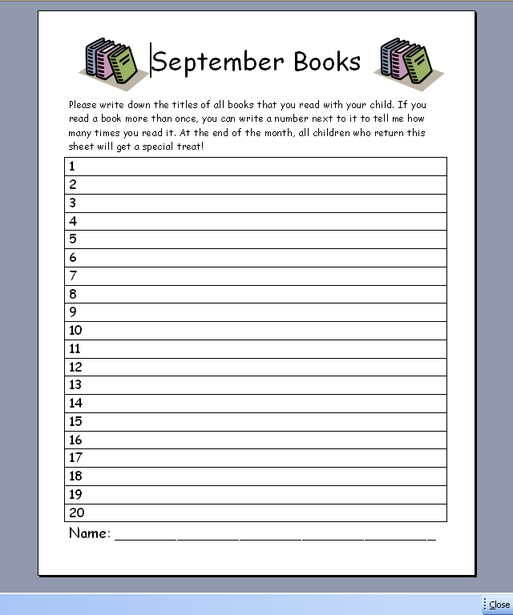
Additionally, students should read or listen to an adult read at least one book every day. Please write down the books that you read with your child on the monthly book list. This book list will be part of our school-wide reading program and students will be eligible for prizes and certificates. If you read a book more than one time, please write a number next to the title so that I can count each time you read it.

Thank you for your help! It’s going to be a great year!
☺ Ms. Nyman

