 | Monday | Tuesday | Wednesday | Thursday
Week 1  Sight Words  and  the  like  I | Practice writing the letters “J” and “j” 5 times each.  Play Simon Says with a family member. | Practice writing the letters “K” and “k” 5 times each.  Draw 2 things that begin with the same sound as “baby”. | Practice writing the letters “L” and “l” 5 times each.  Practice a fire drill with your family. | Practice writing the letters “M” and “m” 5 times each.  Say or sing the days of the week.
Week 2  Sight Words  a  the  in  at  see  and | Practice writing the letters “N” and “n” 5 times each.  Draw a picture of 2 things that are hot. | Practice writing the letters “O” and “o” 5 times each.  Draw 2 things that begin with the same sound as “mouse”. | Practice writing the letters “P” and “p” 5 times each.  Make a list of words that rhyme with “man”. (A grown-up can write the words.) | Practice writing the letters “Q” and “q” 5 times each.  Count to 20.  Count backwards from 10.
Week 3  Sight Words  he  she  see  me  yellow  red  green | Practice writing the letters “R” and “r” 5 times each.  Sing or say the days of the week. | Practice writing the letters “S” and “s” 5 times each.  Color the leaves the right colors. | Practice writing the letters “T” and “t” 5 times each.  Draw 2 things that begin with the same sound as your name. | Write the lowercase letters in order from a to t.  Go outside. Look for a leaf, an acorn, or a pinecone. Bring it to school.
Week 4  Sight Words  all  have  it  we  look  not | Practice writing the letters “U” and “u” 5 times each.  Draw 5 pumpkins with 2 leaves on each. | Practice writing the letters “V” and “v” 5 times each.  Draw 2 things that begin with the same sound as “pumpkin”. | Draw a face on the pumpkin. Write a sentence about your pumpkin. | Practice writing the letters “W” and “w” 5 times each.  Color the pumpkins the right colors.
Week 5  Sight Words  went  can  look  too  not | Practice writing the letters “X” and “x” 5 times each.  Color the apples the right colors. | Cut out letters to spell the words (use newspapers or magazines or the letter sheet in this folder). | Practice writing the letters “Y” and “y” 5 times each.  Draw pictures to finish the pattern. | Practice writing the letters “Z” and “z” 5 times each.  Put the sight words in the correct boxes—look at the letter shapes.

Monday
J j

K k
What begins like “baby”?
Tuesday
L l
Wednesday
M m
Thursday
N n
Draw 2 hot things.
Monday

O o
What begins like “mouse”?
Tuesday
P p
X x
can
look
too
Z z
Y y
went
look
can
too
red
yellow
What rhymes with “man”?
Wednesday
Q q
Thursday
R r
Monday

S s

Tuesday
red
yellow
green
T t
What begins like your name?
Wednesday
Thursday
U u
Draw 5 pumpkins with 2 leaves each.
Monday

V v
What begins like “pumpkin”?
Tuesday
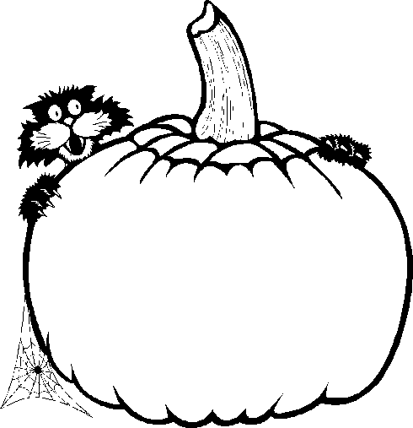
Wednesday
W w
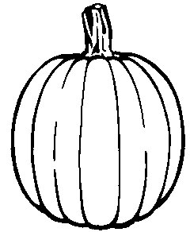
Thursday
orange
green
yellow
green
X x
Monday

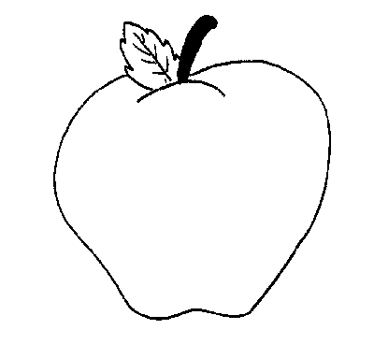
red
yellow
green
Tuesday
went
look
can
too
Y y
Wednesday
Z z
Thursday
can
look
too

