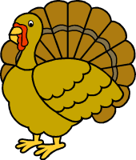

 | Monday | Tuesday | Wednesday | Thursday
Week 1  Sight Words  what  have  do  you  went  said | Draw a picture of an animal that starts with “s” and write the word.  Write the number 2 five times. | Draw a picture of a food that starts with “s” and write the word.  Write the number 3 five times. | Write each of the color words with the correct color crayon.  Count to 30. | Draw a picture of 3 farm animals. Write the words.  Say your birthday 5 times.
Week 2  Sight Words  she  said  in  on  out  over | Draw a picture of something that starts with “m” and write the word.  Write the number 4 five times. | Write an “m” on the first line if it starts with the sound. Write “m” on the second line if it ends with the sound.  Count by 10s to 100. | Draw a picture of something that starts with “d” and write the word.  Write the number 5 five times. | Make a list of 3 things Mrs. Wishy- Washy needs to give the animals a bath.  Say your phone number 5 times.
Week 3  Sight Words  number words  review week | Conference Day—No school | Write the numbers and number words 1 to 5 in order. | Look for the sight words in a book. Count how many times you find each one. | Happy Thanksgiving  No Homework!
Week 4  Sight Words  me  you  can | Draw a picture of something that starts with “p” and write the word.  Write the number 6 five times. | Write the “an” family words to go with the pictures.  Say your birthday 5 times. | Read the story. Color the words.  (Parents: please have you child read the story as independently as possible) | Write “p” on the first line if it starts with the sound. Write “p” on the second line if it ends with the sound.

Draw an animal that starts with S. Write the word.
2
Monday1

3
Draw a food that starts with S. Write the word.
Tuesday1
Wednesday1
red
blue
yellow
green
Thursday1
Who lives on a farm?
Draw a picture of something that starts with “m”. Write the word.
4
Monday2

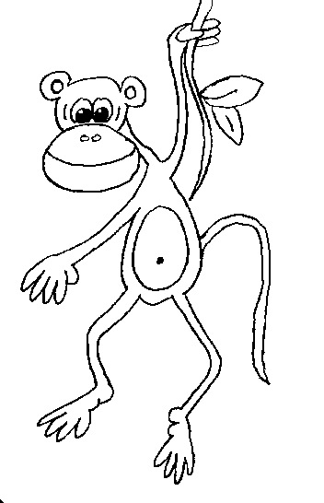




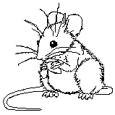

Tuesday2
Draw a picture of something that starts with “d”. Write the word.
5
Wednesday2
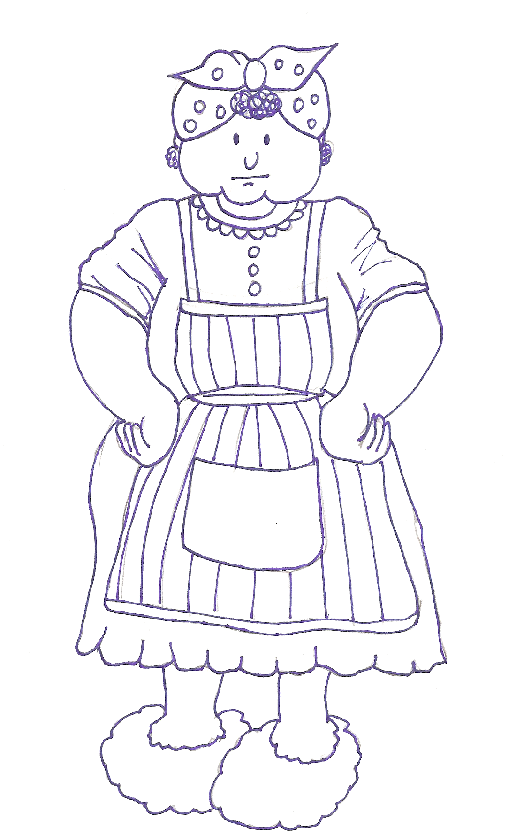
Thursday2
What does Mrs. Wishy-Washy need to give the animals a bath?

1.

2.
3.
Monday3

Parent Conference Day!
two
one
four
five
three

Write the numbers and number words in order from 1 to 5.
Tuesday3
a
How many times did you find each word?
in
at
and
see
the
Wednesday3
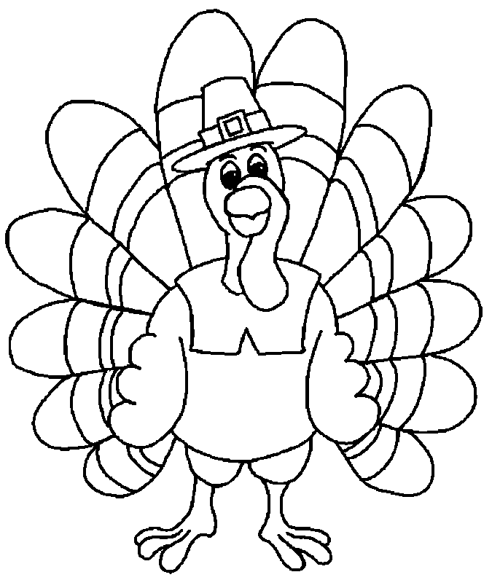
Thursday
Optional coloring page.
Draw a picture of a food that starts with “p”. Write the word.
6
Monday4

_an


Tuesday4
Make up a silly “an” word.
I am Dan, the flying man.
Catch me, catch me if you can.
Over a fan and over a can.
Over a pan and over a man.
I am Dan, the flying man.
Catch me, catch me if you can.
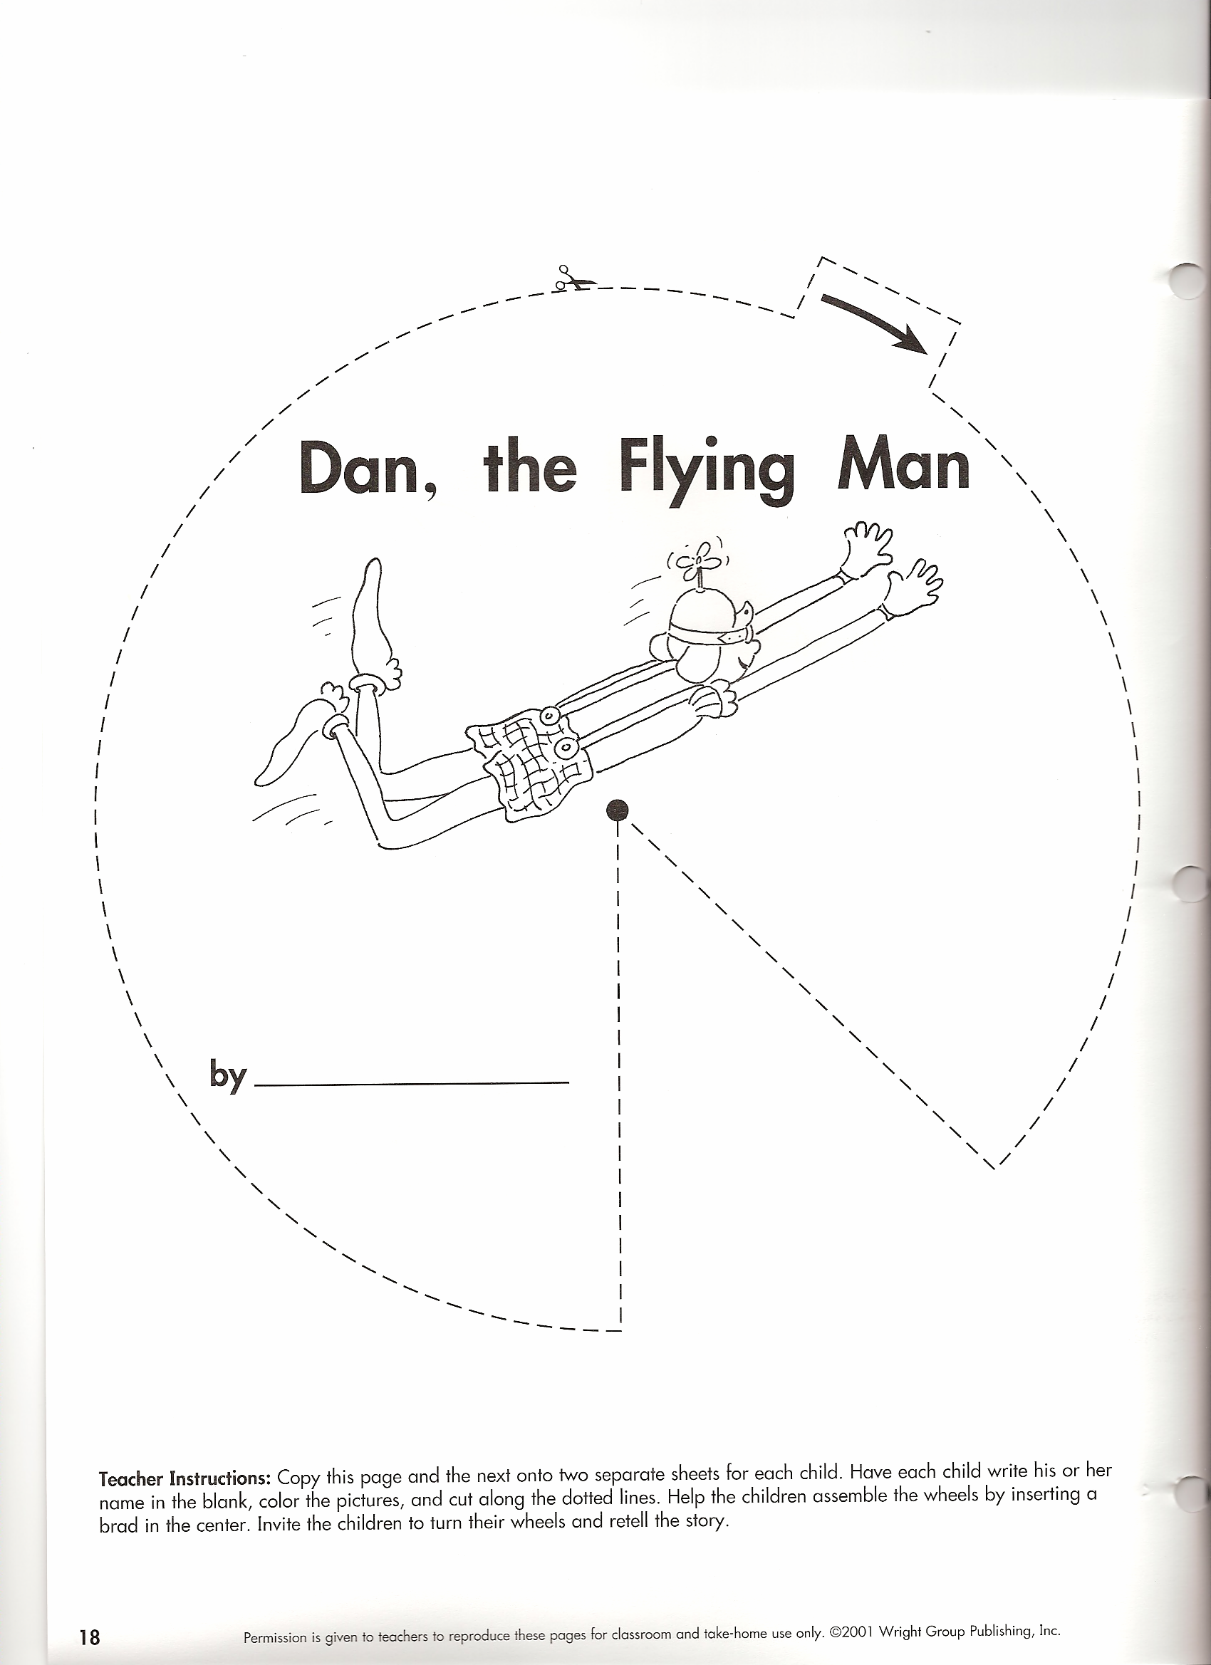
Wednesday4
Color:
am-yellow you-red over-green and-purple
can-orange the-blue me-brown


Thursday4






