Monday | Tuesday | Wednesday | Thursday | Friday
Fill in the missing numbers on the June calendar | Write the letters to spell each word. | Write 2 sentences to answer the question :  Do you like summer? Why or why not? | Find and circle the sight words. | Write the number that comes after the given number.
Write the missing sounds for each word (sh/ch/th). | Make a list of 5 fruits. Include words and pictures in your list. | Count how many of each object you have in your house. Color the graph to show how many you have. | Circle the pictures that have the /ar/ sound in them. Write the words on the lines. | Write 2 sentences and draw a picture:  What did you like best about kindergarten?
Draw pictures to solve the story problems. | Make a list of 5 things that can fly. Include words and pictures in your list. | Write the sight words in the correct boxes. | Solve the addition problems. Use your fingers, pennies, or draw pictures to help you. | Read each word. Draw a line to the correct picture.
Write your address, phone number, and birthday. Practice saying them 5 times. | Draw a picture of something that rhymes with each thing. | Use pennies to measure the pictures. Write the number to show how long each one is. | Fill in a word to finish each comparison. | Count by 5s. Fill in the missing numbers.

Monday

 |  |  |  |  | 1 | 2
10
 |  |  | 20
 |  |  |  |  |  | 30

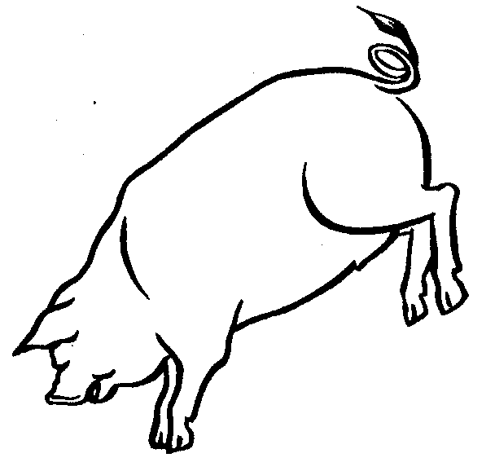
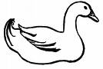

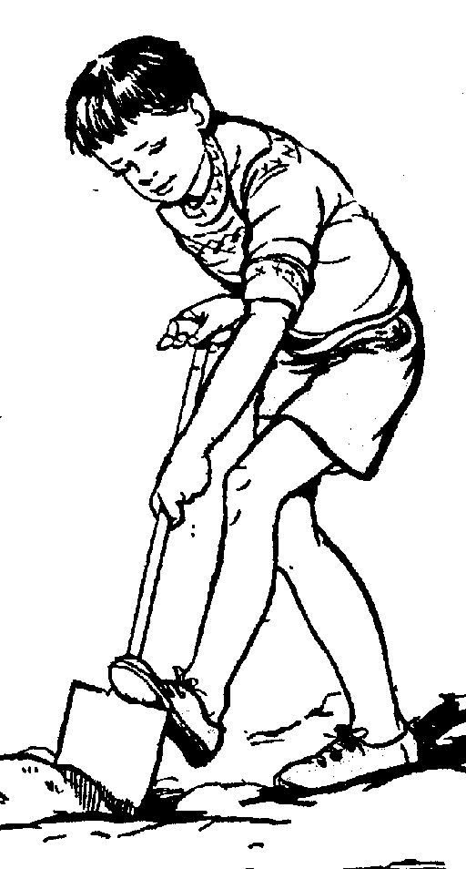
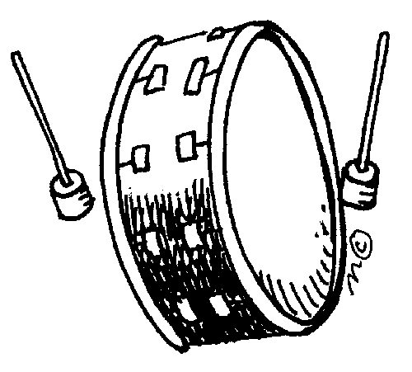
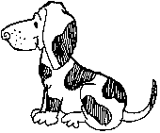
Tuesday
Wednesday
Thursday
this
who
said
make
some
down

s | a | i | d | d
o | d | w | h | o
m | a | k | e | w
e | h | d | n | n
t | h | i | s | x
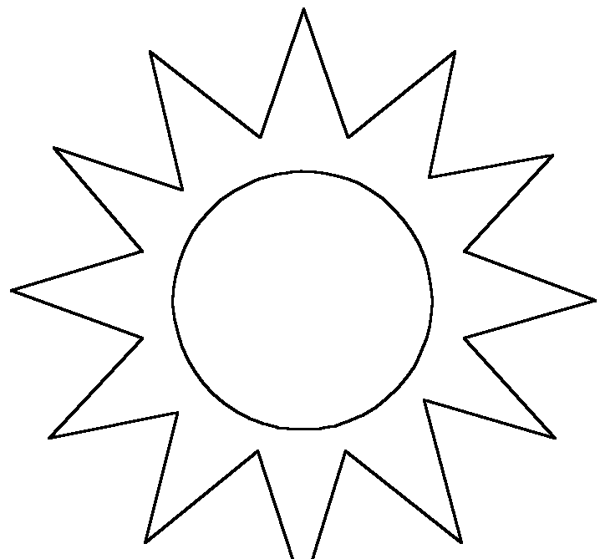
Friday
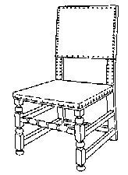
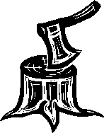
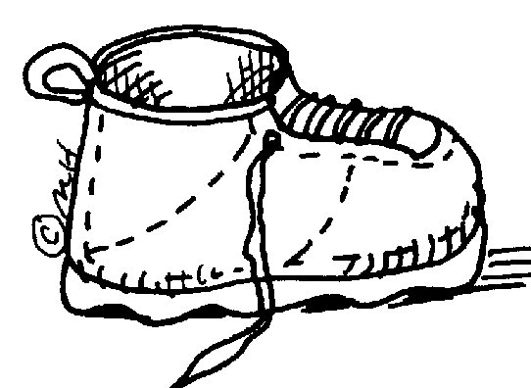
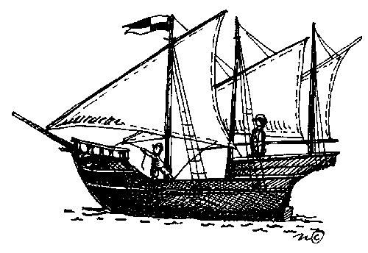
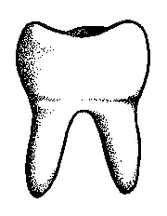
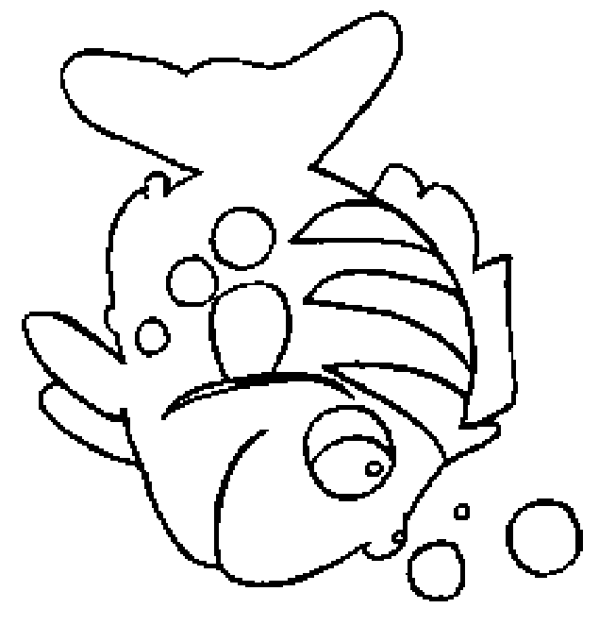
Monday
_ _ air
_ _ oe
_ _ op
_ _ ip
_ _ ree
fi _ _
too _ _
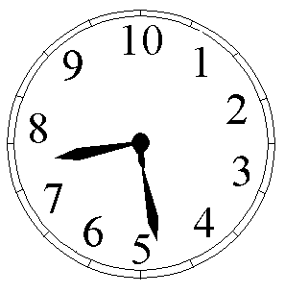
Tuesday
Wednesday


 | 1 | 2 | 3 | 4 | 5 | 6 | 7 | 8



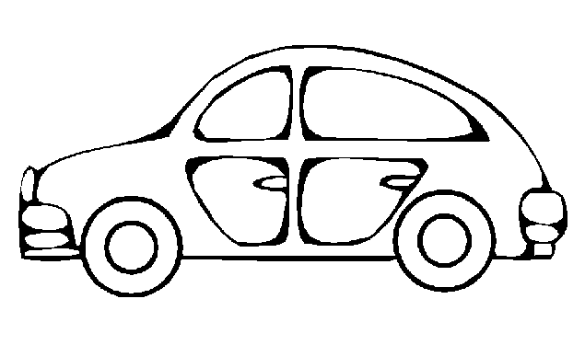

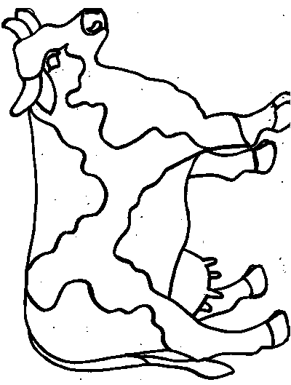
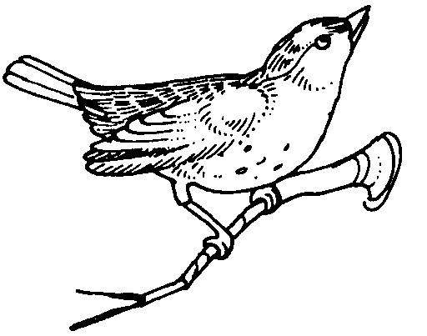


Thursday
Friday
Monday
When I went to the beach I saw 4 blue seashells and 5 pink seashells. How many seashells did I see in all?
On Monday the shark ate 3 fish. On Tuesday he ate 5 more fish. How many fish did he eat in all?
Tuesday
Wednesday
what where said little from pretty

Thursday
4+2= __

1+5= __

3+0= __

2+7= __
6+2= __

1+2= __

0+9= __

4+4= __
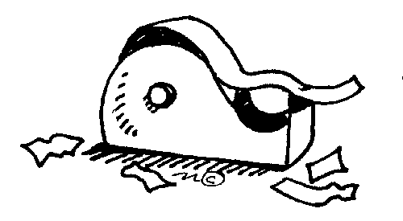
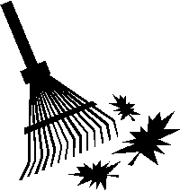
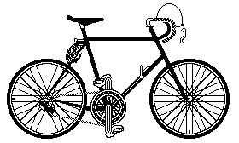
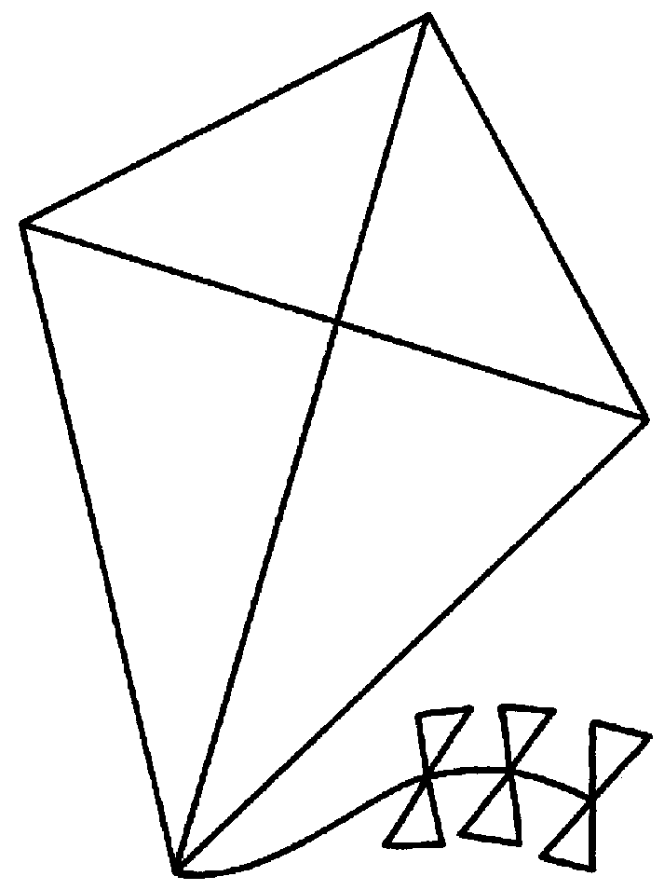
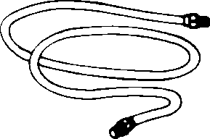
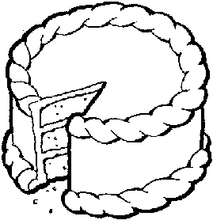

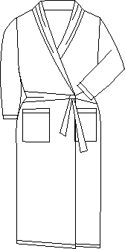
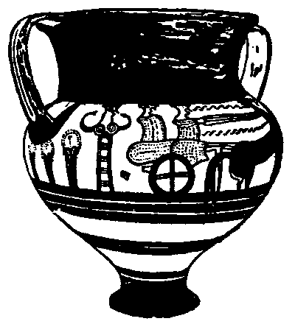
Friday
bike
kite
rake
fire
tape
rope
cake
robe
dime
tire
vase
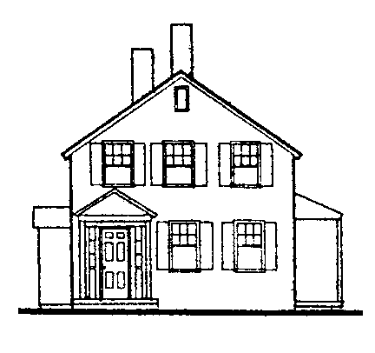
Monday
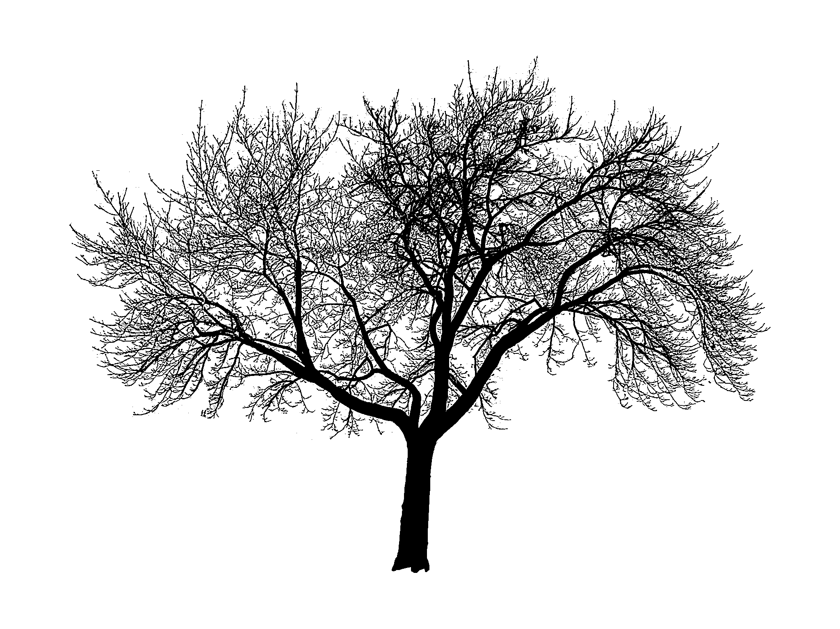
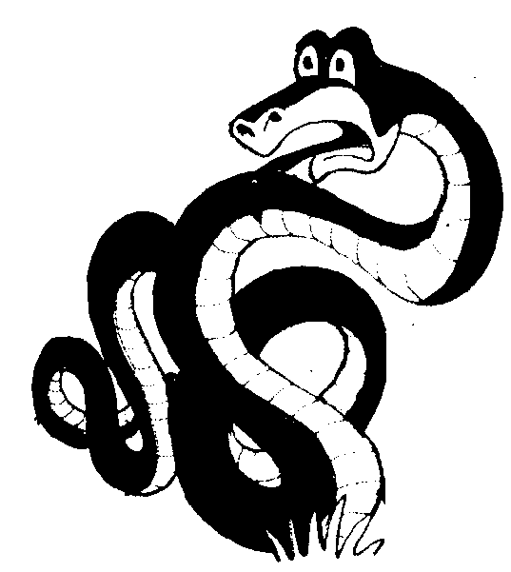
Tuesday
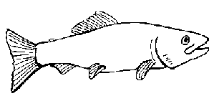
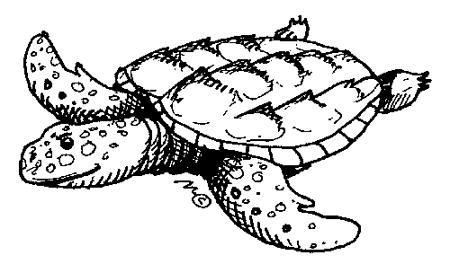
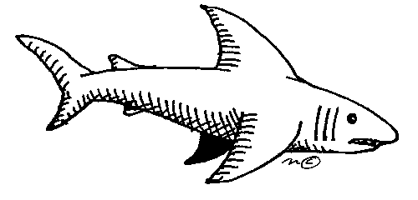
Wednesday
Thursday
I can jump like a
I can run like a
I can swim like a
I can crawl like a
Friday

