Monday | Tuesday | Wednesday | Thursday | Friday
Fill in the missing numbers on the July calendar | Make a list of 5 foods that you like to eat at a cookout. | Draw a picture of fireworks. Write a sentence describing your fireworks. | Fill in the missing letters in each word. | Draw the hands on the clock to show the time.
Count the syllables in each word (claps). Write the number. | Make a list of 5 different occupations (jobs). Draw a picture of equipment that goes with each job. | Read the story. Color the picture the colors indicated in the story. | Write the names and values of the coins. | Solve the addition problems.
Draw pictures to solve each problem. | Write 2-3 sentences telling what you like to do when it is hot. | Draw pictures to solve each problem. | Count the objects. Write the number words. | Make a list of 5 things that begin with the same sound as your name.
Circle the pictures that have long vowel sounds (say their names). Choose any 3 of the long vowel words to write. | Circle the greater number in each pair. | Write 2-3 sentences telling what kind of pet you have or would like to have. | Fill in the missing vowels in each word. | Draw lines to match the digital and analog clocks.
Monday

 |  | 1 |  |  | 4
 |  |  |  | 10
13
 |  |  |  |  | 25
 |  |  |  | 31

Tuesday
Wednesday
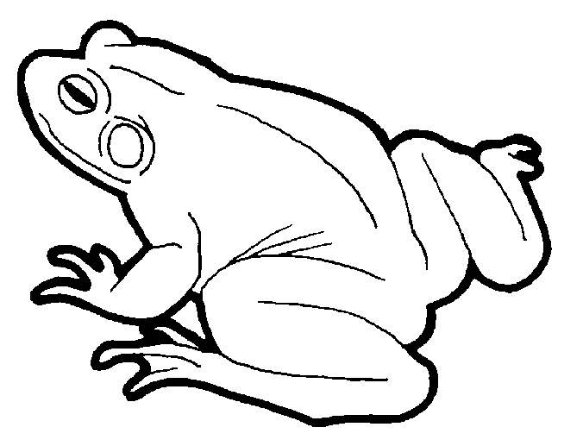
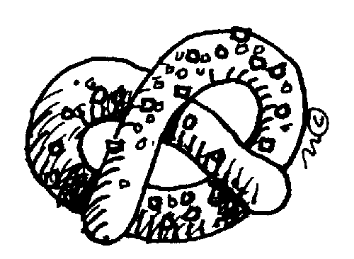
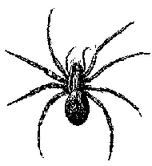




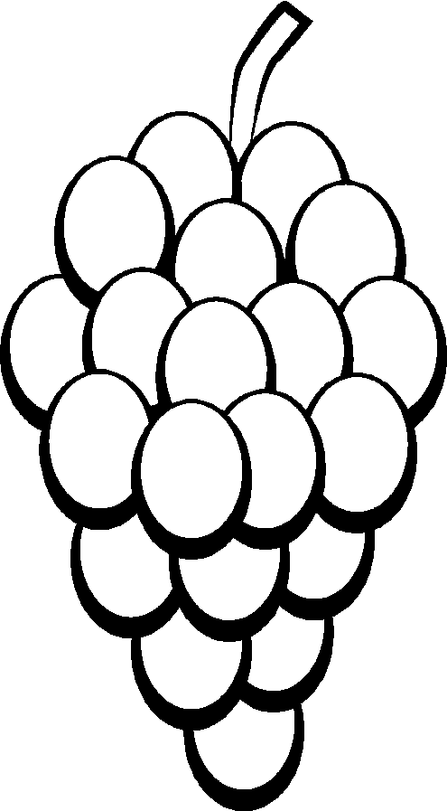
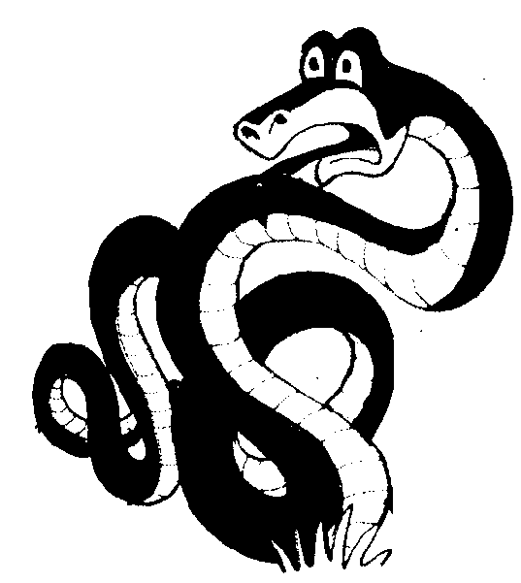
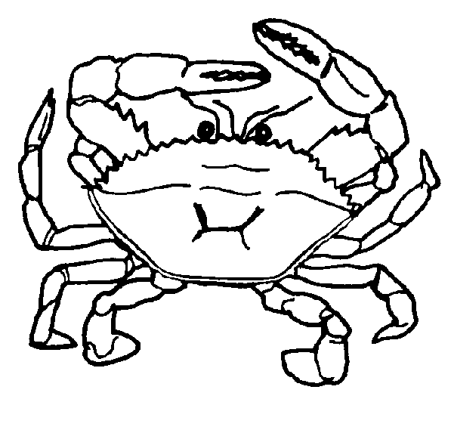

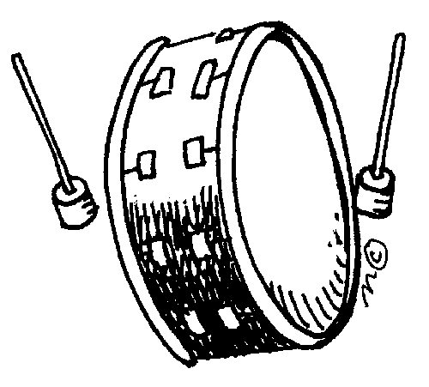
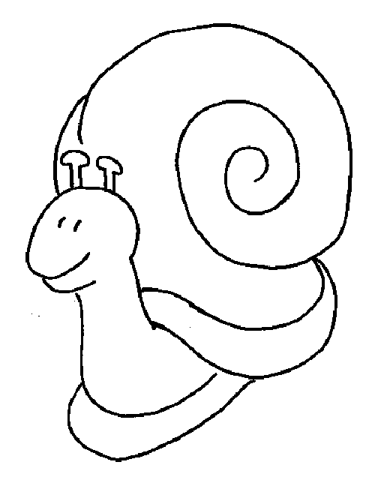

Thursday
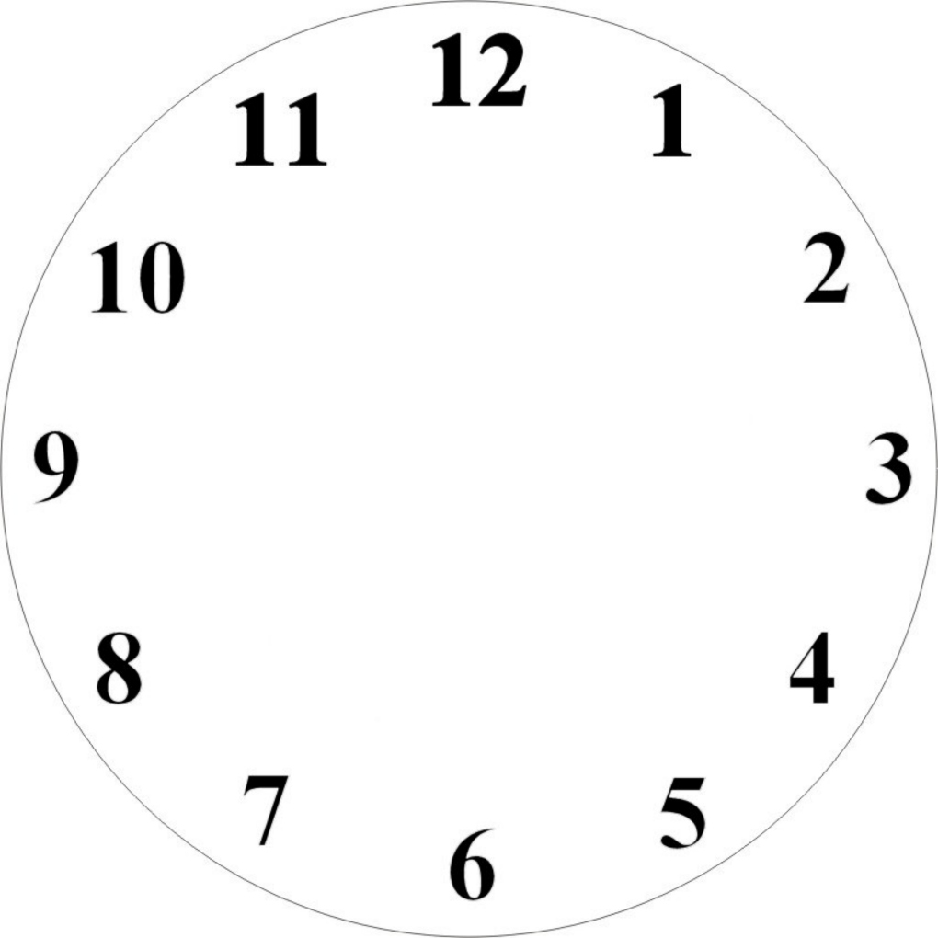
Friday
5:00
4:00
7:00
9:00
1:00
3:00
11:00
12:00
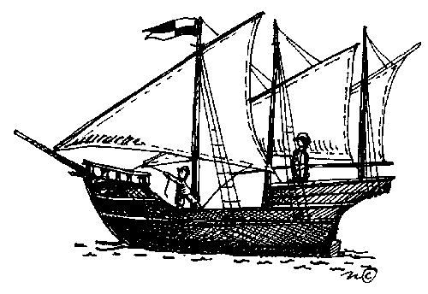

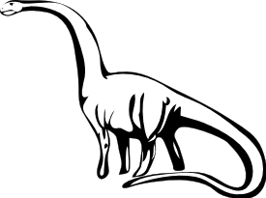
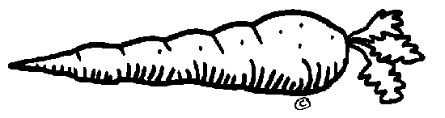

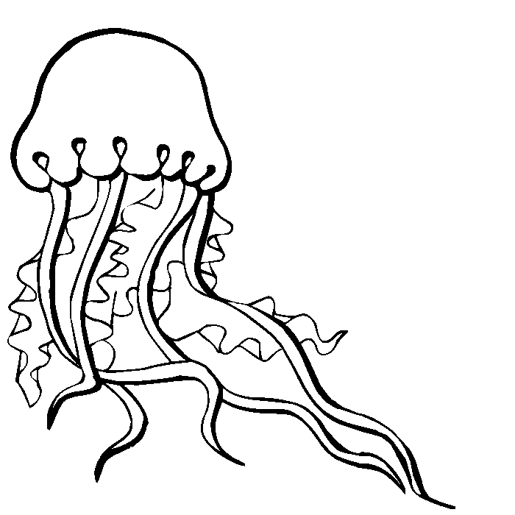

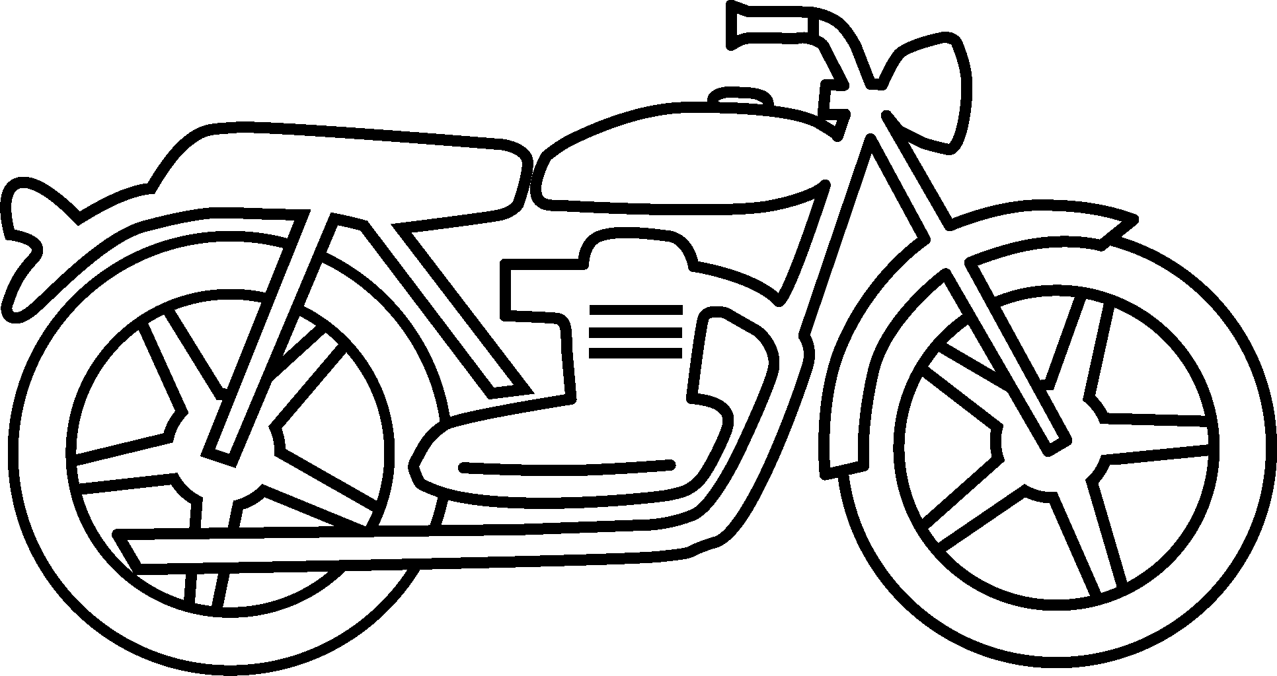
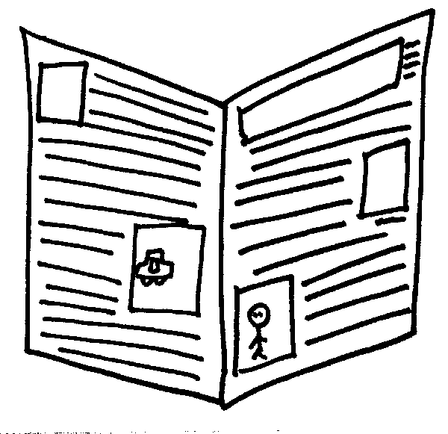

Monday
Tuesday
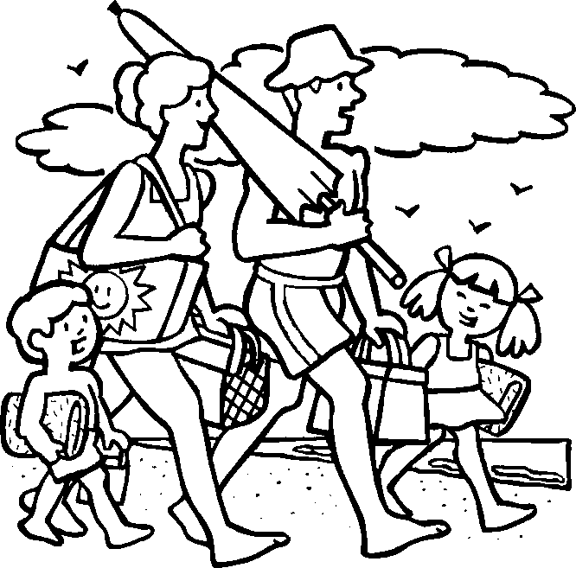
Wednesday
The family is going to the beach. The boy has a green towel. The girl has a yellow towel. Dad has the big red umbrella. Mom has the brown basket and pink bag. Dad’s hat is blue and the girl’s dress has purple dots. They are walking on yellow sand.
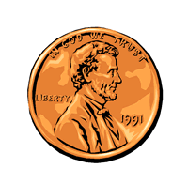
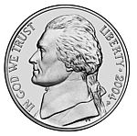
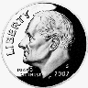

Thursday
¢

¢
¢
¢
Friday
3+2= __

1+6= __

0+0=__

3+7= __
1+2= __

1+8= __

1+9= __

2+2= __
Monday
When I went to the beach I saw 4 blue seashells and 5 pink seashells. How many seashells did I see in all?
On Monday the shark ate 3 fish. On Tuesday he ate 5 more fish. How many fish did he eat in all?
Tuesday
Wednesday
I found 4 seeds in my piece of watermelon. My brother found 6 seeds in his. How many seeds did we find in all?
I bought 8 balloons. When I put them in the car, 2 balloons popped. How many balloons did I have left?
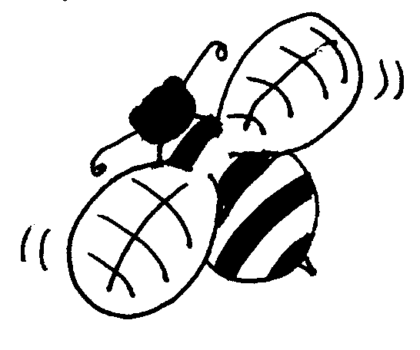
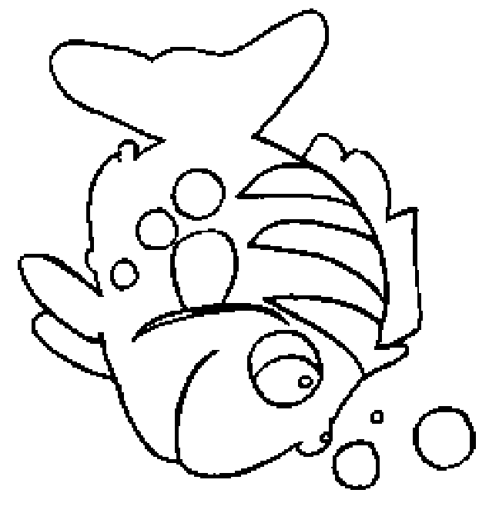
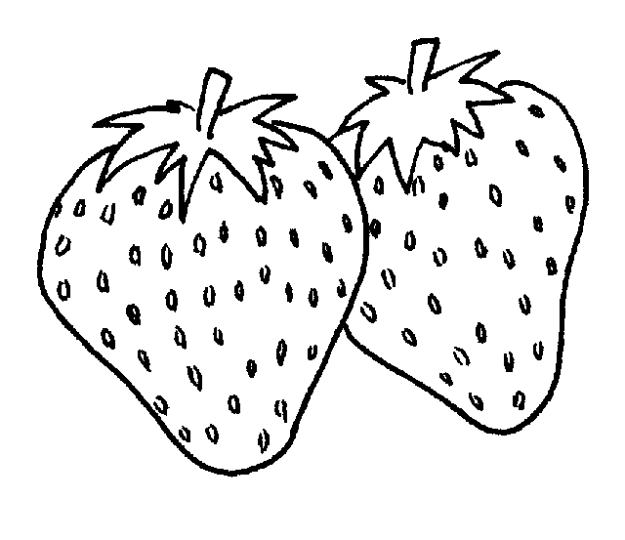
Thursday
Friday

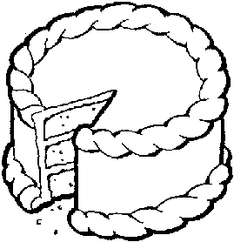
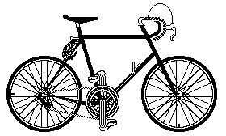
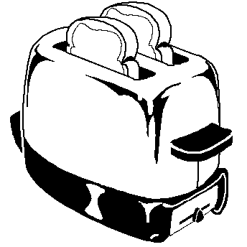
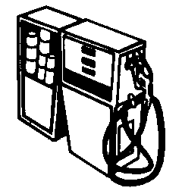
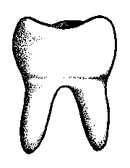
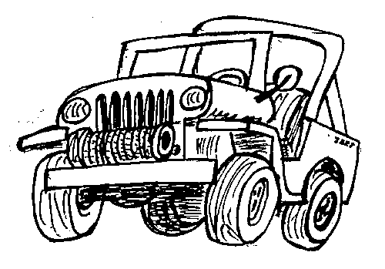
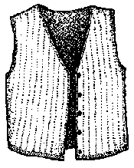
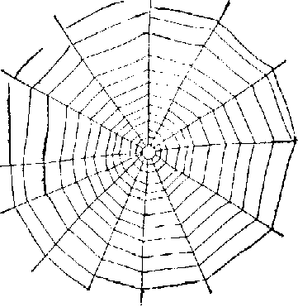
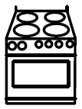

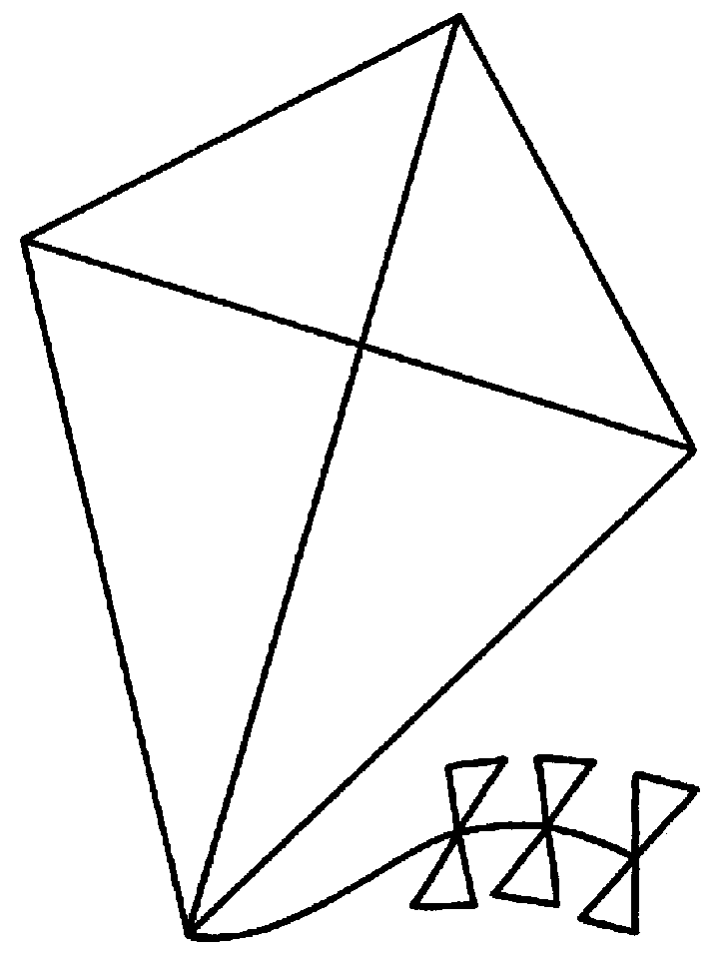

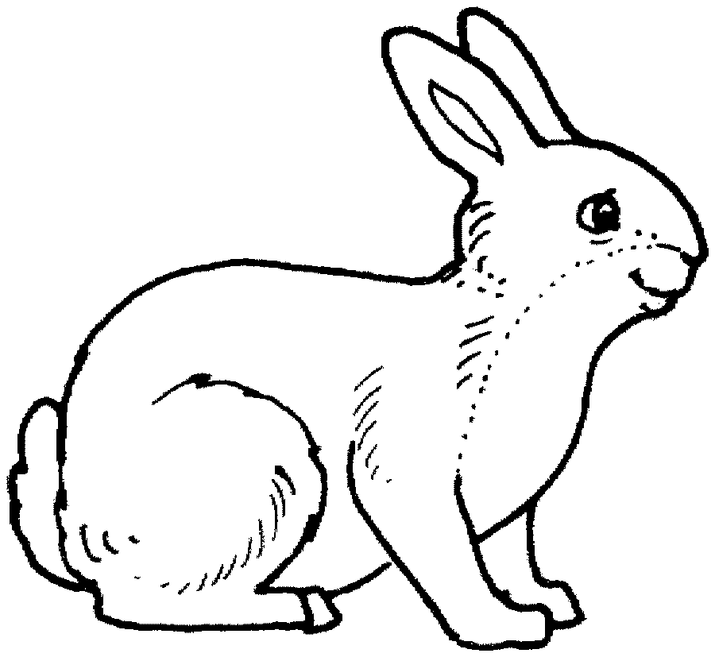
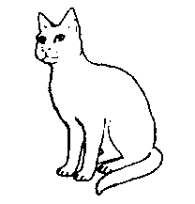

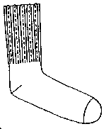
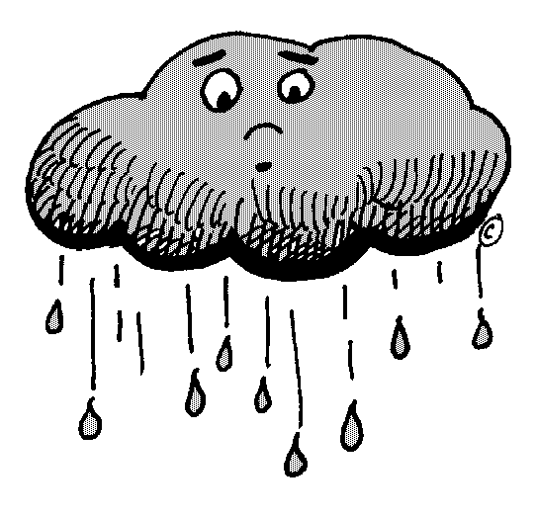
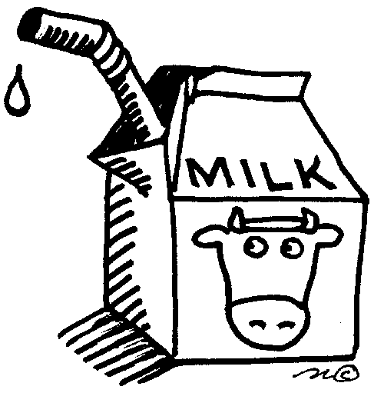
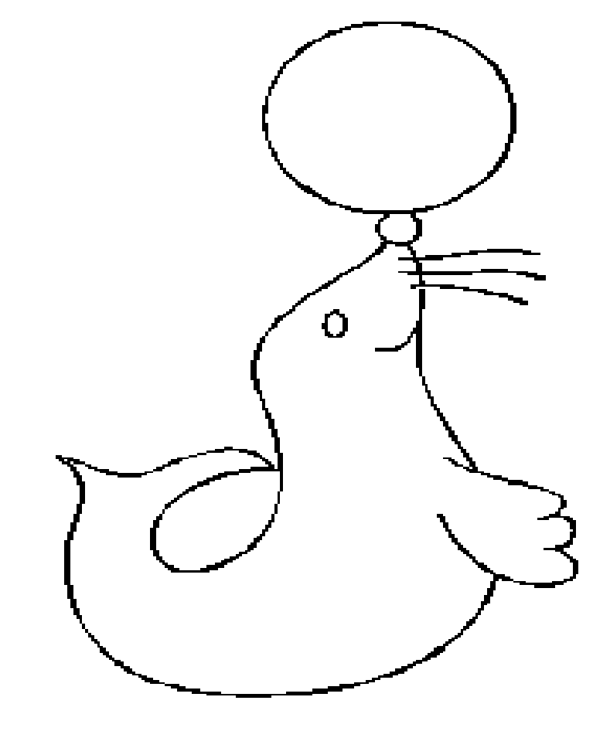
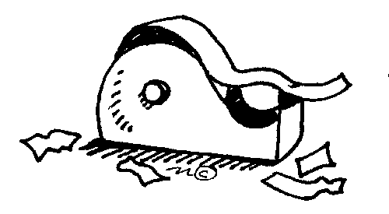
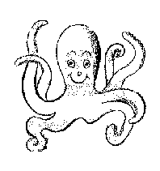
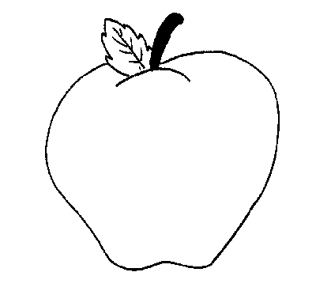
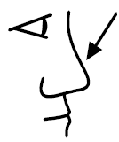
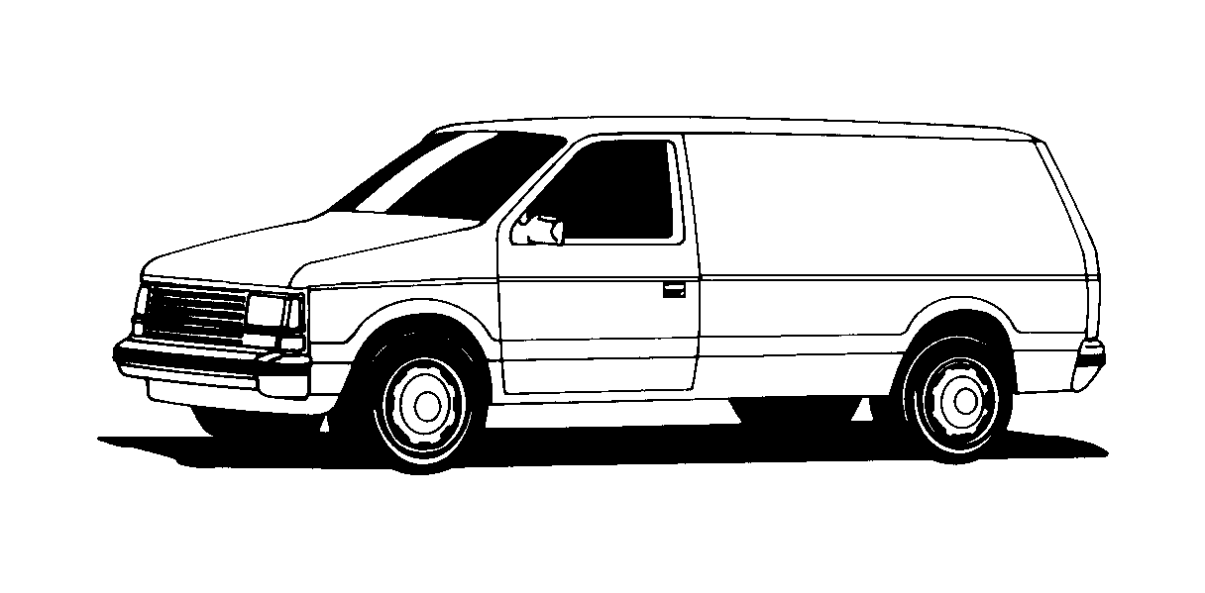
Monday
Tuesday
51
42
12
21
36
67
38
48
63
61
11
99
72
23
50
70
39
40
Wednesday
Thursday
f_r_
k_t_
sn_k_
m_lk
l_ck
s_ck
g_s
w_b
b_n_
v_st
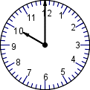
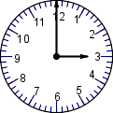
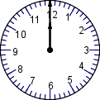
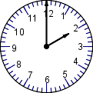
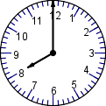
Friday
10:00
2:00
12:00
8:00
3:00

