 | Monday | Tuesday | Wednesday | Thursday
Week 1  Sight Words  number words | Winter Break  No Homework | Write the beginning sound for each picture. | Draw a picture and write a sentence telling about something you did over Winter Break. | Look at a calendar. Count how many days there are until your birthday (ask a grown up to help you).
Week 2  Sight Words  down  all  here  are  this  is | Does the picture have the “n” sound at the end? Write “yes” or “no”.  Say the months of the year in order. | Make a list of 3 words that begin with “snow”.  Write the number that comes next. | Make a list of 3 things that are cold.  Write the number that comes next. | Draw a picture of two things that start with “b”. Write the words.  Circle the number that is greater.
Week 3  Sight Words  did  you  know  that  color words | No School  Martin Luther King Jr. Day | Draw a picture of two things that start with “c”. Write the words.  Color the group that has “more”. | Does the picture have the “c” sound at the end? Write “yes” or “no”.  Say your phone number 5 times. | Color the hats the correct color.  How far can you count in one minute? (Have a grown up time you.)
Week 4  Sight Words  is  are  here  on  in  the | No School  Professional Development  End of Second Quarter | Color the pictures that have the short “e” sound (like “pet”) yellow. Color the other pictures red.  Count to 100 by 5s | Fill in the missing word.  Write the number that comes before. | Draw a picture of two things that start with “f”. Write the words.  Color the group that has “less”.
Week 5  Sight Words  have  has  in  went | Write a “b” on the first line if it starts with the sound. Write “b” on the second line if it ends with the sound.  Count to 100 | Write the short “e” words.  Fill in the missing numbers. | Read the story. Color the words.  (Parents: please have you child read the story as independently as possible) | Draw a picture of two things that start with “g”. Write the words.  Fill in the missing numbers.

Monday1

Happy New Year!

No Homework

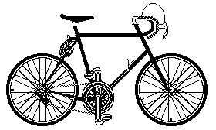
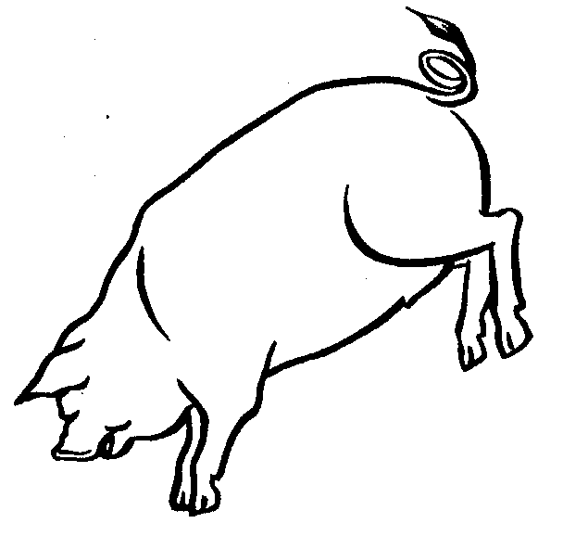
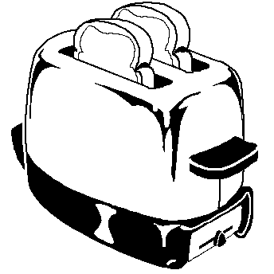
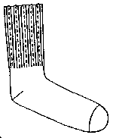
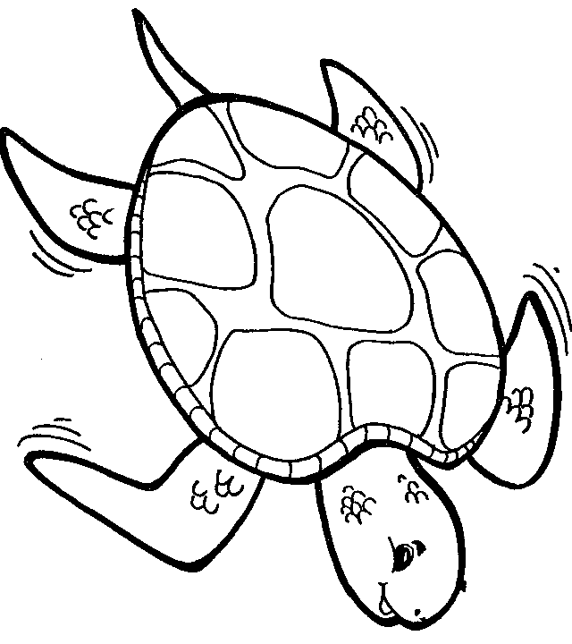
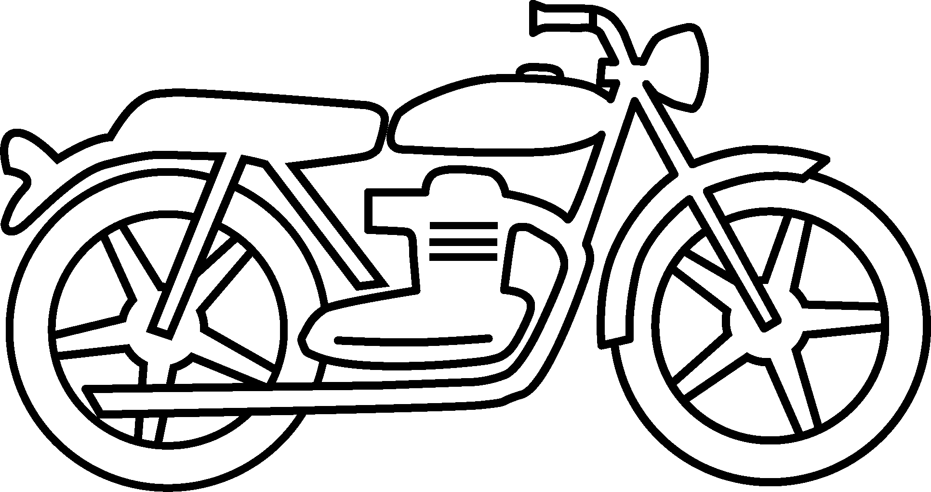
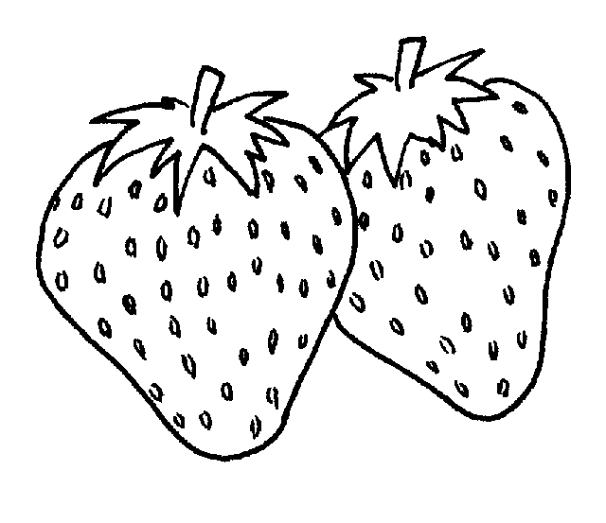
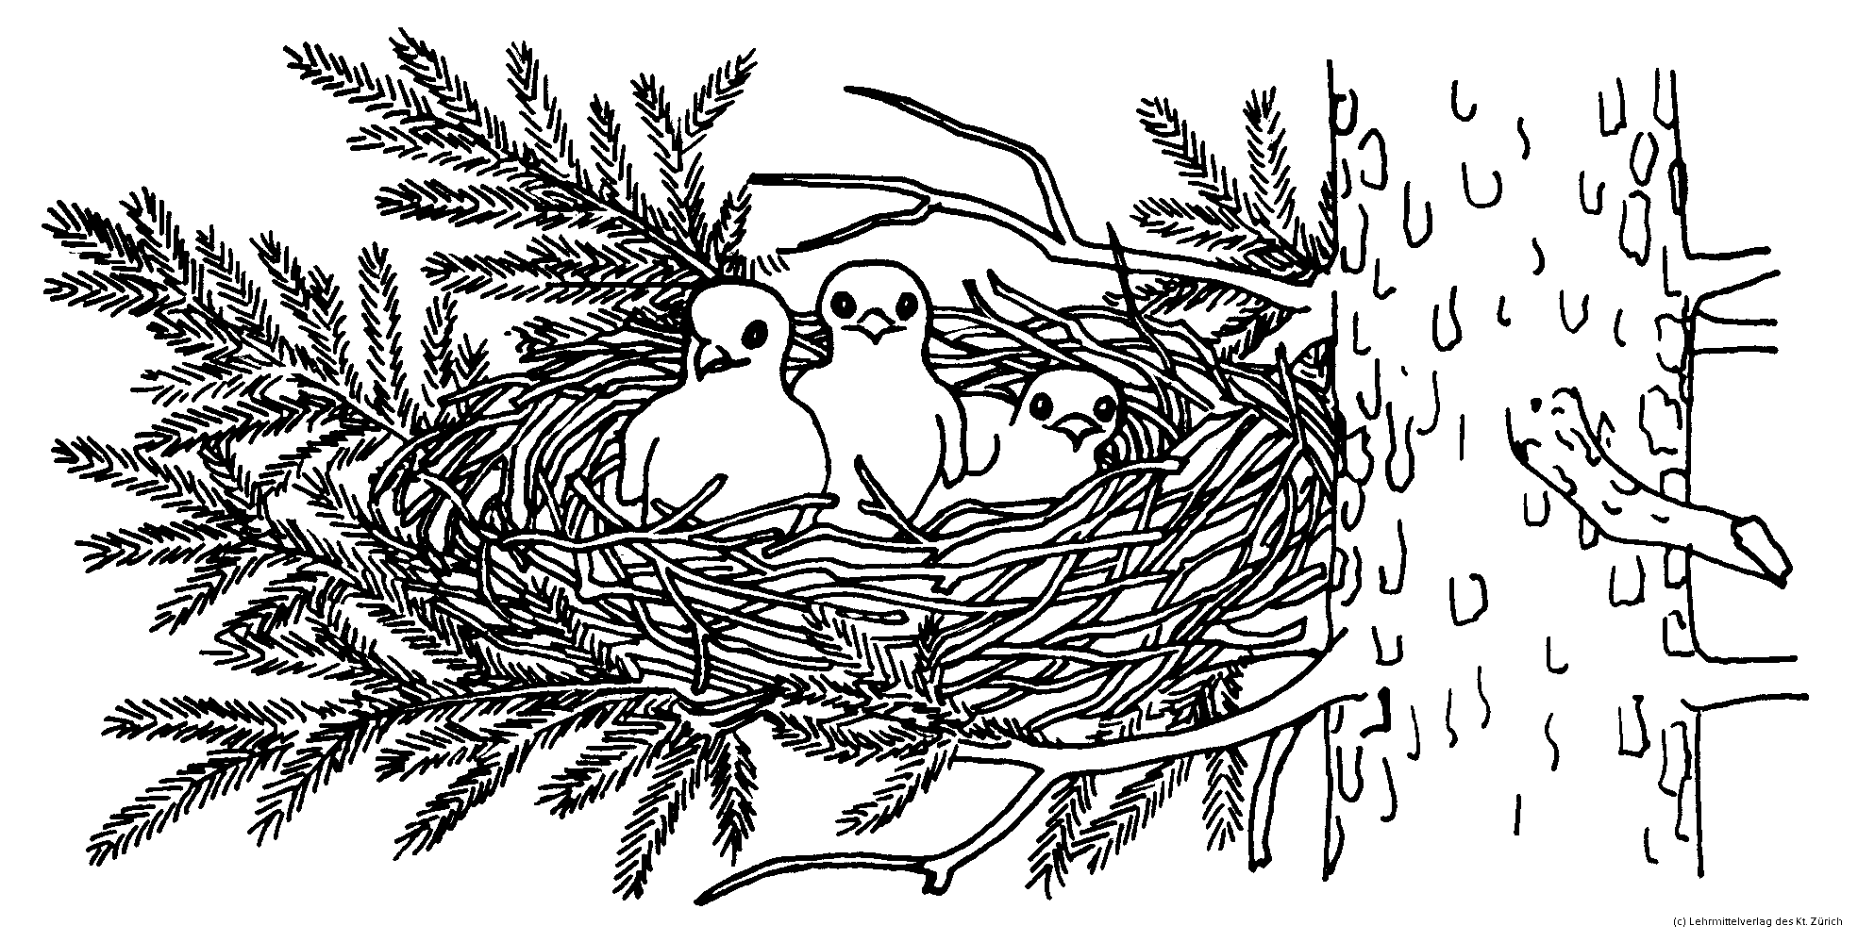
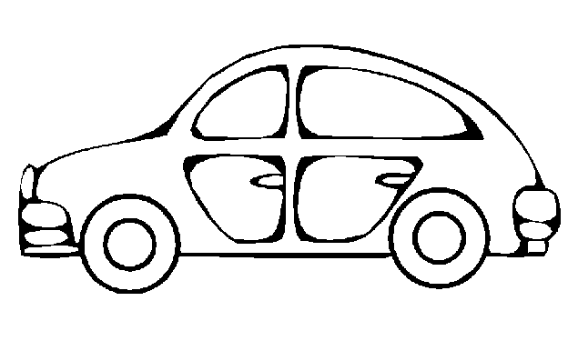
Tuesday1

Wednesday1
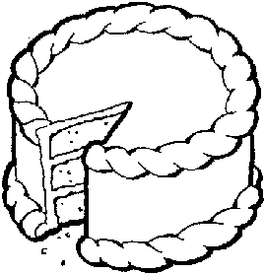
Thursday1
My birthday is
.
How many days are there until your next birthday?
Draw candles on the cake to show how old you will be.
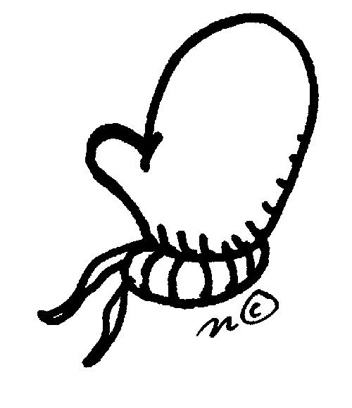
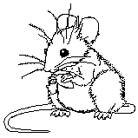

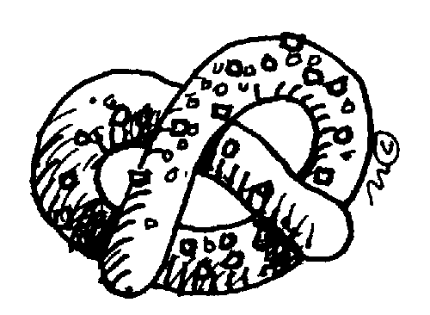
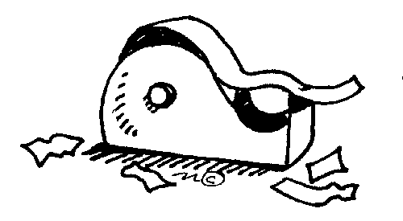

Does the picture have the “n” sound at the end? Write “yes” or “no”.
Monday2

Make a list of 3 words that begin with
“snow”.
Tuesday2
5
8
3
7
Make a list of 3 things that are cold.
Wednesday2
11
14
17
13
Draw a picture of 2 things that starts with “b”. Write the words.
Thursday2
3 or 6
5 or 2
9 or 8
2 or 10
Monday3

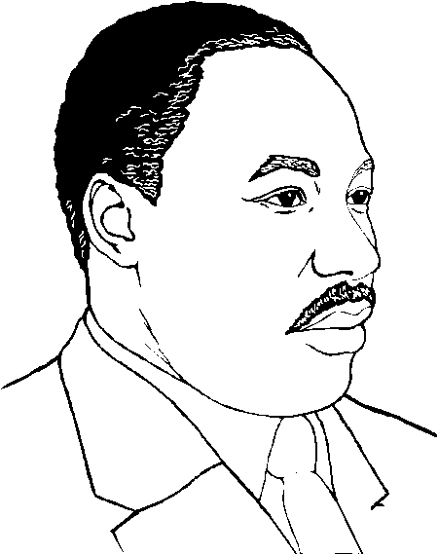
No School
Draw a picture of 2 things that starts with “c”. Write the words.
Tuesday3
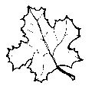
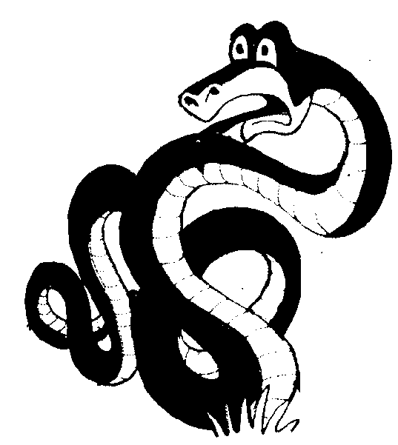
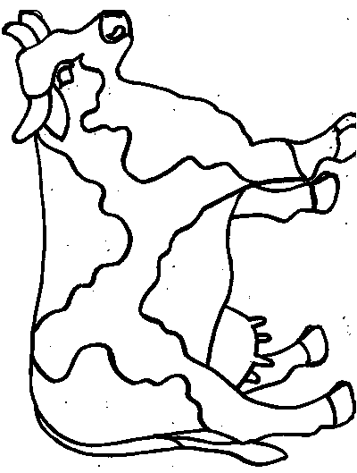
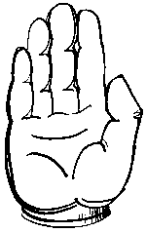
Does the picture have the “c” or “k” sound at the end? Write “yes” or “no”.
Wednesday3
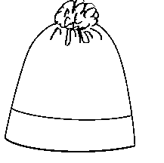
red
blue
green
yellow
orange
purple
brown
Thursday3

Monday4

No School

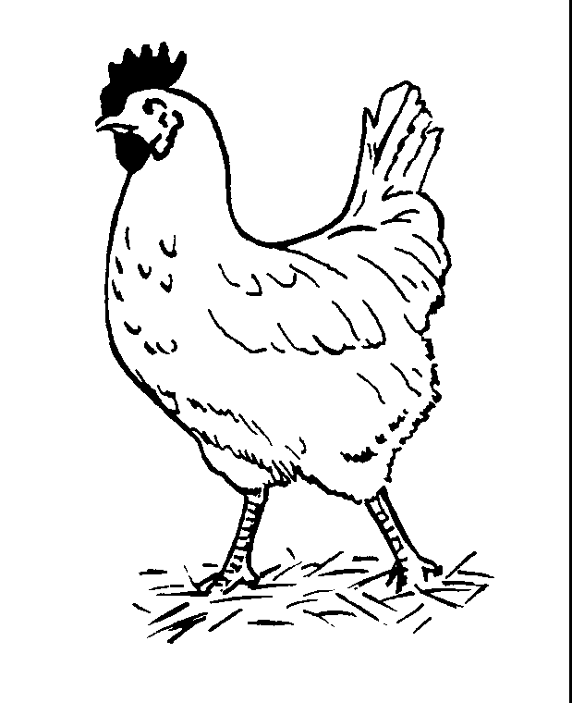
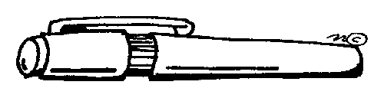
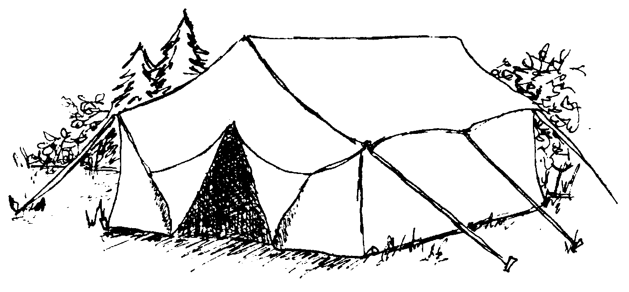
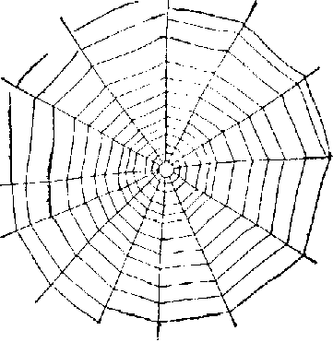

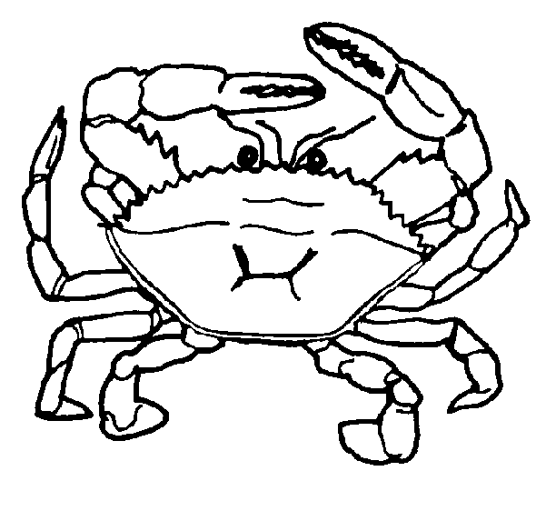

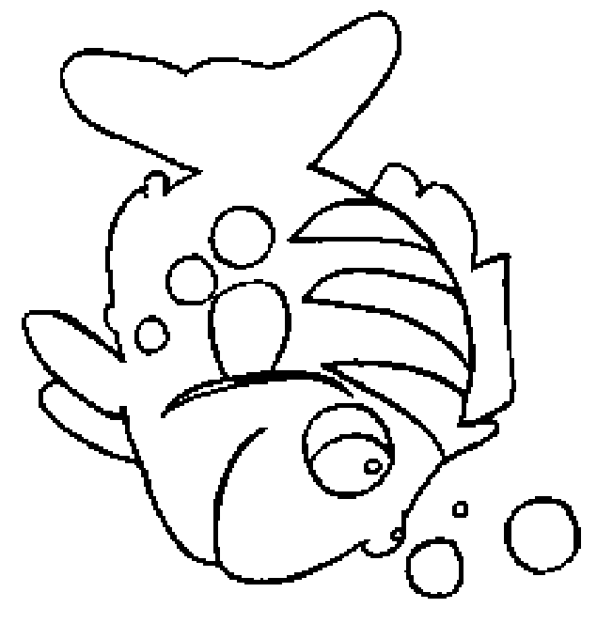
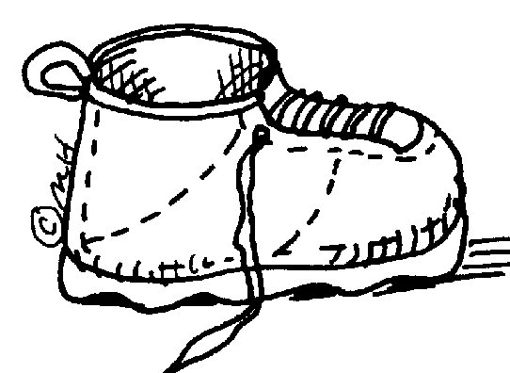


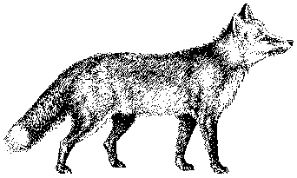
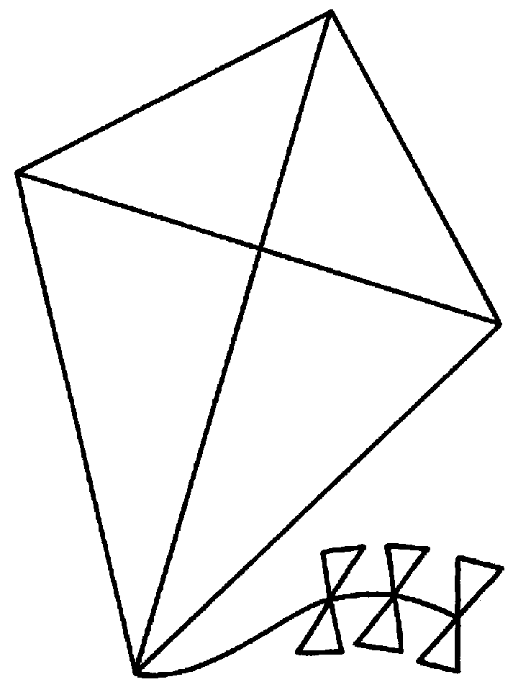
Tuesday4
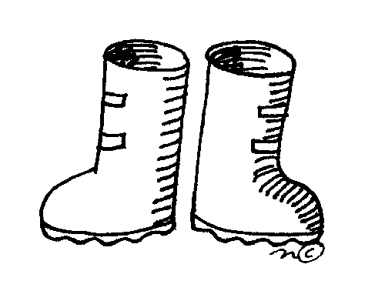
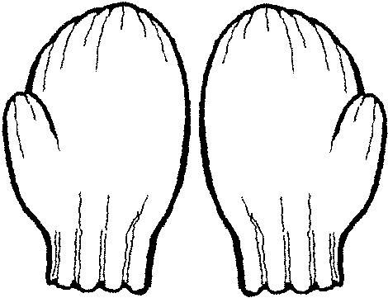
Here
my mittens.
Here
my hat.
Here
my boots.
Fill in the missing word with “is” or “are”.
Wednesday4
5
8
3
7
Draw a picture of 2 things that starts with “f”. Write the words.
Thursday4
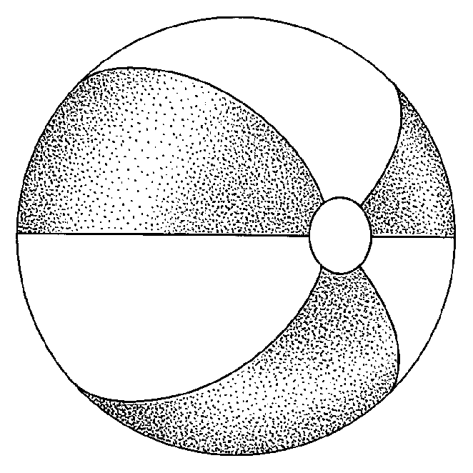

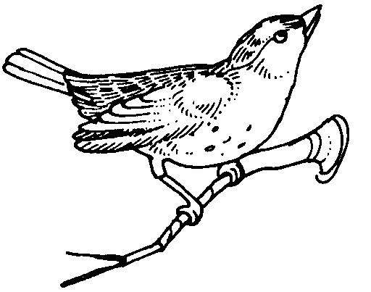
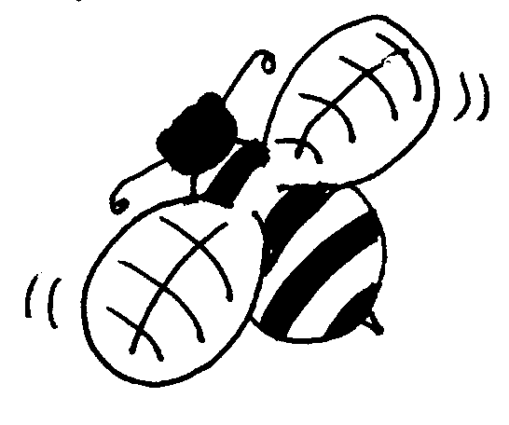
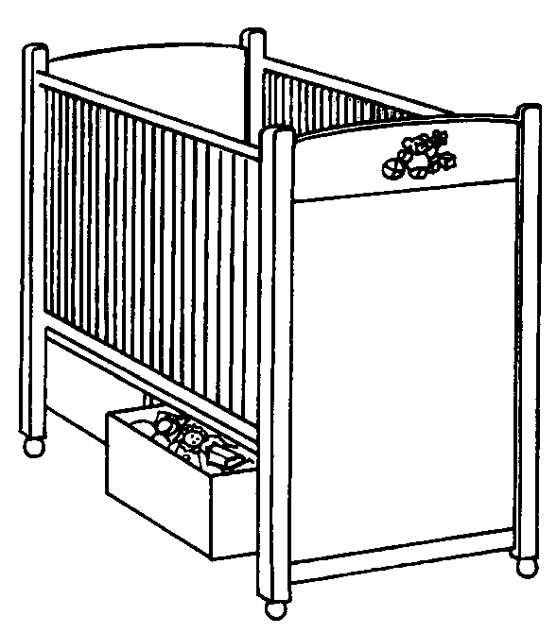
Monday5

Tuesday5
10
,5,
8,
,11
,7,
,
The mole went in the mitten.
The fox went in the mitten.
The owl went in the mitten.
The bear went in the mitten.
The mouse went in the mitten.
They all came out of the mitten.
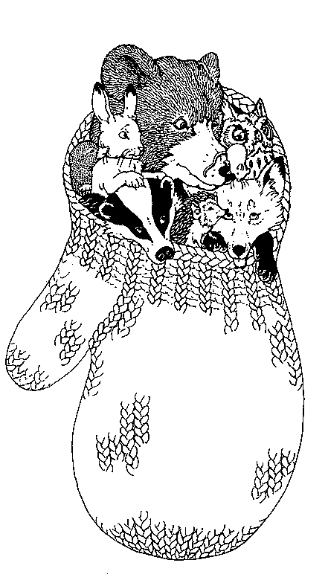
Wednesday5
Color:
in-yellow all-red out-green
of-orange the-blue

Draw a picture of 2 things that starts with “g”. Write the words.
Thursday5

,13,
8,
,11,
,15
,

