 | Monday | Tuesday | Wednesday | Thursday
Week 1  Sight Words  come go  on off  big little  out in  up down | Write the sight word to tell what each picture shows.  Count by 10s to fill in the missing numbers. | Write a “g” on the first line if it starts with the sound. Write “g” on the second line if it ends with the sound. | Read the word. Write the sight word that is the opposite.  Read the graph. Answer the questions. | Put the sight words in the correct boxes—look at the letter shapes.  Say your address 5 times.
Week 2  Sight Words  some  are  made  of | Write the letter for each picture’s beginning sound.  Finish the pattern. | Cross out the pictures that do not start with “h”.  Color the hearts in a pattern. | Color the pictures that have the short “i” sound (like “pig”) red. Color the other pictures black. | Read the word by yourself (sound it out). Draw a line to the picture.  Count by 10s to connect the dots
Week 3  going  to  have  play  we  we’re | No School  Presidents Day | Color the pictures that begin with “j”.  How many jumping jacks can you do in one minute? Have a grown up time you. | Write a “j” word for each clue.  Circle the numbers that are greater than 12. | Make a list of 3 tools.  Choose a room in your house. Look for nails and screws. Make tally marks (lines) to show how many you find.
Week 4  This week we will celebrate Dr. Seuss’ birthday. Read your Dr. Seuss books this week! | Draw a picture of 2 things that begin with “k”. Write the words.  Color the letters of your name on the keyboard. | Make a list of words that rhyme with “cat”.  Look at the picture. Count how many of each and write the numbers. | Pretend to type the sight words on the keyboard. Color the letters of your favorite sight word.  Dr. Seuss would have been 103 years old on March 2nd . Count to 103. | Finish each phrase with a word that rhymes with the underlined word.  Make groups of 10 candles. Count the candles. Write how many.

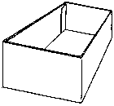
Monday1
up
down
in
out
on
off

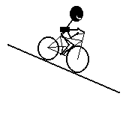
10
50
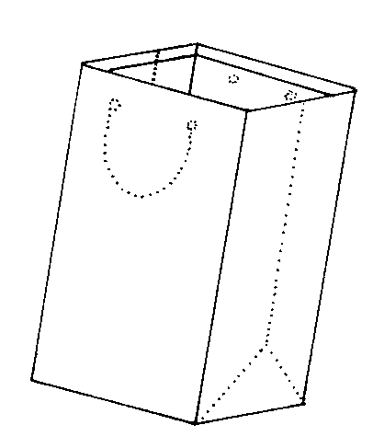
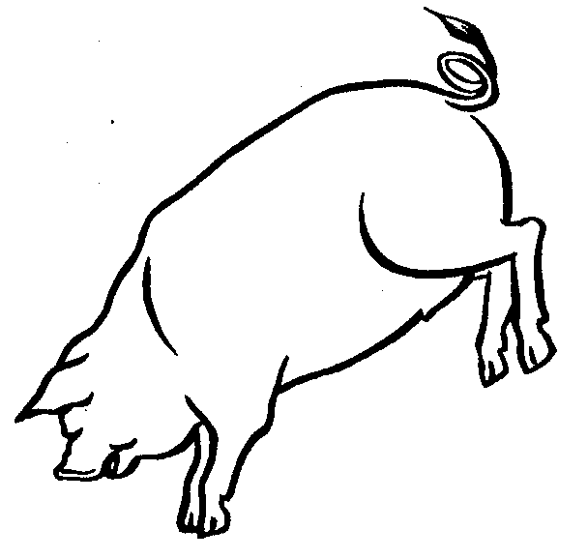

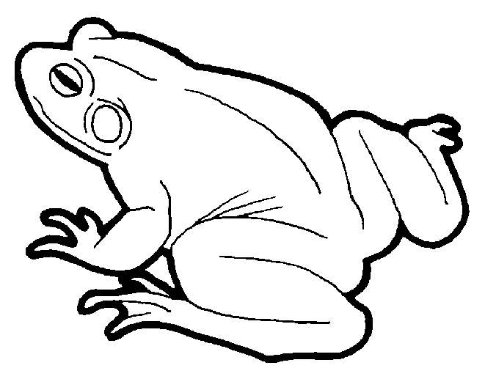

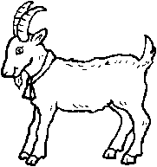
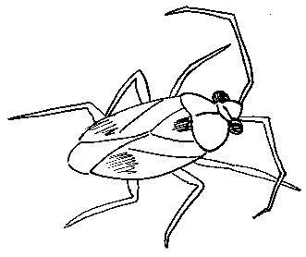
Tuesday2
in
big
on


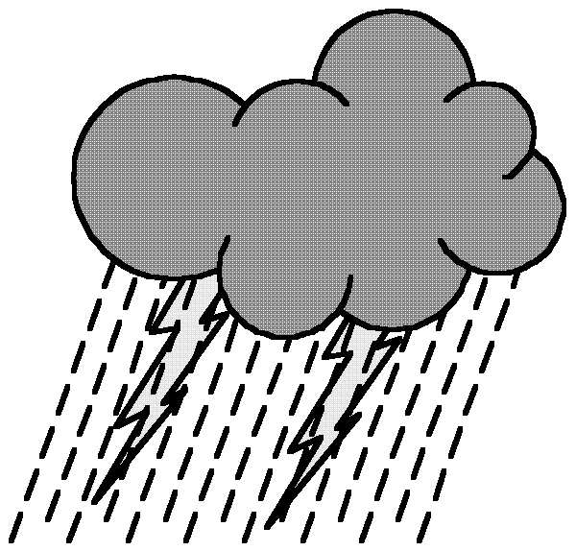

Wednesday1
up
go
come
little
off
out
down
Weather Graph
Which type of weather did we have the most of?
Which 2 types of weather did we have on the same number of days?
How many sunny days did we have?
Thursday1
up in
down out
big go
little come
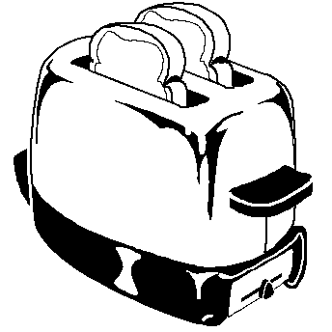

Monday2

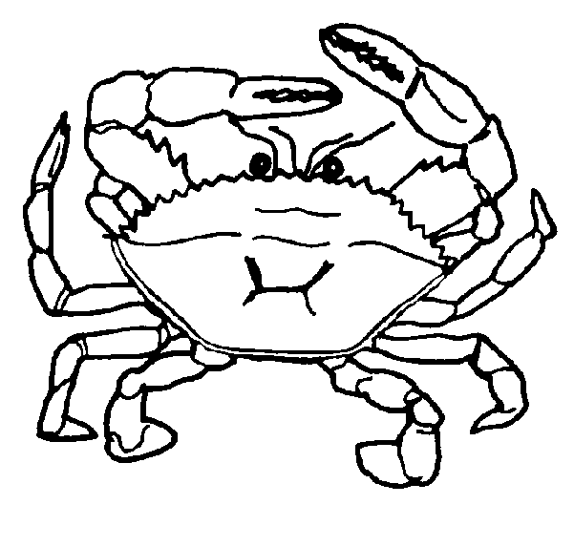



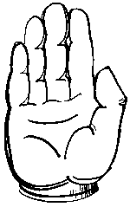
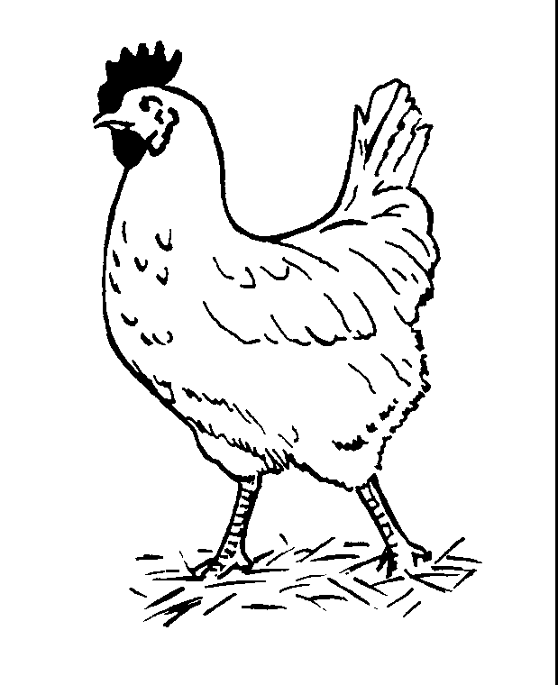
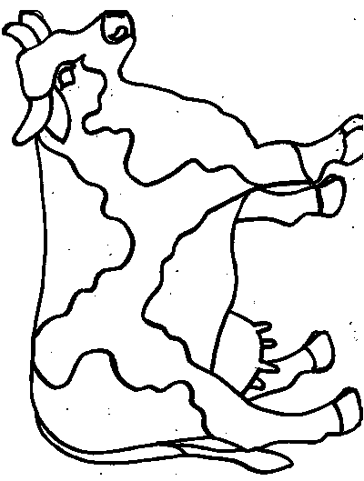



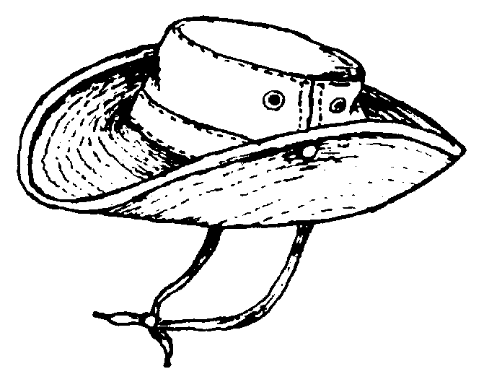
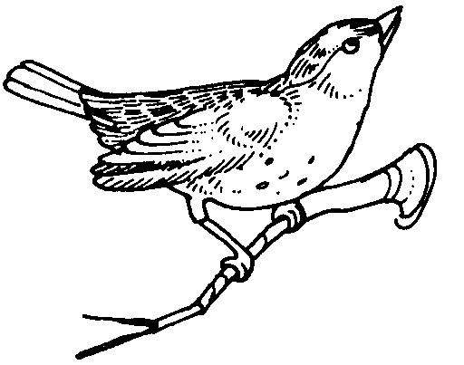
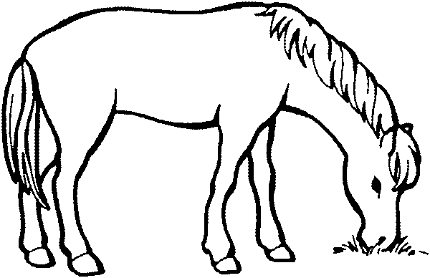
Tuesday2
Cross out the pictures that DO NOT begin with “h”.
My pattern is
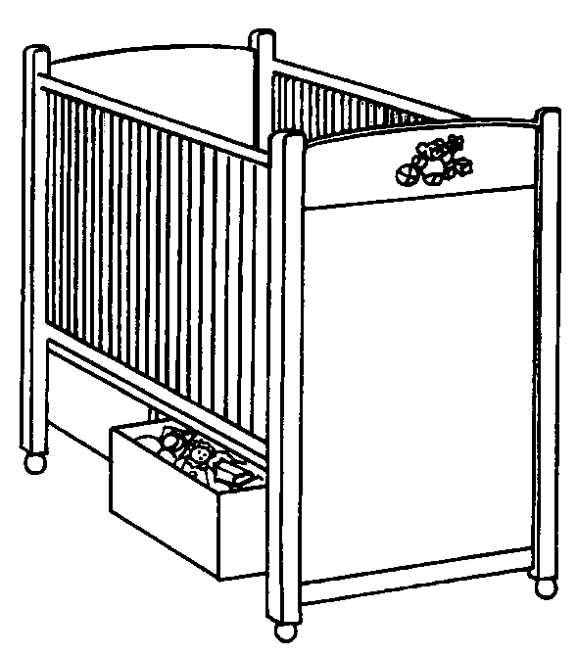
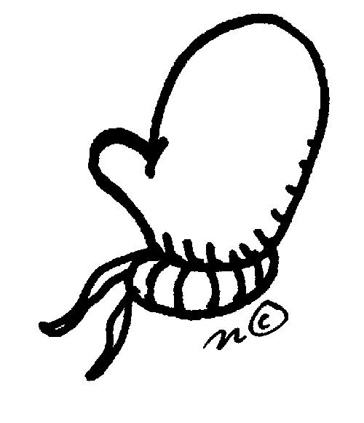

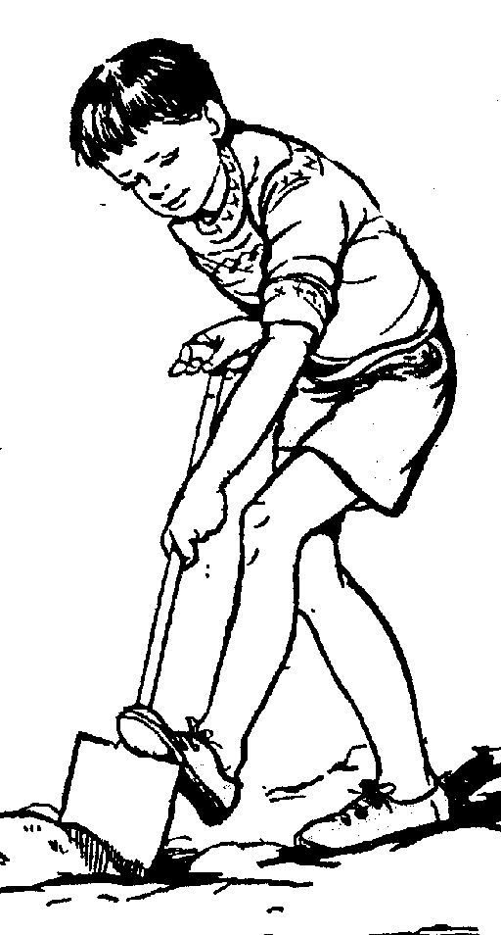

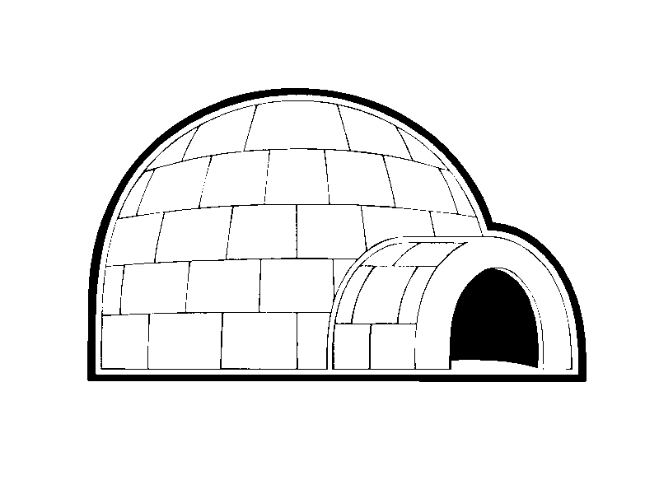

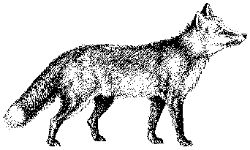
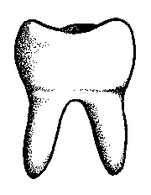
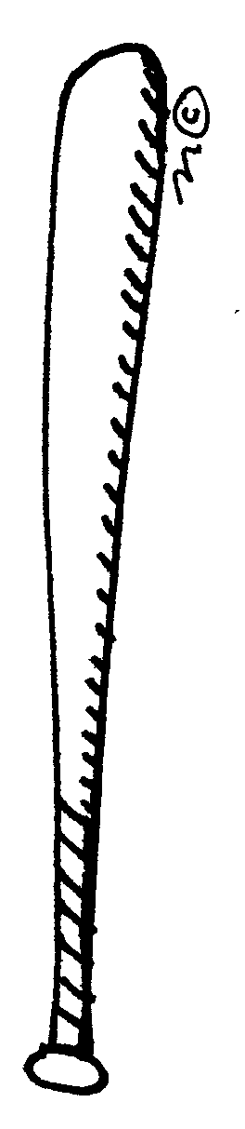

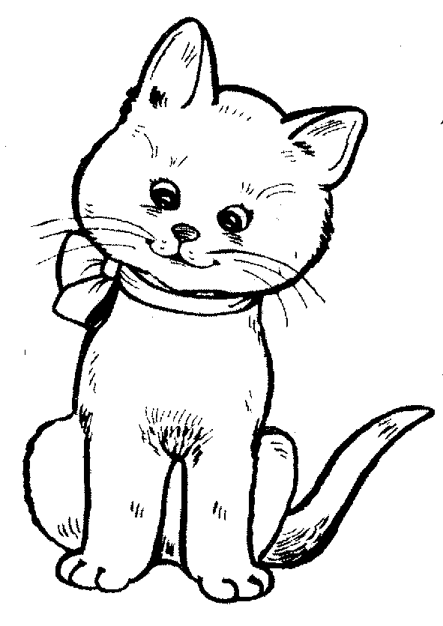
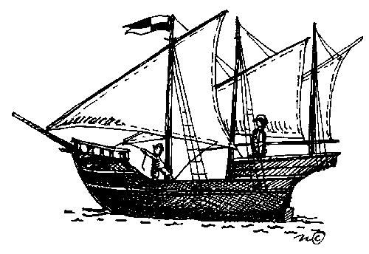
Wednesday2
Thursday2
Monday3

No School

President’s Day

Do you know who our current president is?

How many presidents can you name?
My phone number is


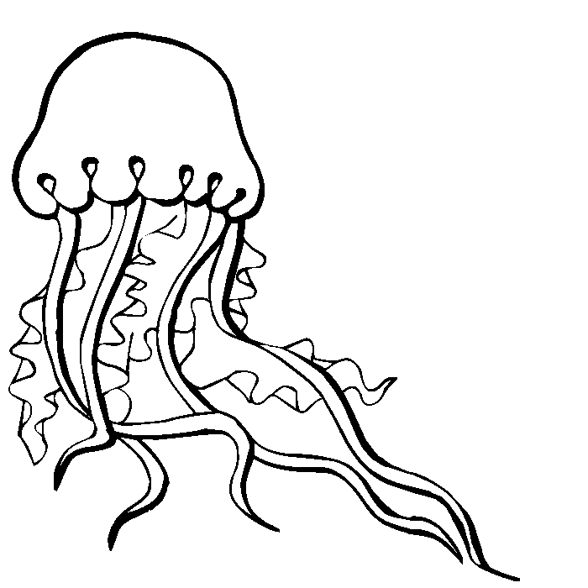

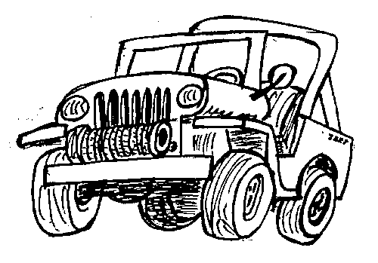

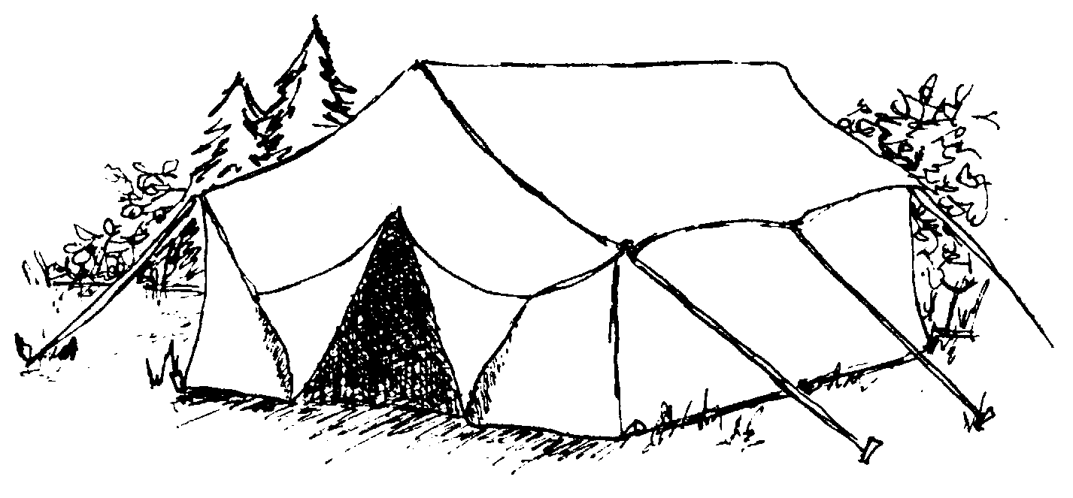
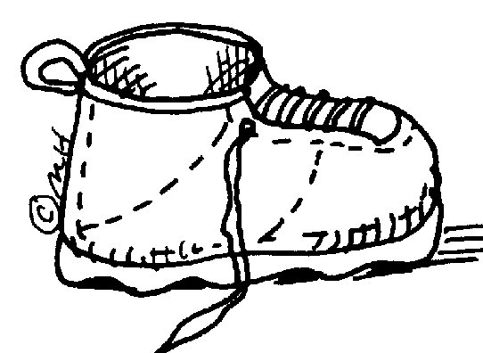
Tuesday3
Color the pictures that begin with Jj
Wednesday3
An animal that begins with “j”:
A food that begins with “j”:
A month that begins with “j”:
12
Circle the numbers that are GREATER than 12.


Thursday3
How many nails or screws did you find? Make tally marks.
Draw a picture of 2 things that starts with “k”. Write the words.
Monday4

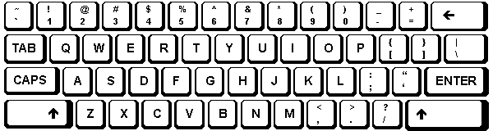
Look at the computer keyboard. Color the letters in your name.
Make a list of words that rhyme with cat.
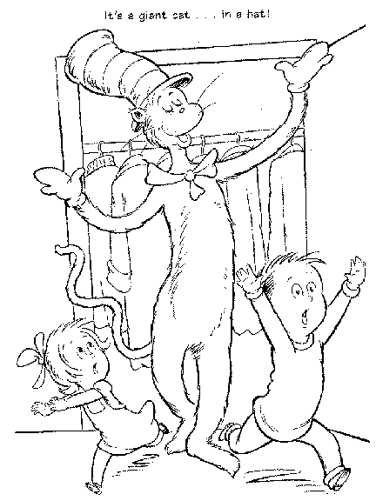
Tuesday4
Look at the picture above. Count and write how many of each:
Stripes on the cat’s hat:
Coats in the closet:
Bows:
Shoes:
Pretend to type the sight words. Color the letters for your favorite.
going to have play we we’re some
are made of come go on off
big little out in up down
Wednesday4
A mouse in a
A fox in a
A goat in a
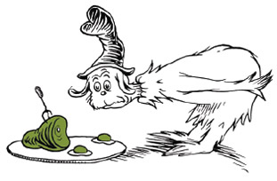
Thursday4
Finish each phrase with a word that rhymes with the underlined word.
Divide the candles into groups of 10. Circle each group of 10 (see example) and color each group a different color. Count by 10s to 100.

