 | Monday | Tuesday | Wednesday | Thursday
Week 1  Sight Words  in  came  the  said  this  it  no | Color the pictures that have the short “a” sound (like “cat”) yellow. Color the other pictures blue.  Say your phone number 5 times. | Write the “op” family words to go with the pictures.  Count to 50. | Put the sight words in the correct boxes—look at the letter shapes.  Write the number 7 five times. | Draw a picture of 2 things that start with “h”. Write the words.  Name the shapes.
Week 2  Sight Words  up  down  my  you  in  it | Write the correct word next to each arrow.  Write the number 8 five times. | Draw a picture of 2 things that start with “t”. Write the words.  Finish the pattern. | Write a “t” on the first line if it starts with the sound. Write “t” on the second line if it ends with the sound.  Say your birthday 5 times. | Circle the words that are the same in each row.  Write the number 9 five times.
Week 3  Sight Words  Color Words | Color the presents the correct colors.  Count the doorknobs in your house. | Color the pictures that have the short “o” sound (like “mop”) yellow. Color the other pictures red.  Count by 10s to 100 | Draw a picture to rhyme with each word.  Finish the pattern. | Draw a picture of 2 things that start with “n”. Write the words.  Write the numbers 1 to 10 in correct order.
Week 4/5 | Winter Break  No Homework!

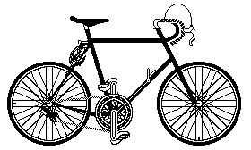
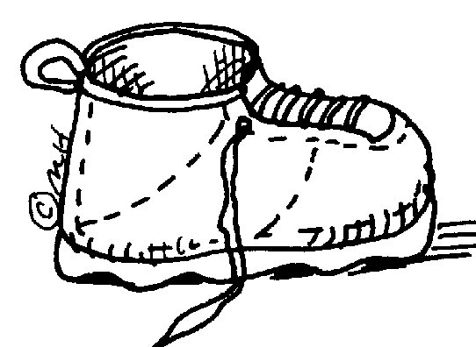
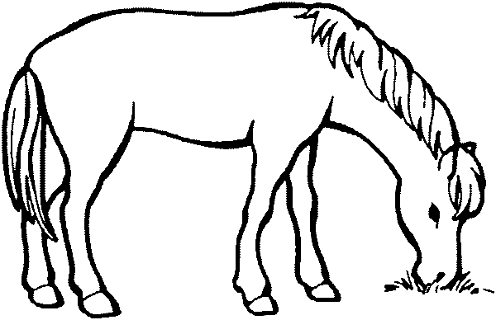
Monday

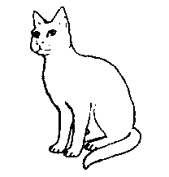
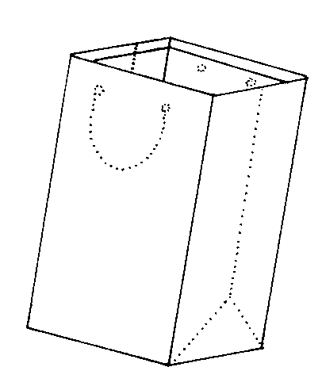
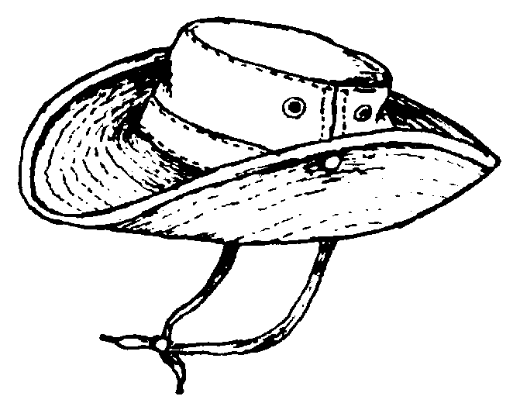

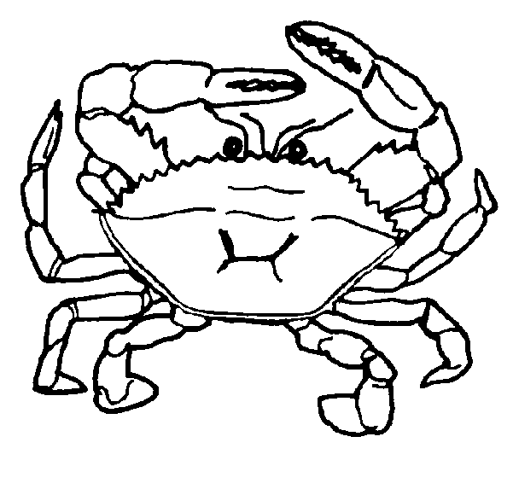
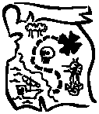
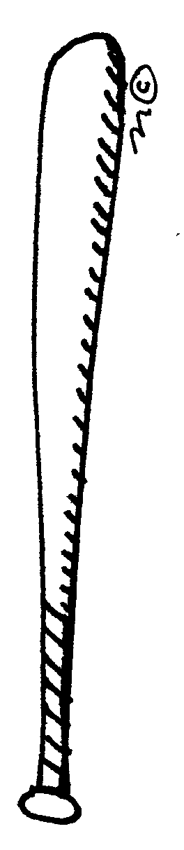

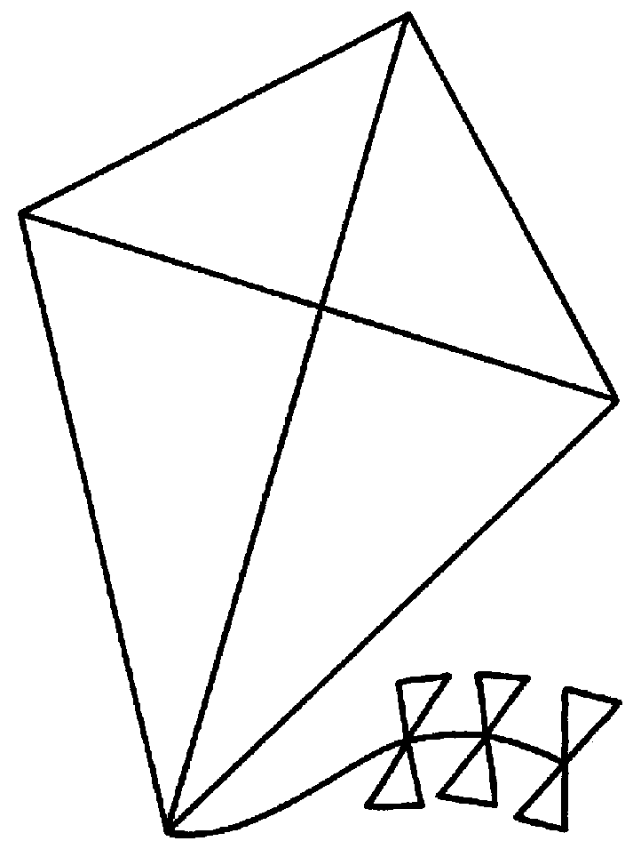
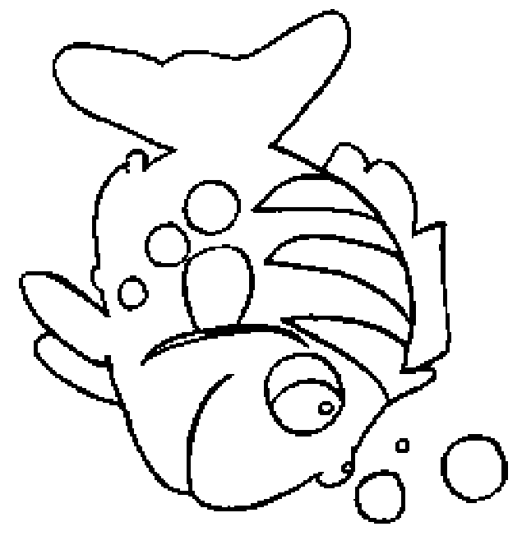
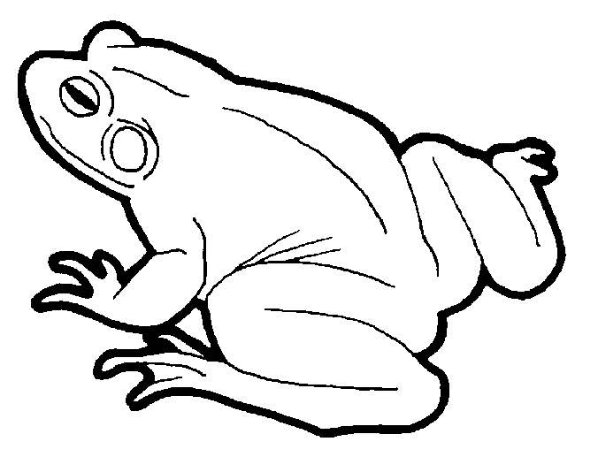
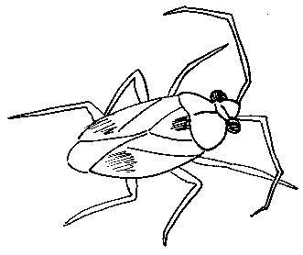
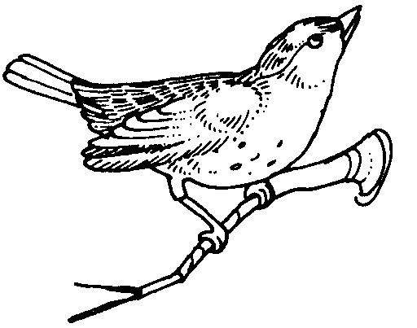

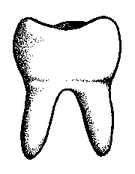
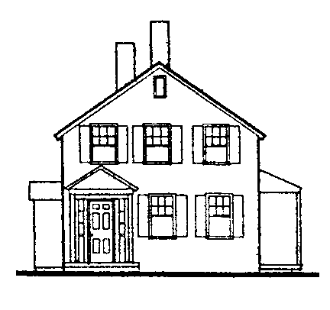
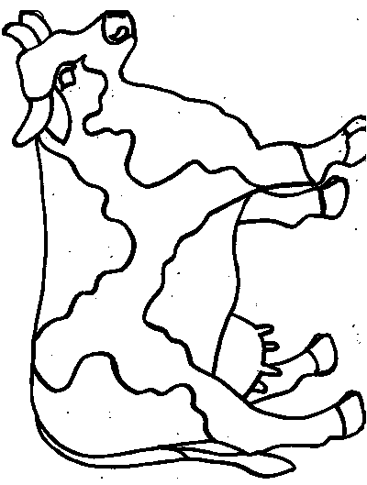
_op



Tuesday
Make up a silly “op” word.
Wednesday
6
in
came
said
this
no
it
Draw a picture of 2 things that starts with “h”. Write the words.
Thursday
Up or Down
Monday

8
Draw a picture of 2 things that starts with “t”. Write the words.
Tuesday
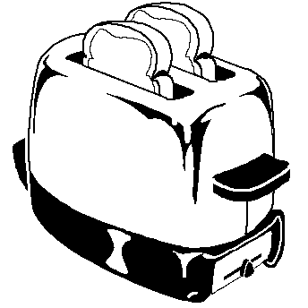
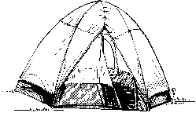
Wednesday
my may me my by
Thursday
9
you yes you yet your
it in is at it
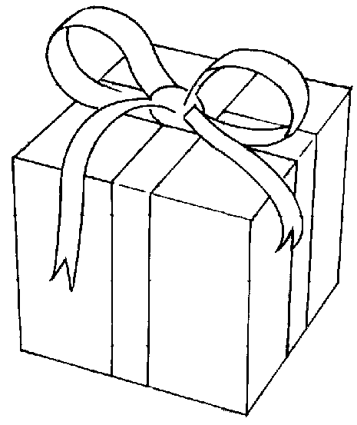
Monday
blue
green
brown
red
yellow
orange
purple
My favorite color is
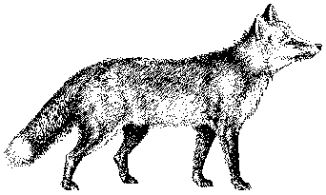
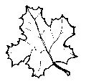

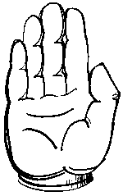
Tuesday

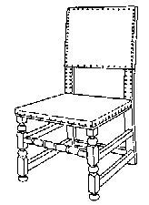
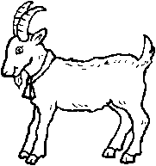
Wednesday
spoon
chair
goat
Draw a picture of 2 things that starts with “t”. Write the words.
Thursday

