Monday | Tuesday | Wednesday | Thursday | Friday
Fill in the missing numbers on the August calendar | Read the words. Circle the picture that goes with each word. | Write 2-3 sentences telling what you ate for dinner last night. Draw a picture. | Read the sentences. Fill in the missing sight words. | List an animal that begins with each letter.
Write the ending sound for each picture. | Color the stars in a pattern. Draw a picture in the middle. | Read the riddles. Write the answer. | Sort the pictures into categories by writing the words in the columns. | Solve the addition problems.
Draw the picture that comes next in each pattern. | Circle the correct spelling for each word. | Write 2-3 sentences telling about what kind of ice cream you like. Be sure to tell about the topping s you like! | Solve the addition problems. Color the picture according to the key. | Fill in the missing letters (oo, ow).
List 5 things that you can find in the ocean. | Circle combinations of 6. | Make a list of words that rhyme with each picture. | Read the questions. Write yes or no. | Are you ready for school to start? Write 2-3 sentences telling why or why not.
School Starts…Welcome Back

Return your Summer Packet for a treat!
Monday

 |  |  |  |  | 1
24 | 25
31


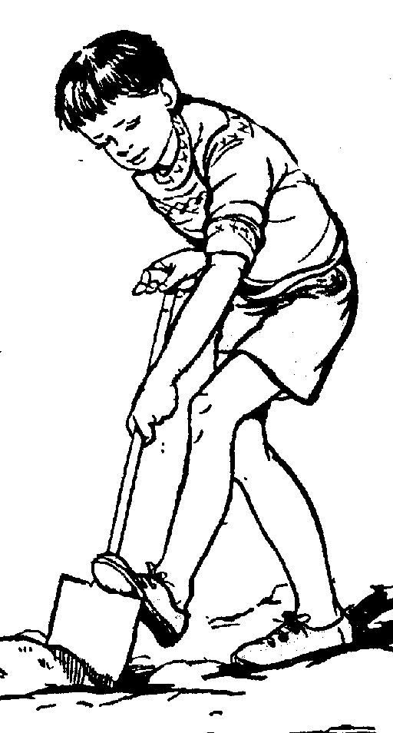
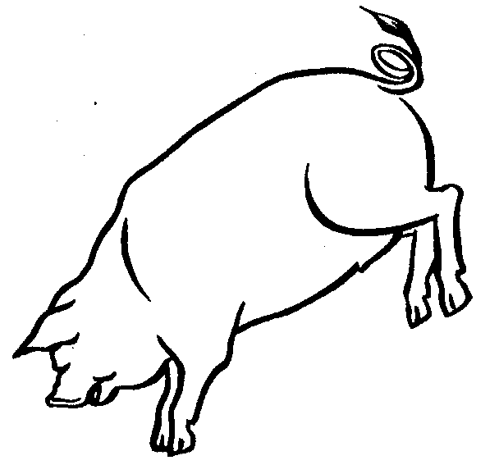
dig

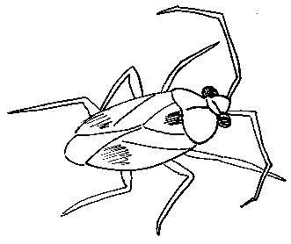
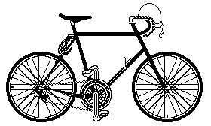
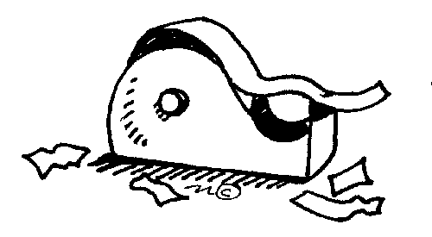
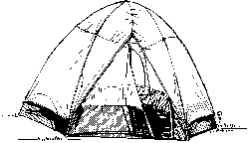

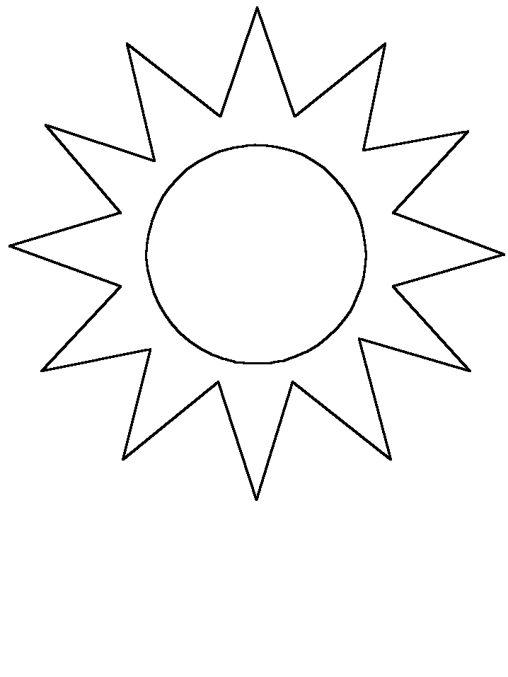

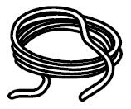

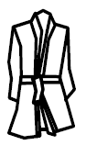
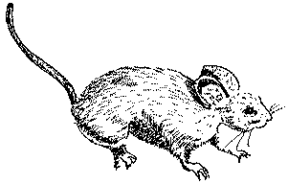

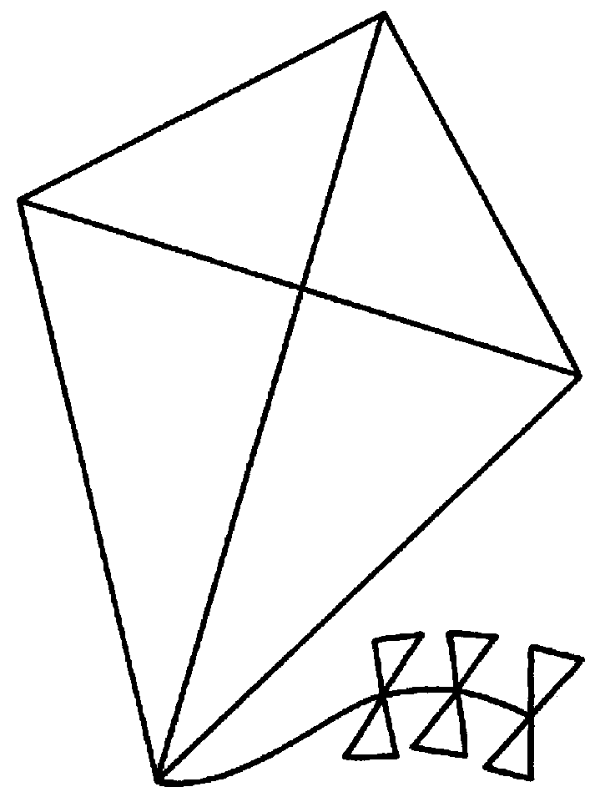
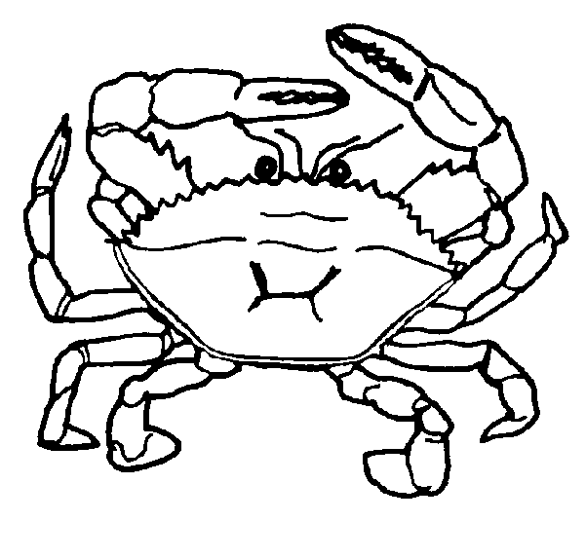
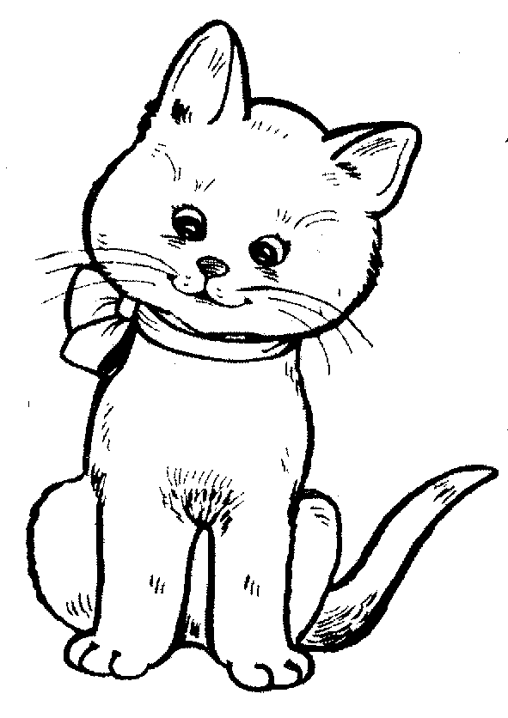
Tuesday
bike
tape
rose
rat
sun
kite
Wednesday
Thursday
is down make are from
I got a gift ____ my mom.
We can _____ a cake.
He will go _____ the slide.
The trees _____ big.
Friday
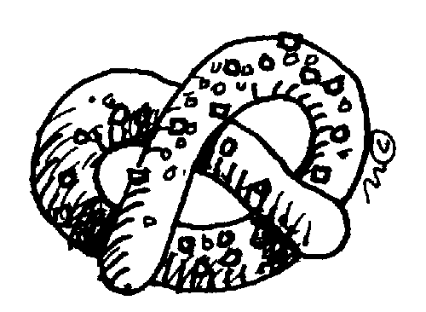
Monday


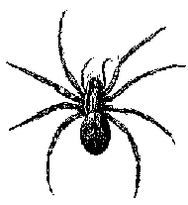
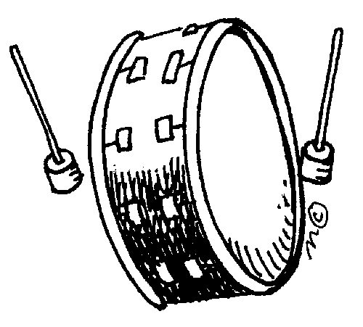

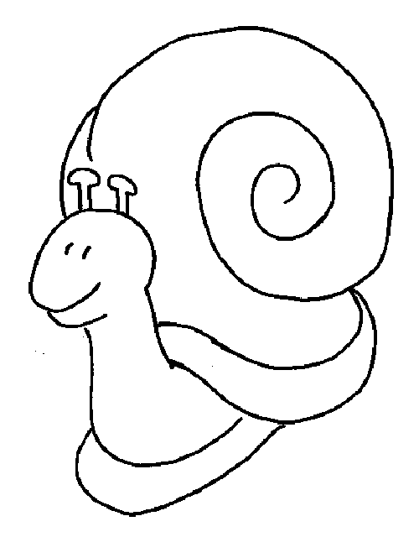
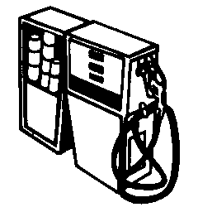
Tuesday
Wednesday
I am an animal. I have four legs and a tail. I like to eat bones. What am I?
I am yellow. I am shaped like a moon. Monkeys like to eat me. What am I?
I am round. I have a string. Be careful because I can pop.
What am I?

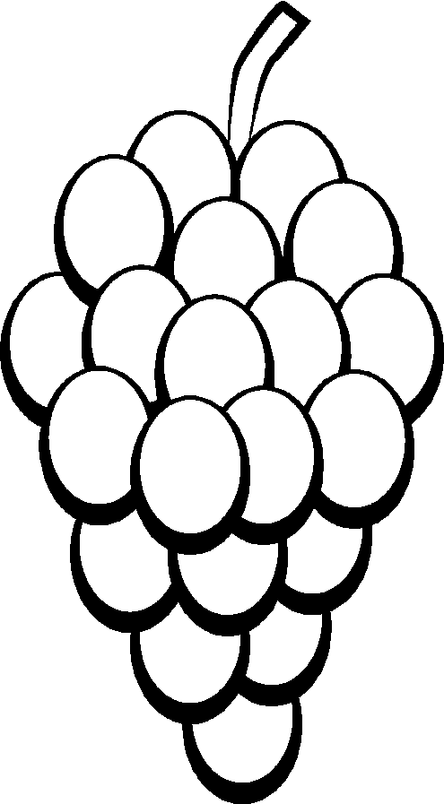
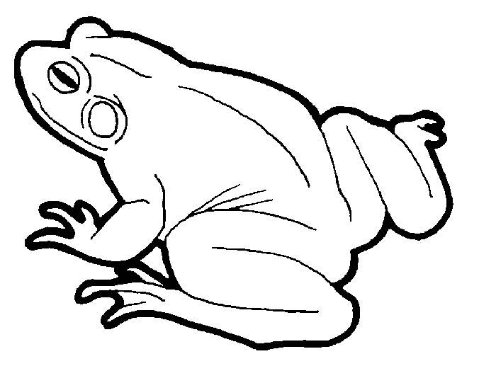
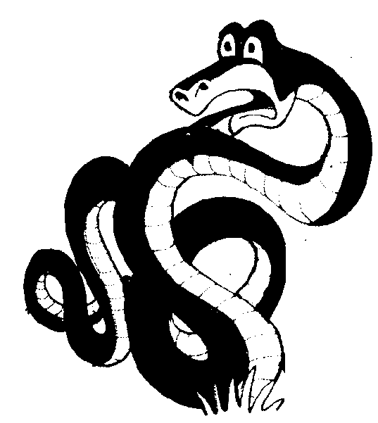
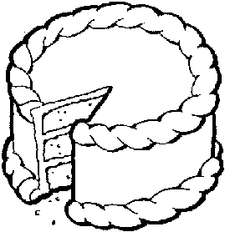
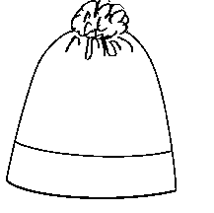
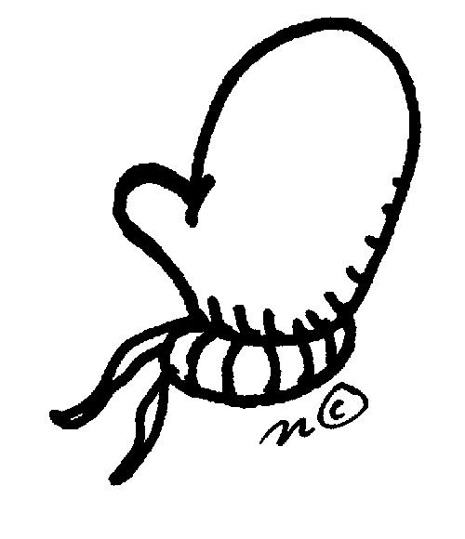
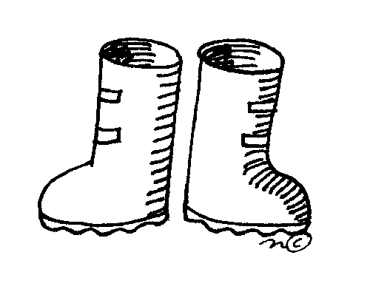
Thursday
Friday
4+4= __

6+6= __

2+2= __

7+7= __
3+3= __

5+5= __

1+1= __

0+0=__
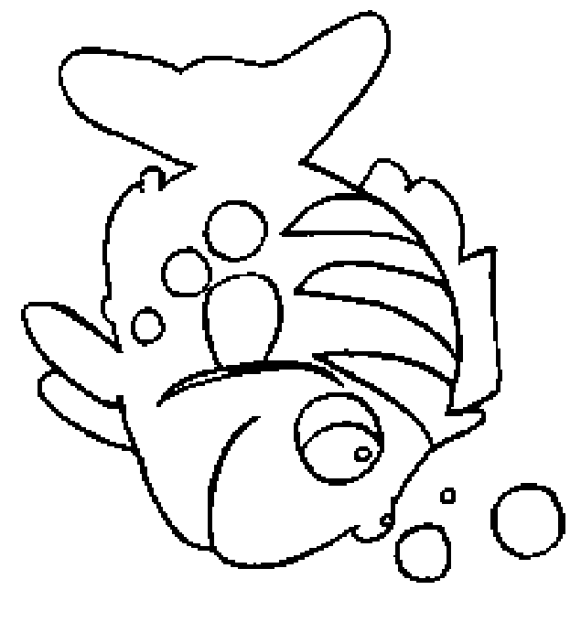
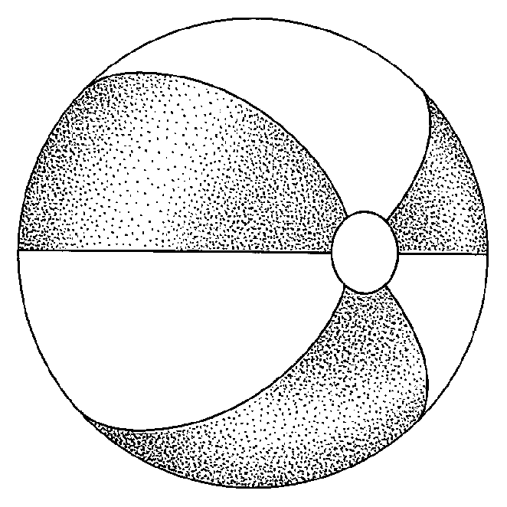
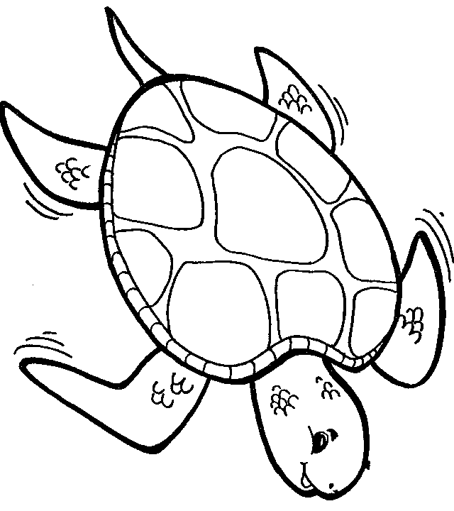

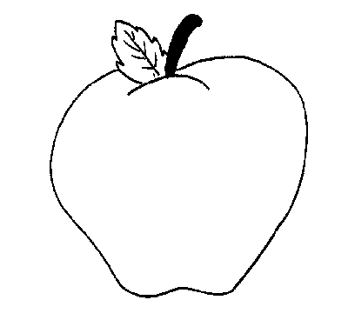
Monday
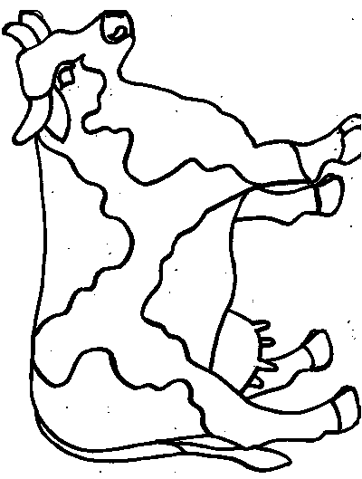


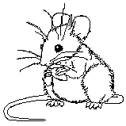
Tuesday
coo cow col
clood coud cloud
town toon tarn
colon clowd clown
moose mouse
Wednesday
Thursday
3+3= _
2+1= _
4+4= _
5+1= _
0+3= _
5+3= _
2+4= _
Color the spaces as follows:

6-red
8-blue
3-yellow

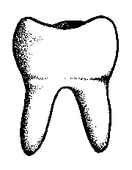
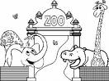

Friday
b _ _ ts
c _ _
cl _ _ n
h _ _ p
t_ _ th
t_ _ n
z_ _
m_ _ n
sp_ _ n
Monday
Tuesday
2 | 3 | 5 | 1 | 4 | 2 | 0
4 | 3 | 6 | 0 | 5 | 1 | 6
6 | 2 | 0 | 3 | 3 | 5 | 1
2 | 2 | 4 | 5 | 1 | 6 | 3
5 | 1 | 3 | 2 | 3 | 3 | 3
0 | 5 | 6 | 4 | 1 | 5 | 4
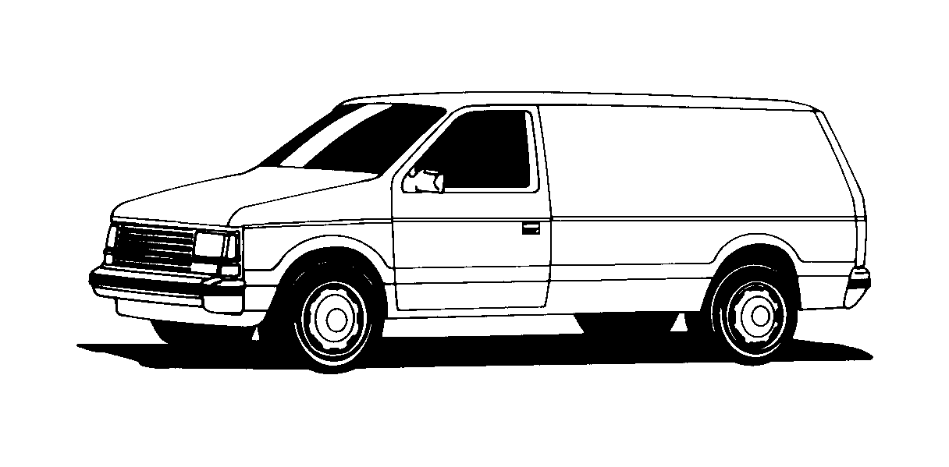
Wednesday
Thursday
Are you a boy?
Do you like dogs?
Can you skip?
Are you six?
Do you like chips?
Friday

