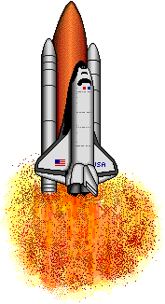  running | jumping | skipping
singing | telling | yelling
playing | hopping | picking

licking | shopping | popping
mopping | napping | kicking
sticking | going | sitting

locking | rocking | dropping
putting | cutting | hunting
calling | falling | shocking
petting | standing | smelling
wagging | seeing | planting
mixing | fixing | doing

