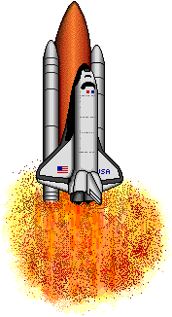  bag | bat | bed
big | box | bug
bus | cap | cub

cup | cut | dad
did | dip | dog
dug | fan | fed

fix | fox | fun
get | gum | had
ham | hen | hid

hip | hit | hop
hot | hug | hum
jam | jet | job

kid | lap | leg
lid | lip | log
mad | man | men

mug | nap | net
nut | pen | pin
pop | pup | rag

rug | rub | run
sit | tag | tip
top | tub | tug

wag | wax | web
wet | win | yet
yes | zip | set

