sh | th | sh
ch | th | th
ch | sh | sh
ch | sh | th
sh | sh | ch
th | th | ch
ch | sh | sh
th | ch | ch
th | sh | th
ch | ch | sh
th | th | sh
ch | sh | th

th | ch | ch
sh | th | sh
ch | th | sh
ch | th | th
sh | ch | sh
th | ch | sh

 | 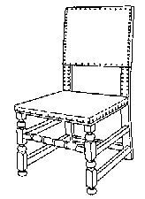 |  | 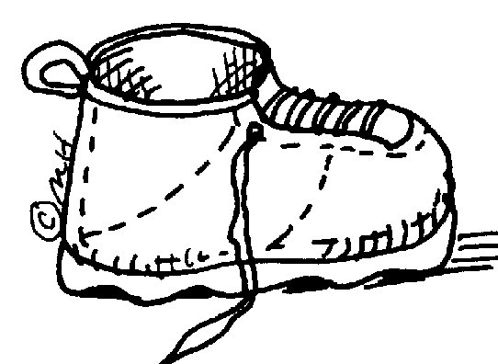 | 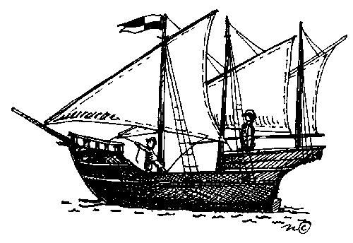
 |  |  |  | 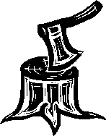
 |  |  |  | 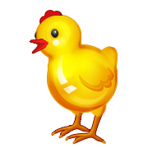

 |  |  |  | 
 |  |  |  | 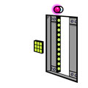
 | 

