Extra Turn! | Extra Turn! | Extra Turn!
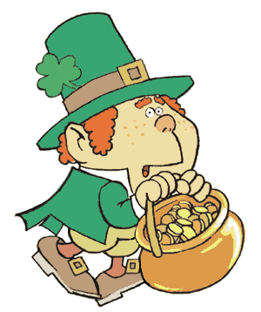  Take a card. | Take a card. | Take a card.

