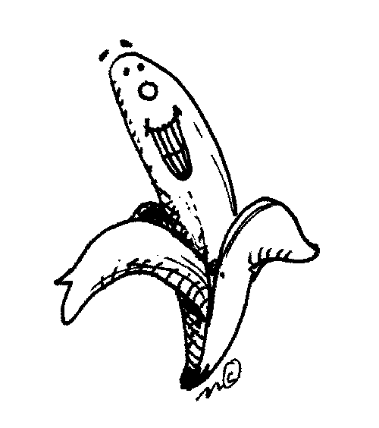
Take a banana. | Take a banana. | Take a banana.

