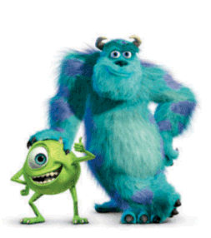  and | big | do
here | look | make
not | she | he

yes | no | has
in | am | all
can | on | me

and | big | do
here | look | make
not | she | he

yes | no | has
in | am | all
can | on | me

