print on first color

print on first color
print on second color
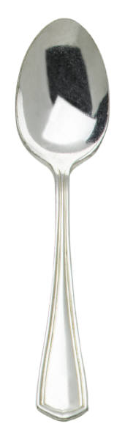
print on second color

