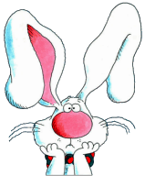
Find a carrot. Extra turn!
Stop to eat candy. Lose a turn
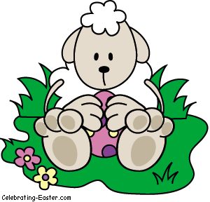
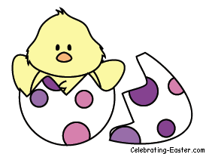
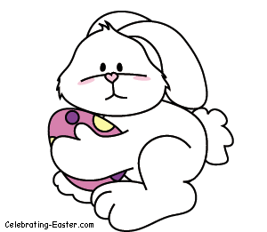
Help the bunny find his basket of eggs! Write one sight word on each egg space. Cut out the characters above to use as game pieces. Fold them in half to make them stand. Then cut out the number cards. Shuffle these and place them face down. To play take turns choosing the top number card and moving that number of spaces. Read the word on the space where you land. The first player to reach the basket wins!

