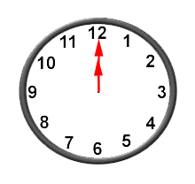
  Take a Cinderella card. | Take a Cinderella card. | Take a Cinderella card.

