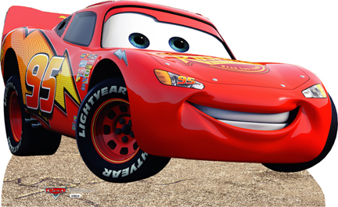  by | come | are
four | have | like
make | my | one

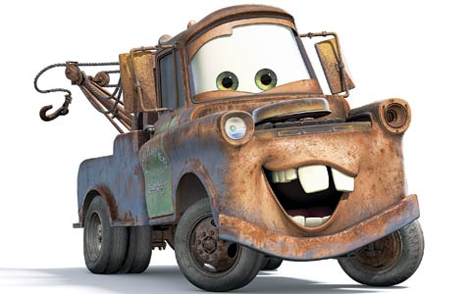  by | come | are
four | have | like
make | my | one

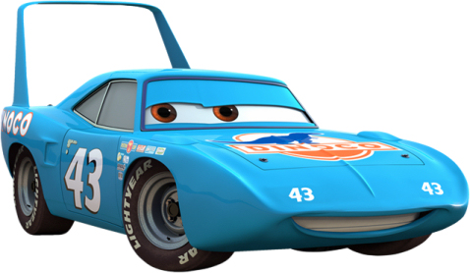  by | come | are
four | have | like
make | my | one

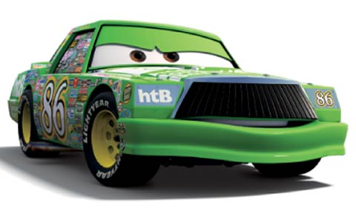  by | come | are
four | have | like
make | my | one
Draw 2 | Draw 2 | Draw 2
Draw 2 | Wild! | Wild!
Wild! | Draw 4 | Draw 4

Draw 4

