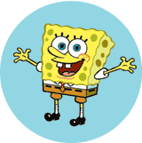  some | come | what
where | who | was
this | said | from

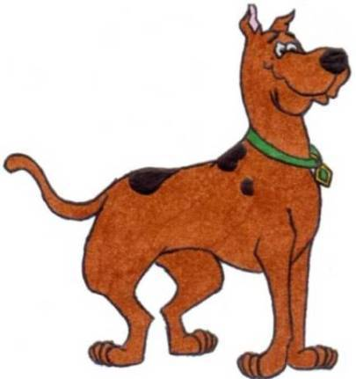  some | come | what
where | who | was
this | said | from

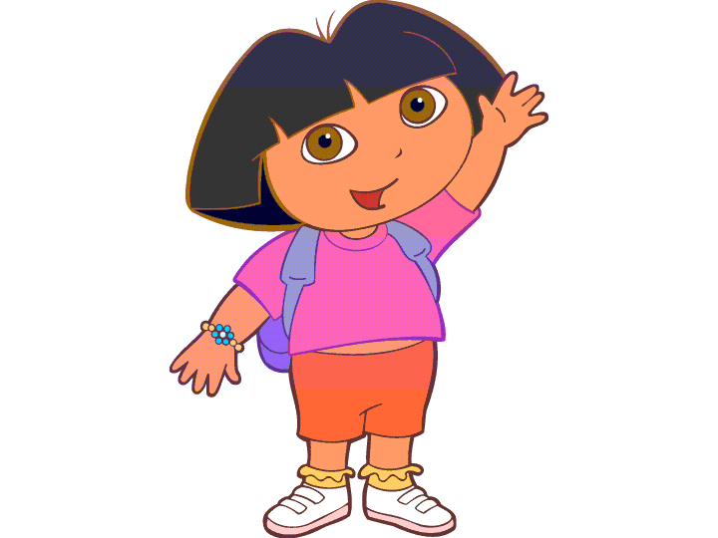  some | come | what
where | who | was
this | said | from

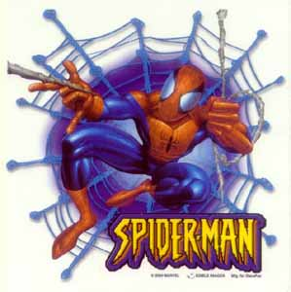  some | come | what
where | who | was
this | said | from

  Draw 2 | Draw 2 | Draw 2
Draw 2 | Wild! | Wild!
Wild! | Wild! | Wild!

