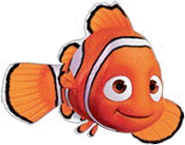  is | see | the
my | to | go
like | for | red

yellow | green | blue
you | are | up
it | six | one

is | see | the
my | to | go
like | for | red

yellow | green | blue
you | are | up
it | six | one

