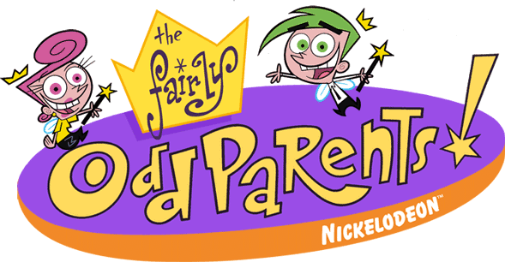






Vicki baby-sits. Go back 4
Wanda grants a wish. Move ahead 5.
Cosmo grants a wish. Take the shortcut ---→
Wanda grants a wish. Roll again.
Cosmo grants a wish. Move ahead 1
Get chased. Lose a turn.

