  this | what | was
from | come | some
where | said | who

under | over | out
of | down | have

this | what | was
from | come | some
where | said | who
under | over | out
of | down | have
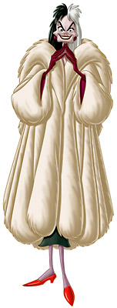
Cruella De Vil

