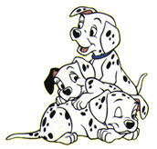  is | see | the
my | to | go
like | for | red
yellow | green | blue
you | are | up

is | see | the
my | to | go
like | for | red
yellow | green | blue
you | are | up

Cruella De Vil

