Clifford’s Words

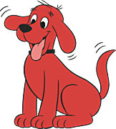  the | is | an | red
my | blue | orange | brown

Clifford’s Words

here | a | yellow | see
green | purple | black | white

Clifford’s Words

the | here | an | yellow
my | green | orange | black

Clifford’s Words

is | a | red | see
blue | purple | brown | white

Clifford’s Words

white | orange | purple | my
see | an | a | the

Clifford’s Words

here | is | yellow | red
green | blue | black | brown

the | is | here | a
an | red | yellow | see

my | blue | green | purple
orange | brown | black | white

