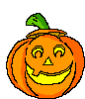  bat | cat | jet
wet | fit | sit
mop | dog | cup

sun | bag | pen
win | pig | pop
top | fun | bug

mad | sad | hen
ten | wig | hop
fox | tub | rug

rag | red | mom
dad | cut | box
six | fix | tag

