
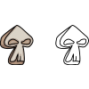
Pizza
medium
large
small
pepperoni
mushrooms
sausage
green peppers
extra cheese
Toppings:
anchovies
$3
$4
$5
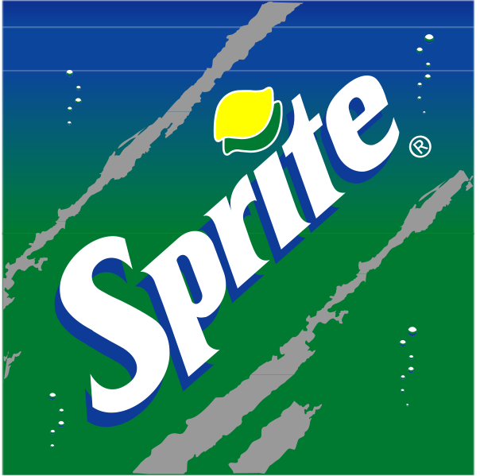
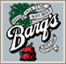
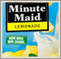
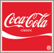
$1
$2

