Breakfast
Calendar
Message
Writing
Math
Lunch
Open Court
Reading Groups
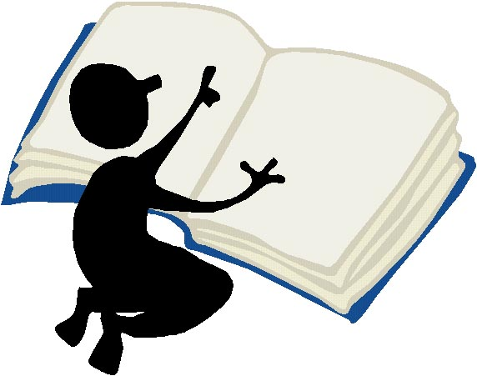
Big Book
Story


Art
Music
P. E.
Library
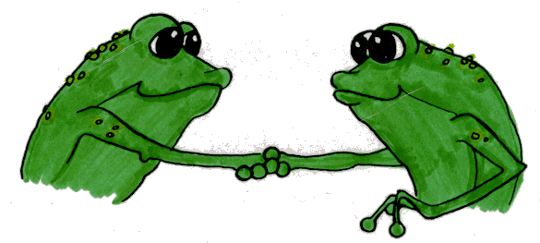
Computer Lab
Guidance
Outside
Centers
Special Event
Snack
Home
Science
Social Studies

