0
Writing
Center
ABC
Center

Math
Center

Science
Center

Art
Center

Puzzles
Center

Blocks
Center

Dramatic Play

Bucket
Blocks

Listening Center

Computer
Center

Library

Doll House

Games
Center

Mr. Potato Head

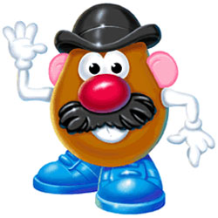

Marble Works

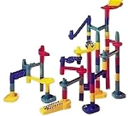

Play Dough

