Sign up for a center that is open.
Closed
☹


Play at the center where you are signed up.
Use materials on a rug or a table.


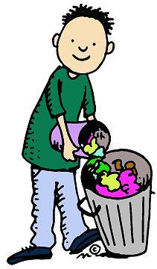
Clean up your center before you move to a new one.

Follow class rules!

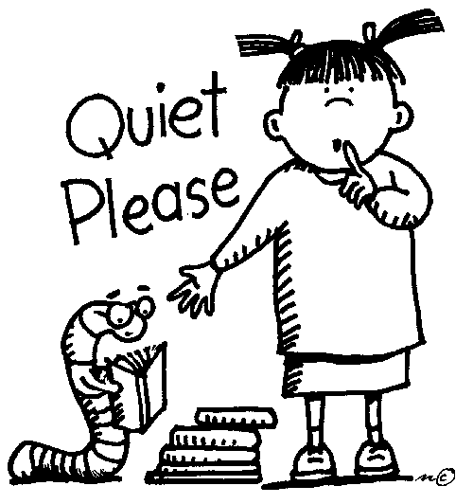
- Work together-don’t fight.
- Use quiet voices.

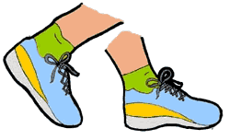
- Keep your hands and feet to yourself.

- Follow directions.
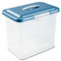
Finish your Bucket Center before you sign up for a Choice Center.

