What do you want to do in the spring?
ride my bike | play ball | jump rope | go swimming
Do you play on a sport’s team?
yes | No

Do you like rain in the spring?
yes | No
In the spring, I like….
Rain |  | Snow | Sunny days

Do you like to swim?
yes | No
Do you like spring or winter?
Winter | Spring
What do you like to use in the rain?
Umbrella | Raincoat | Rain boots
What do you like to write with?
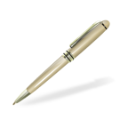  Pen  Author   | Pencil  Illustrator | Marker | Crayon

What would you rather be?
Vet | doctor
What would you rather be?
Rest! | Have friends over! | Play outside! | Go on a trip!
What do you want to do for spring break?
Cheese | Pepperoni | 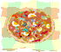 Everything on it! | X  Nothing, I don’t like pizza!
What kind of pizza do you like?
What do you want to do this summer?
Go on a trip! | Play outside! | Go Swimming! | Make new friends
Do you ride a bike with:
2 wheels | 3 wheels | 1 wheel
Which would you rather watch on TV?
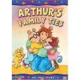  Arthur | 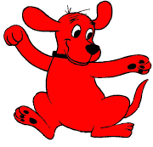Clifford | - Caillou |  Curious George
Who do you like better?
Arthur | 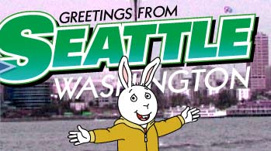 Buster | 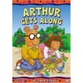 D.W.

Mrs. Oliphant talks…
Loud | Quiet
Mrs. O’s hearing is…
A bummer! | cool |  | sad | A.Ok
Which character do you like best?
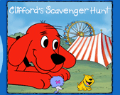  Tbone | 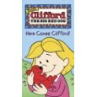  Emily Elizabeth |  | Clifford
Which character do you like the best?
Arthur | Clifford
If I could write a book, I’d like to be the author of….
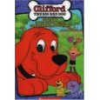 Clifford | Arthur |  | 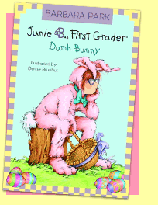 Junie B. | 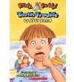Ready Freddy
My favorite Dr. Seuss book is….
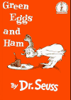 | 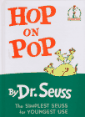 |  | 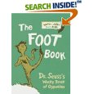 | 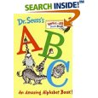
My favorite Dr. Seuss character is….
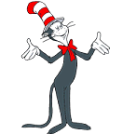 | 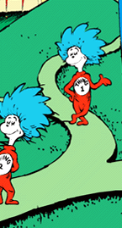
When I grow up, I want to be a…..
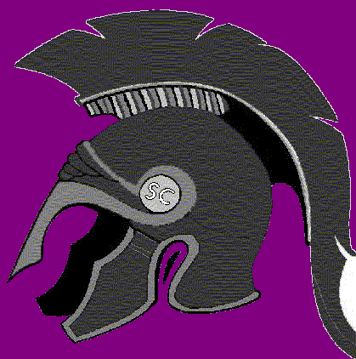 Spring Creek Spartan Football Player | Spring Creek Cheerleader | Spring Creek Spartan Basketball Player |  |  | Spring Creek Spartan Band Member

American Idol is….
Freaky! |  | cool | awful | Awesome
If Mrs. O was on American Idol, she would be…
Freaky! | cool |  | awful | Awesome

