Which pig book do you like best?
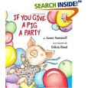 | 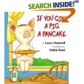 | 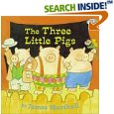 | 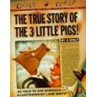
Which book do you like best?
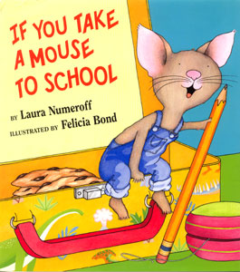 | 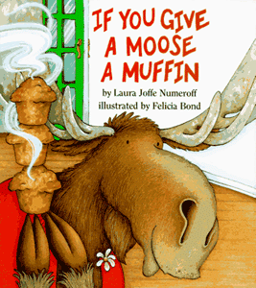 | 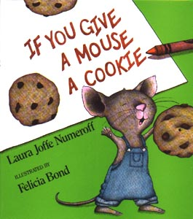 | 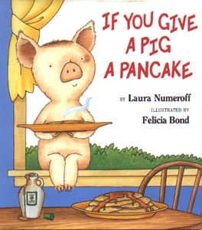

What would you like for lunch today?
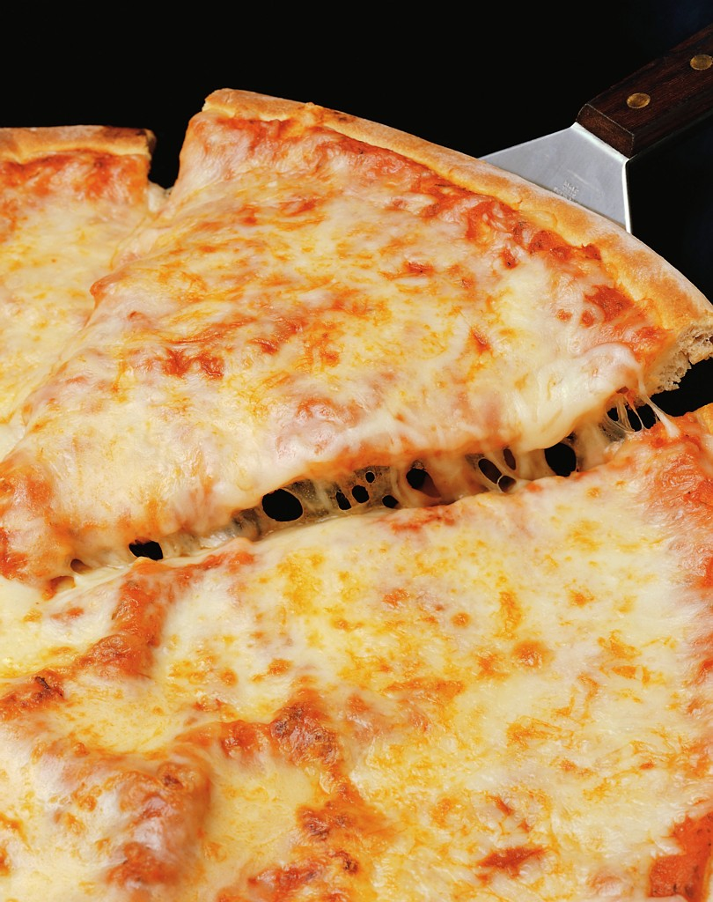  pizza | 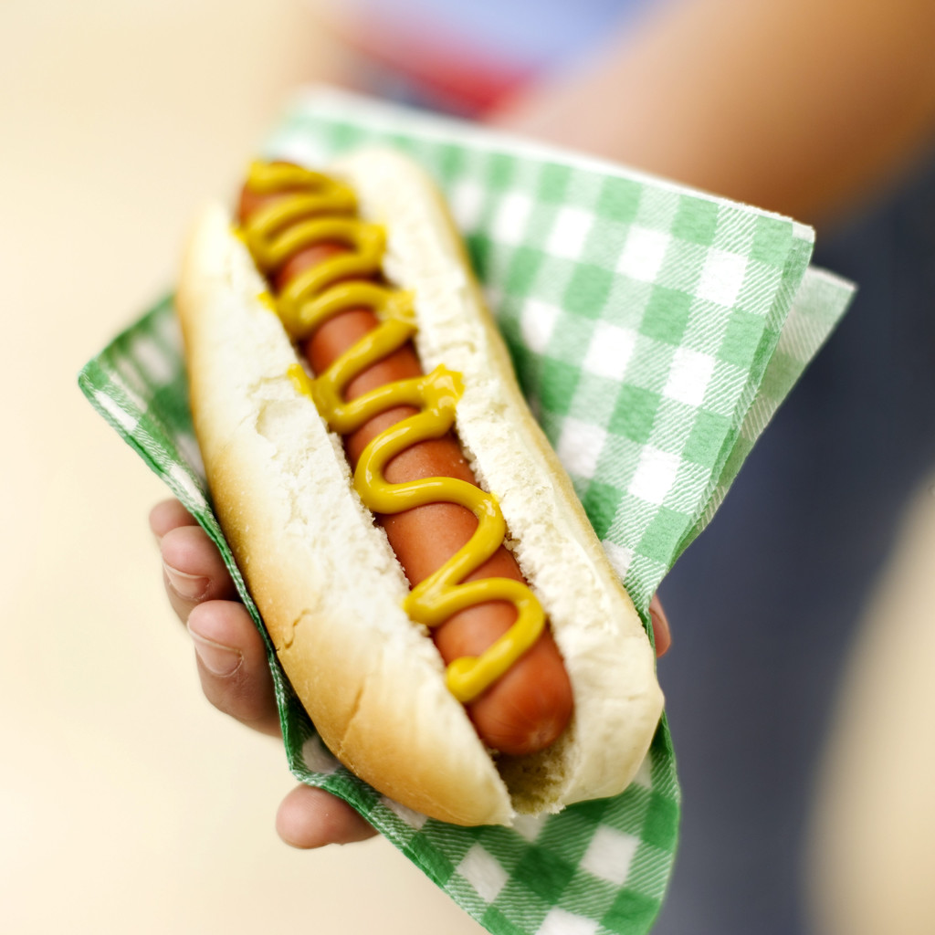  Hot dog | Cold lunch | peanut butter and jelly
What is Mrs. O?
Crazy | Silly | Funny | Goofy

What do you wish the weather was today?
  cloudy | 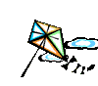  windy | sunny | snowy
What do you like better?
Computer Lab  Yes | P.E.  No | Art | Music
Do you like Pumpkin Pie?
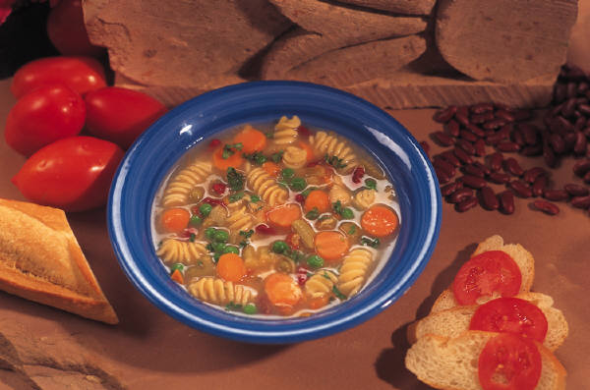  Chicken noodle | Tomato | 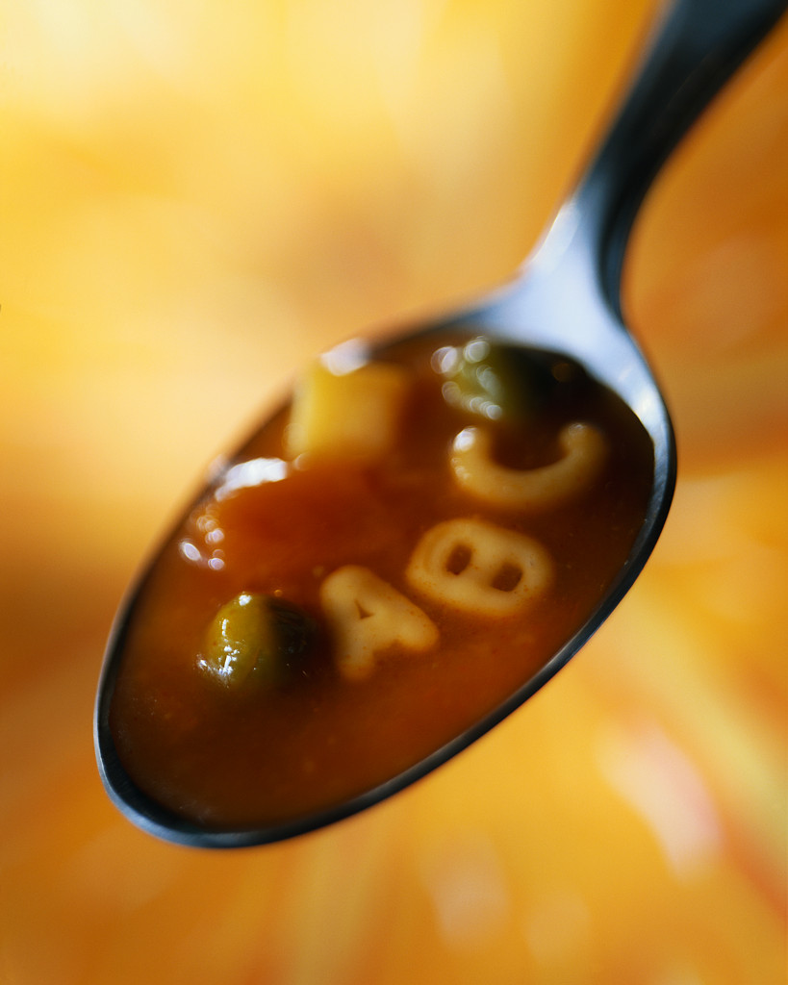  Vegetable Beef | Cheese
What is your favorite soup?

What do you like best at night?
Snuggling with mom or dad | A warm blankie | A stuffed animal | Reading stories
Which Halloween candy is your favorite?
Candy Corn | Suckers | Chocolate | Gum
Would you rather be a teacher or a doctor?
teacher | doctor | X  neither
What is your favorite kind of sandwich?
Peanut butter | just Jelly | Cheese | X  None of them!
What do you like best?
Books | TV | Puzzles | 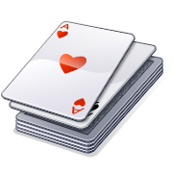  Cards
What is your favorite inside game?
cards | 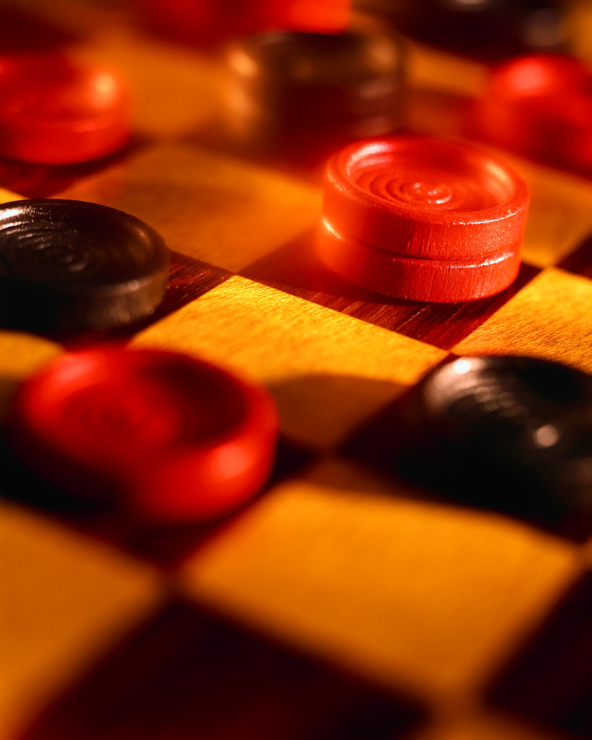  Checkers | Board games | Dice Games
Do you like hot lunch or cold lunch best?
hot | cold
What is your favorite thing to do in the rain?
Watch TV | Snuggle | Play Games | Bake cookies

Which character do you like best?
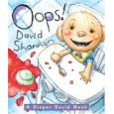 | 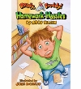 | 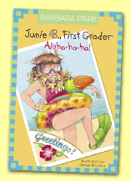 | 
Have you ever broken a bone?
What David Shannon book do you like best?
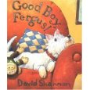 |  | 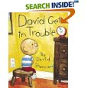 | 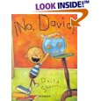
What is your favorite pop?
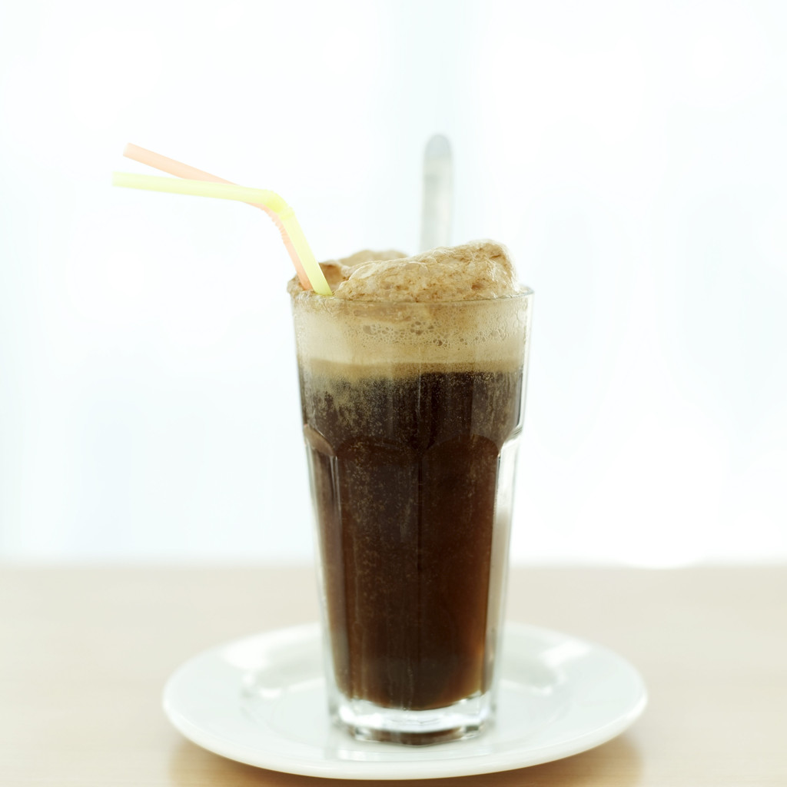  Root beer | 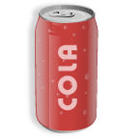  Coke | Sprite |  | X  None, I don’t drink pop!
Would you rather have a float or a sundae?
Float | 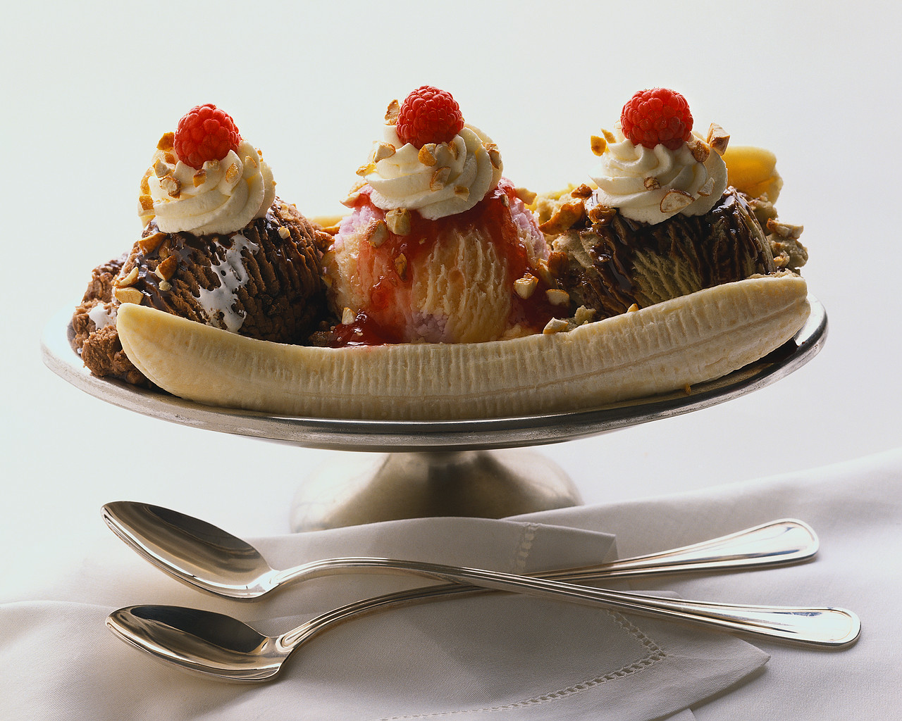Sundae
Would you rather have pizza or tacos for supper?
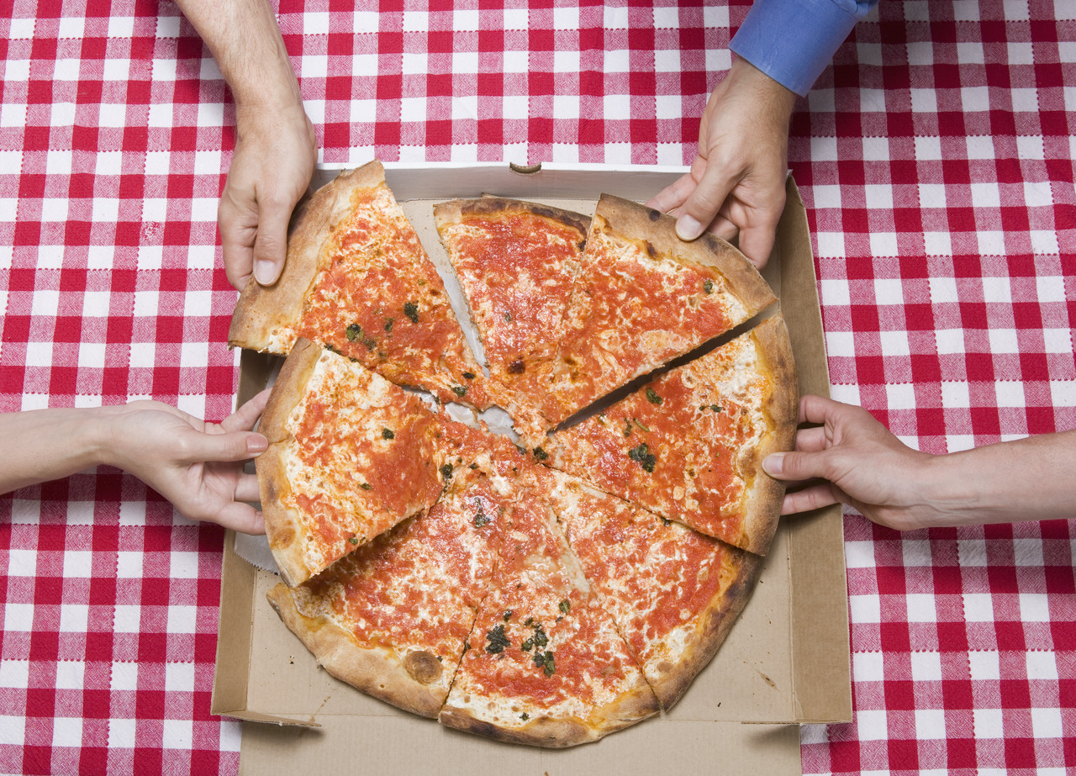Pizza | Tacos
Do you like to sleep with one or two pillows?
1  one | 2  two
Have you ever gone to Disneyland?
Yes | No

Which Junie B. Book do you like?
 | 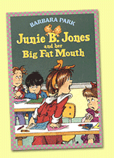 | 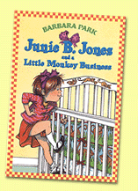 | 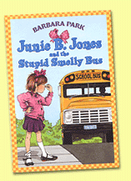
What monster book do you like?
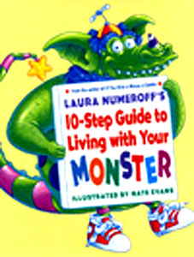 | 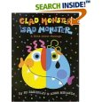 | 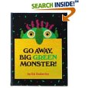

Do you like scary movies?
Yes | NO!
What do you like better?
Bath | Shower | X  Neither!

What smell do you like best?
Shampoo |  | Soap | Perfume | Flowers
What do you like best?
Birthday | Christmas |  | Snow Day!

What do you like better?
Backpack boogie song |  | School is cool song |  | Calendar songs |  | None, I don’t like when we sing!
Which do you like best?
Monday | Friday |  | Saturday |  | Sunday

