Which color do you like best?
red | yellow | green | blue
What do you like to do?
ride my bike | play ball | jump rope | go swimming

Which pet would you like to have?
dog | bird | cat | fish
What is a good name for a Dalmatian?
Spot | Sparky | Fire Dog | Buddy

Which color of leaves do you like best?
red | yellow | brown | orange
Do you like Fall or Summer better?
Fall | Summer
Which candy do you like best?
gum | lollipop | chocolate
Which apple product do you like best?
Apple juice | 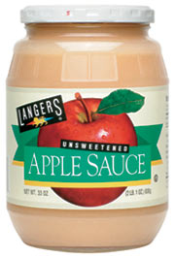  Applesauce | Apple pie

Which vegetable do you like best?
green beans | corn | carrots | broccoli
Which Thanksgiving food is your favorite?
mashed potatoes | turkey | vegetables | pie
Would you rather be a police officer or firefighter?
police | firefighter | X  neither
What is your favorite kind of cookie?
ginger-bread | chocolate chip | peanut butter | 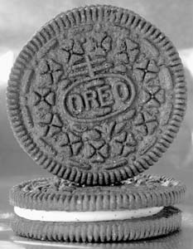Oreo
Which Christmas song do you like best?
Jingle Bells | Rudolph | Must Be Santa | 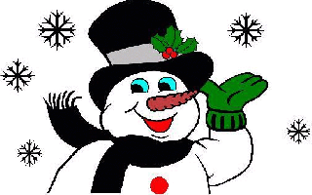  Frosty
What is your favorite inside toy?
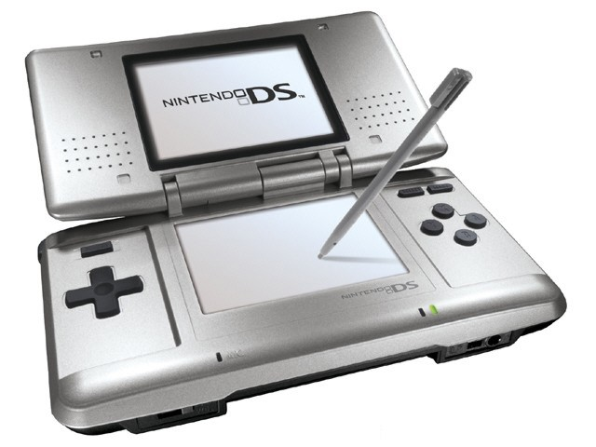  video games | cars and trucks | books | dolls
Do you like Summer, Fall, or Winter best?
Fall | Summer | Winter
What is your favorite thing to do in the snow?
build a snowman | ride a sled | go ice skating | 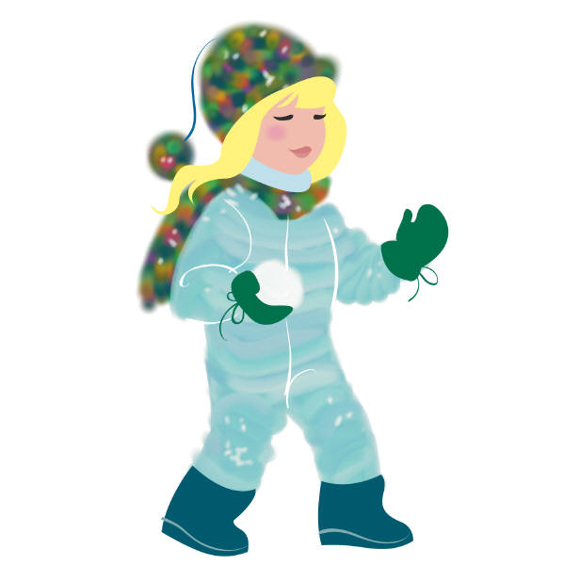  make snowballs

Which bear book do you like the best?
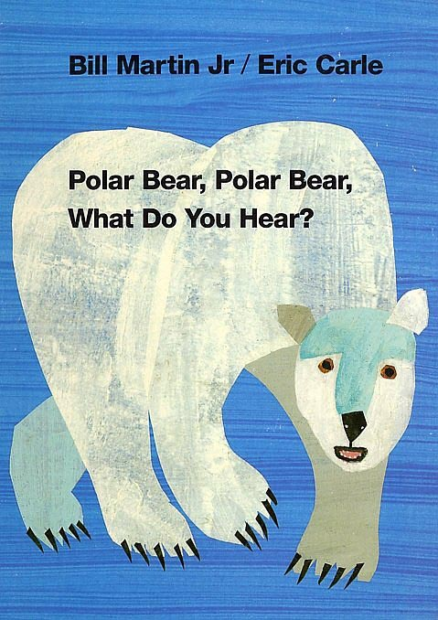 | 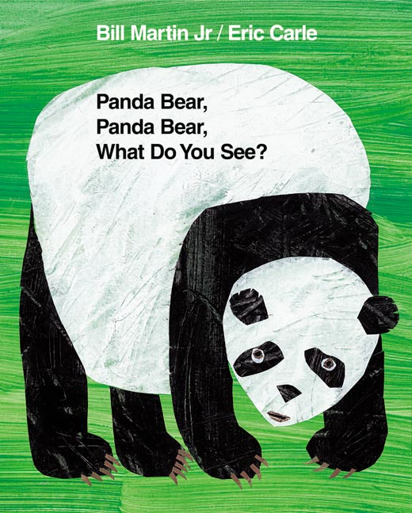 | 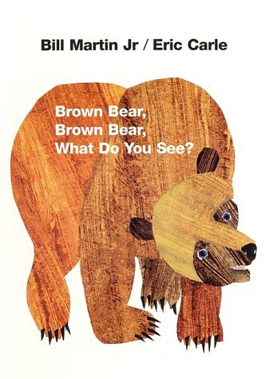 | 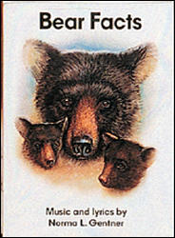
How many teeth have you lost?
0 | 1 | 2 | 3 or more
Which character do you like best?
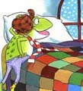  Froggy | 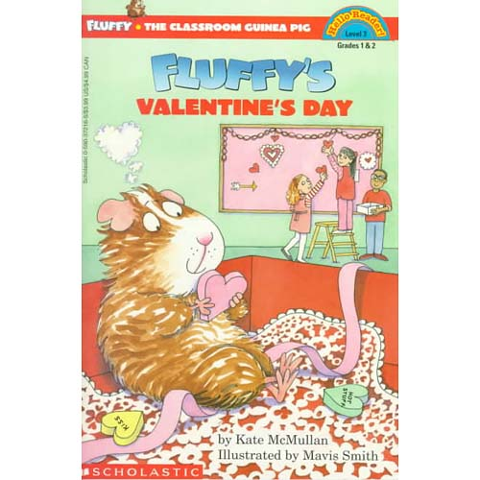  Fluffy | 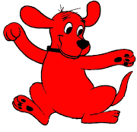Clifford
What is your favorite pizza topping?
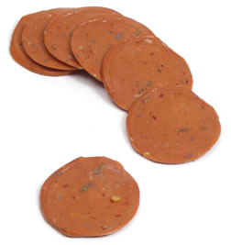  pepperoni | mushrooms | 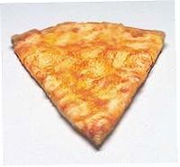  plain cheese | sausage
What flavor of ice cream is your favorite?
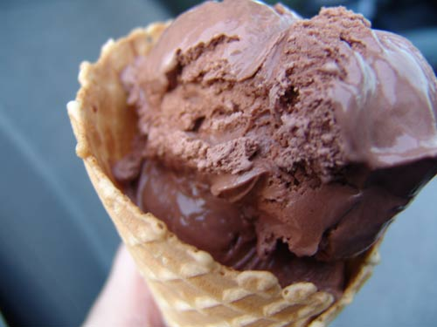  chocolate | 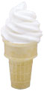  vanilla | 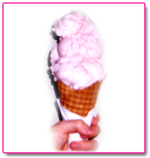  strawberry | 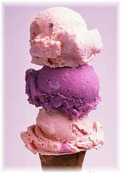  other
Which Cat in the Hat character do you like best?
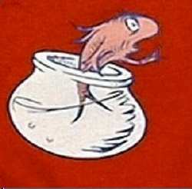  Fish | 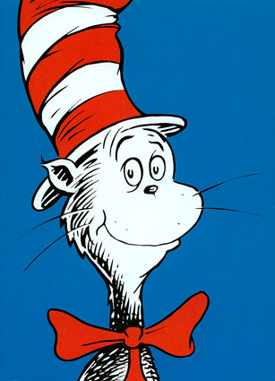  Cat in the Hat | 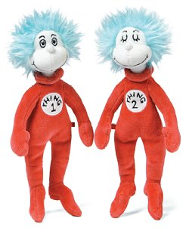  Thing 1 and 2
How do you come to school?
car | van | truck | walking
Have you ever flown on an airplane?
Yes | No

Which Easter egg looks the prettiest?
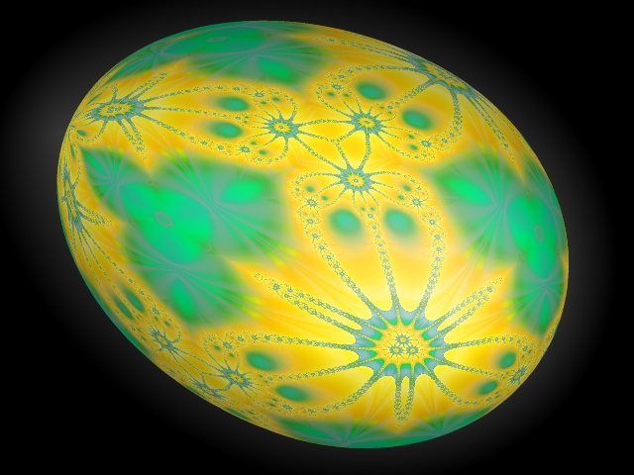 |  | 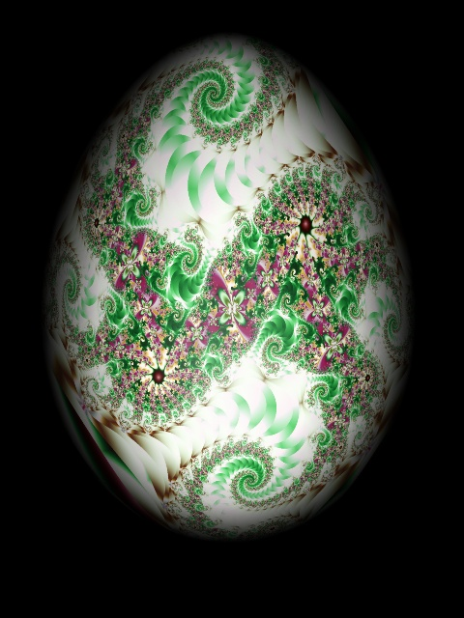 | 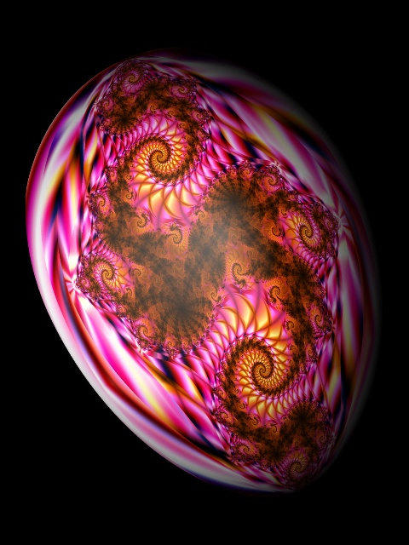
Which bug is the yuckiest?
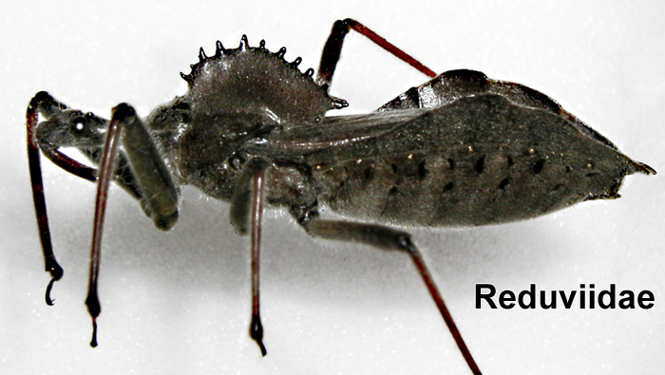 | 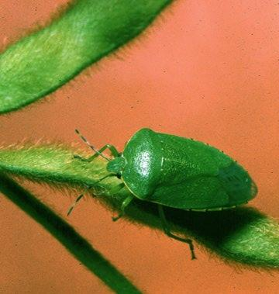 | 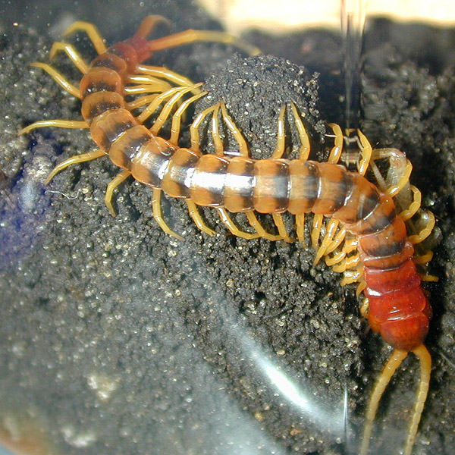 | 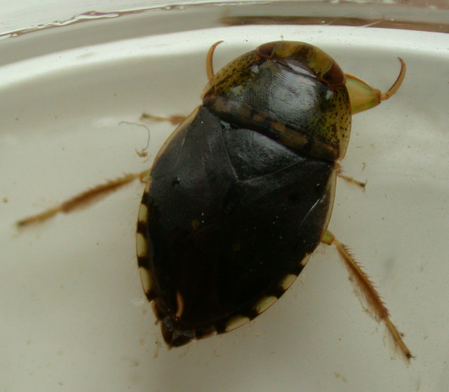

Which flower would you like to grow?
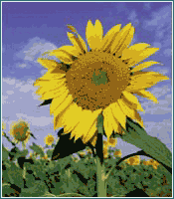  sunflower | 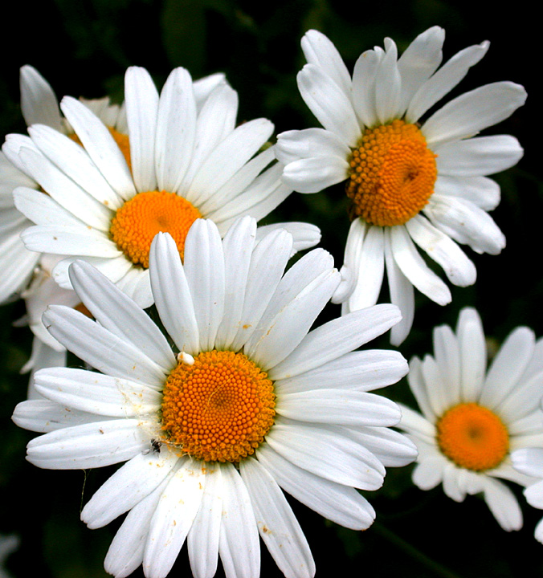  daisy | 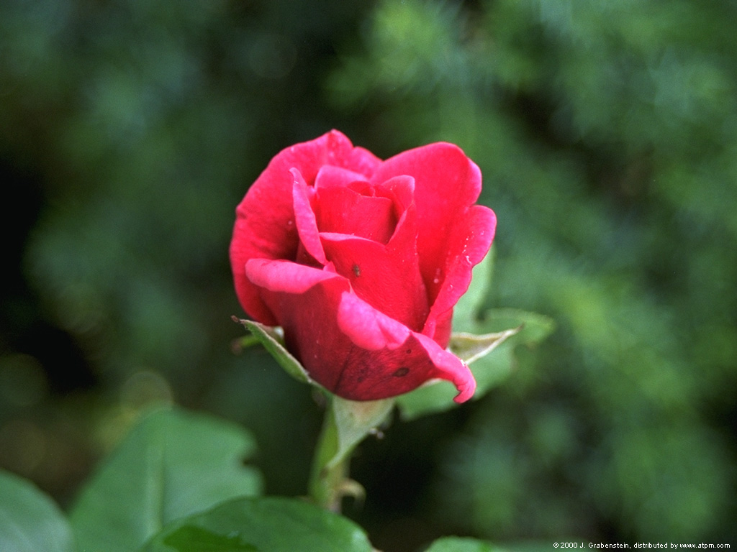rose | 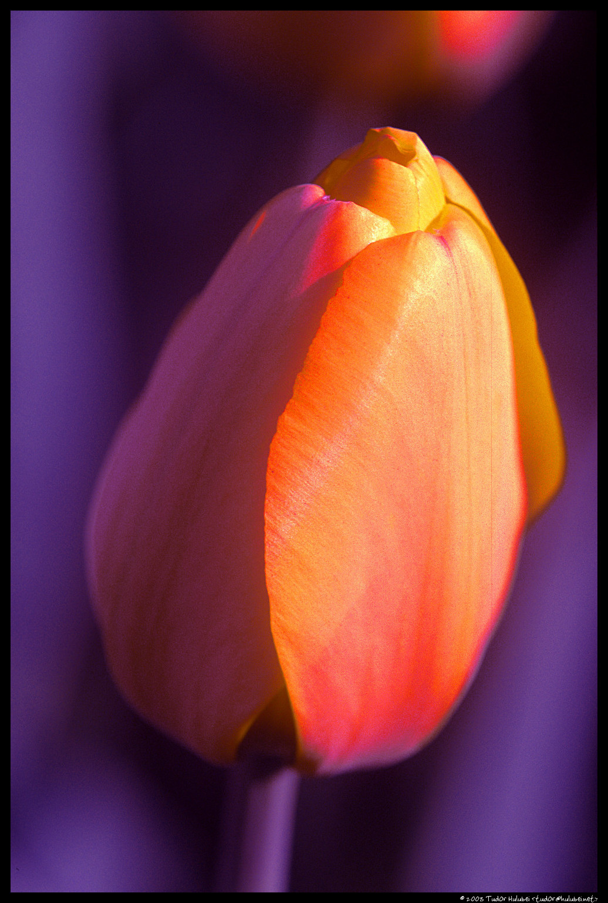  tulip
Which farm animal is the most helpful?
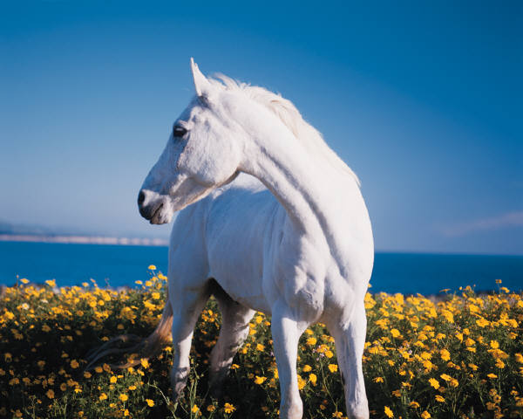  horse | 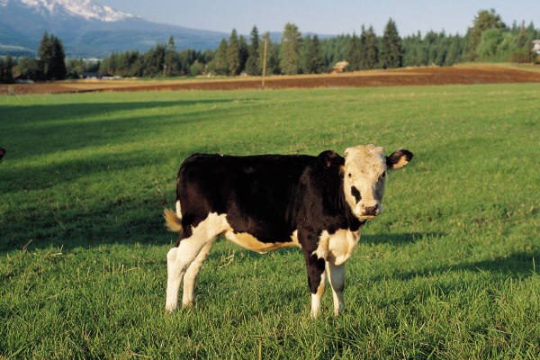  cow | 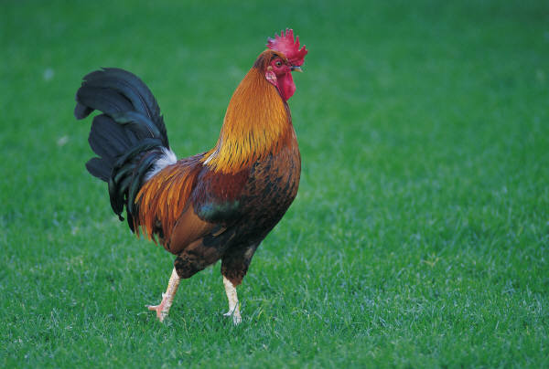  chicken | 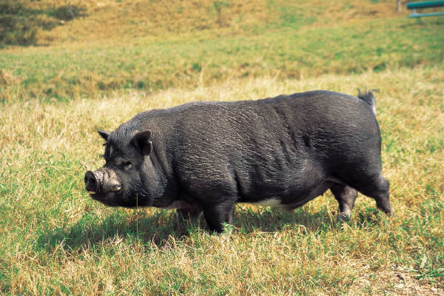  pig

Which dairy product do you like best?
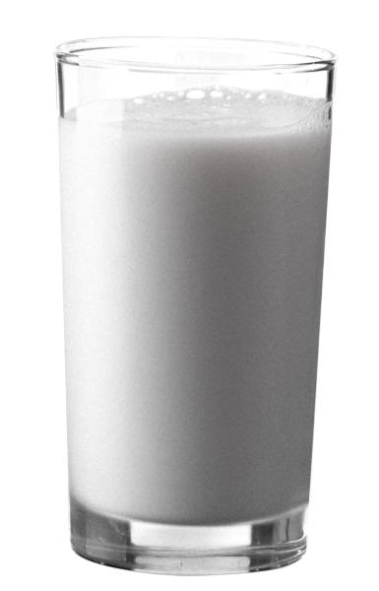  milk | 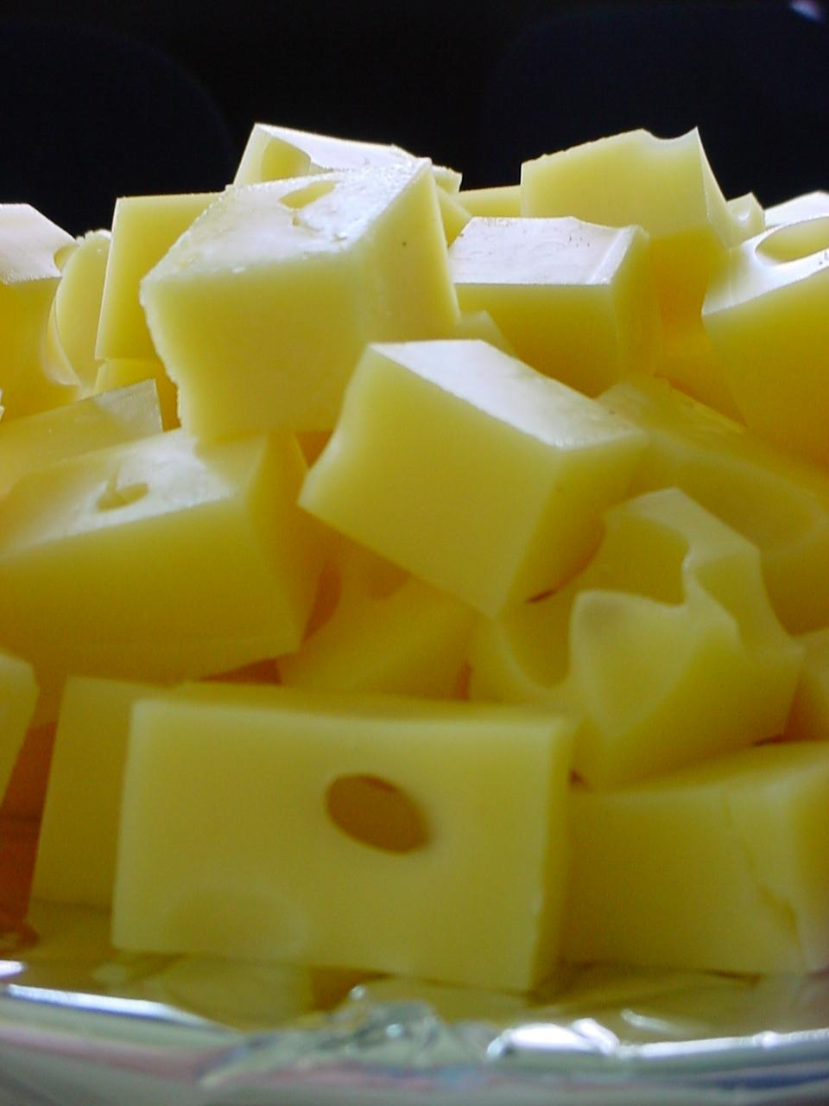  cheese | 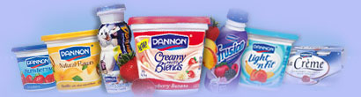yogurt | 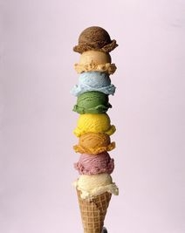  ice cream
Which zoo animal is the meanest?
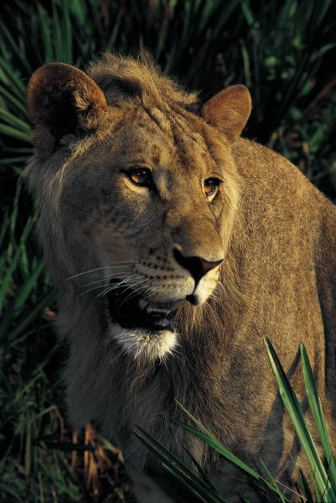  lion | 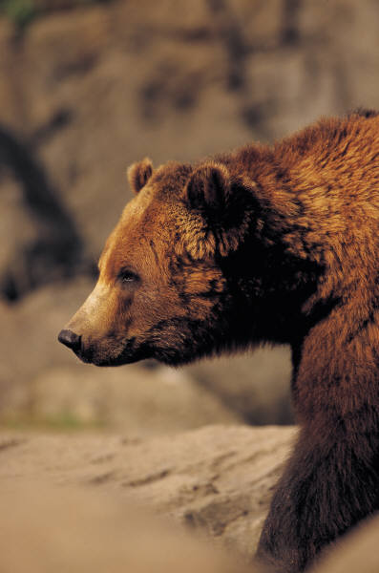  bear | 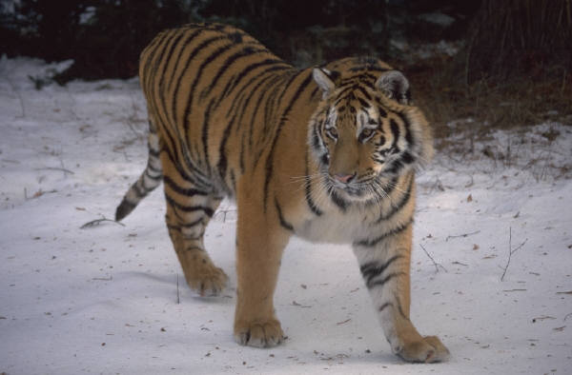  tiger | 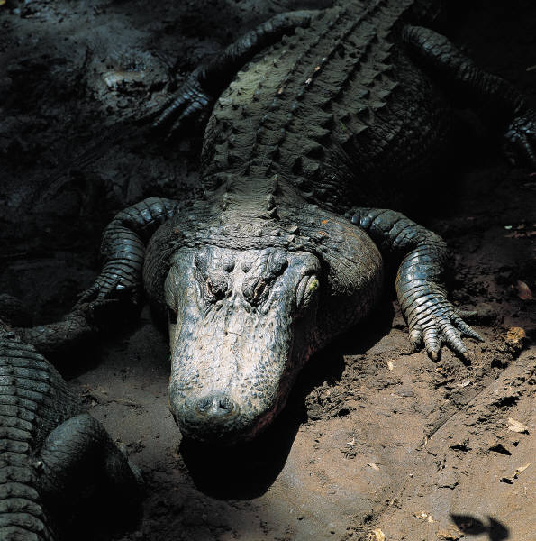  crocodile

Which zoo animal has the best camouflage?
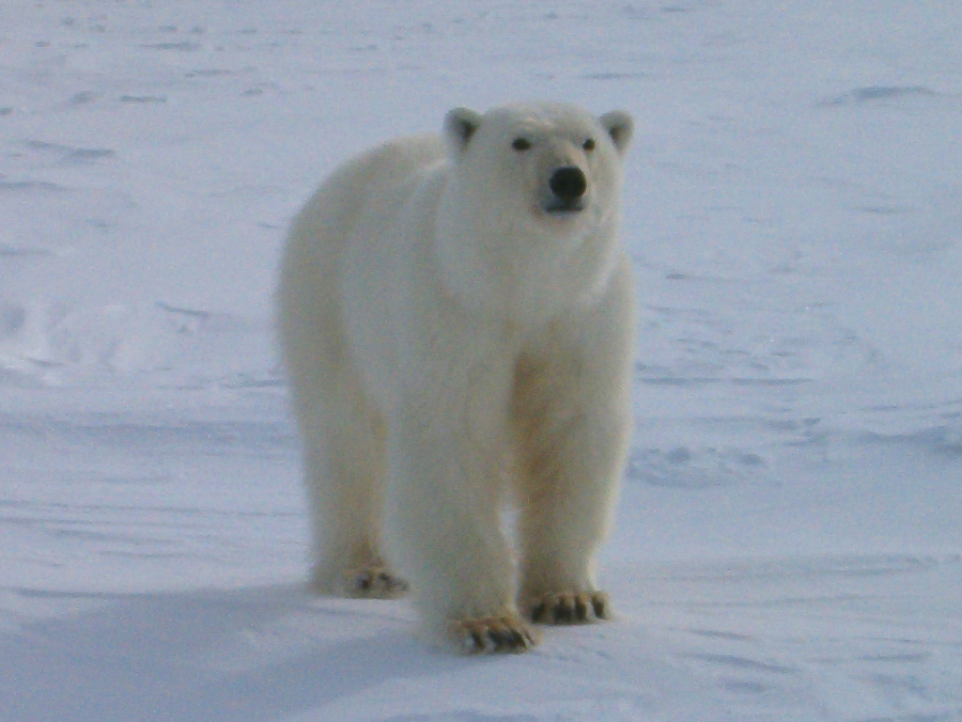  polar bear | 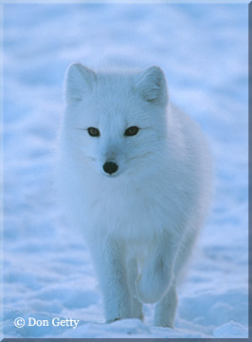  artic fox | 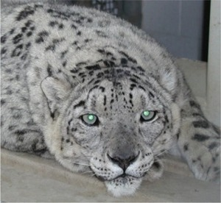  snow leopard
Which season do you like best: summer, winter, fall, or spring?
Fall | Summer | Winter | Spring

