What do you like to do?
Sing | Not Sing
Which do you like best?
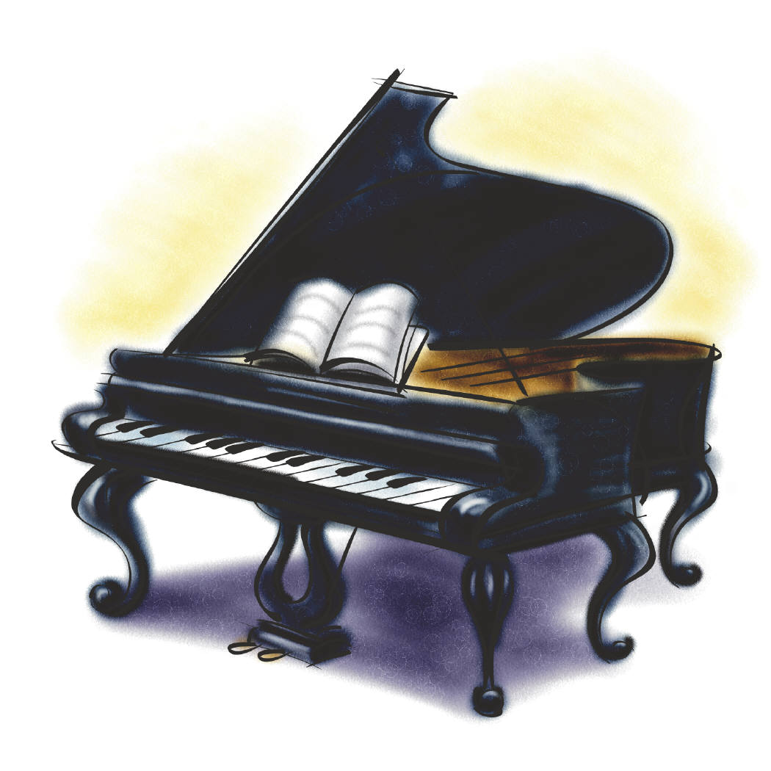

What would you like for lunch today?
Burrito | Chicken nuggets | Taco Snack | peanut butter and jelly
What is Mrs. O?
Tired | Happy | Sick | Silly

What do you wish the weather was today?
windy |   foggy | sunny | rainy
What do you like better?
 Candy Hearts |  | 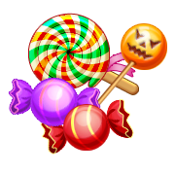  Suckers |   Chocolates
What do you like better?
Noisy kids | Talking kids | Quiet kids | Touching kids

My favorite color is:
Pink | Purple |   Blue | Green
When Mrs. Oliphant is absent, I feel:
Happy | Sad | Scared | Worried
I like to wear:
Jeans | Dresses | Shorts | sweatpants
What is your favorite restaurant?
McDonalds | Burger King | Wendys | X  None of them!
What do you like best?
  Calendar | Story Time | Reading | Centers
What is your favorite outside game?
Tag | Monkey bars | Soccer | Hula hoops
What is your favorite sport?
Wrestling | Gymnastics | Football | Soccer

What is your favorite holiday?
What do you like to write with?
Pen |  | Pencil |  | Crayon
I wish my hair was…
Curly |  | Straight

I wish my hair was….
long | Brown | Black | Short
What sound do you like better?
Cows mooing | Dogs Barking | Pigs Oinking | Horses Neighing

If I could have a farm animal for a pet, I would have….
Cows | Dogs |  | Pigs | Horses
My least favorite farm animal smell is….
Cows |  | Horses |  | Pigs
I would rather live….
On a farm | In a city |  | In an apartment | On a boat

I love spring because of…
Rain |  Flowers | More sunshine |  | Plants are growing!
In the spring I can’t wait to…
Play t-ball | Play soccer | Plant flowers |  | Have no winter coat!
My favorite spring holiday is….
Mother’s day | Father’s day | Easter |  | May Day
In the spring I get to…
Stay up later | Play outside more | Wear short sleeves |  | Join a team
My favorite Easter candy is…
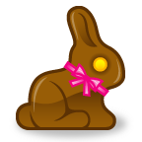Chocolate Bunnies | 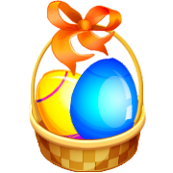  Chocolate Eggs | Jelly beans
My favorite color of Easter Egg is…
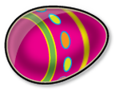  Pink | 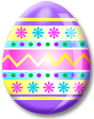  Purple | 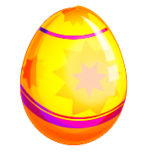  Yellow | Blue
I want the Easter Bunny to bring me a….
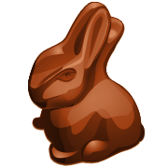Chocolate Bunny | Toy | Game |  | Book

